**TUGAS JOBSHEET 03**

**PRAKTIKUM STRUKTUR DATA**



**DOSEN PENGAMPU:**

**Vera Irma Delianti, S.Pd., M.Pd.T.**

**OLEH:**

**M. Ilham**

**23343008**

**PROGRAM STUDI INFORMATIKA  
DEPARTEMEN TEKNIK ELEKTRONIKA**

**FAKULTAS TEKNIK**

**UNIVERSITAS NEGERI PADANG**

**2024**

1. **singly-linked-list.c**
   1. **SOURCE CODE**

/* Nama File: Circular Doubly Linked List

Pembuat: M.ilham (23343008)

Tanggal Pembuatan: 28 Februari 2024

*/

#include <stdio.h>

#include <stdlib.h>

struct node

{

int data;

struct node *next;

};

struct node *head;

void beginsert();

void lastinsert();

void randominsert();

void begin_delete();

void last_delete();

void random_delete();

void display();

void search();

int main () {

int choice = 0;

while (choice != 9 )

{

printf("\n*****Singly Linked List*****\n");

printf("\n*****Main Menu *****\n");

printf("\nChoose one option from the following list... \n");

printf("=====================================\n");

printf("\n1.Insert in beginning \n2.Insert at last \n3.Insert at any random location\n4.Delete node from beginning \n5.Delete from last \n6.Delete node after specified location \n7.Search for an element \n8.Show \n9.Exit\n");

printf("\nEnter your choice?\n");

scanf("%d", &choice);

switch (choice) {

case 1:

beginsert();

break;

case 2:

lastinsert();

break;

case 3:

randominsert();

break;

case 4:

begin_delete();

break;

case 5:

last_delete();

break;

case 6:

random_delete();

break;

case 7:

search();

break;

case 8:

display();

break;

case 9:

exit(0);

break;

default:

printf("Please enter a valid choice..\n");

}

}

}

void beginsert() {

struct node *ptr;

int item;

ptr = (struct node *) malloc (sizeof(struct node));

if (ptr == NULL) {

printf("\nOVERFLOW");

} else {

printf("\nEnter Value\n");

scanf("%d", &item);

ptr->data = item;

ptr->next = head;

head = ptr;

printf("\nNode Inserted");

}

}

void lastinsert() {

struct node *ptr, *temp;

int item;

ptr = (struct node*) malloc(sizeof(struct node));

if(ptr == NULL) {

printf("\nOVERFLOW");

} else {

printf("\nEnter Value?\n");

scanf("%d", &item);

ptr->data = item;

if (head == NULL) {

ptr->next = NULL;

head = ptr;

printf ("\nNode inserted");

} else {

temp = head;

while (temp->next != NULL) {

temp = temp->next;

}

temp->next = ptr;

ptr->next = NULL;

printf("\nNode inserted");

}

}

}

void randominsert() {

int i, loc, item;

struct node *ptr, *temp;

ptr = (struct node *) malloc (sizeof(struct node));

if (ptr == NULL) {

printf("\nOVERFLOW");

} else {

printf("\nEnter element value: ");

scanf("%d", &item);

ptr->data = item;

printf("\nEnter the location after which you want to insert: ");

scanf("%d", &loc);

temp = head;

for (i = 0; i < loc; i++) {

temp = temp->next;

if(temp == NULL) {

printf("\nCan't insert\n");

return;

}

}

ptr->next = temp->next;

temp->next = ptr;

printf("\nNode inserted");

}

}

void begin_delete() {

struct node *ptr;

if (head == NULL) {

printf("\nList is empty\n");

} else {

ptr = head;

head = ptr->next;

free(ptr);

printf("\nNode deleted from the beginning...\n");

}

}

void last_delete() {

struct node *ptr, *ptrl;

if (head == NULL) {

printf("\nlist is empty");

} else if (head->next == NULL) {

head = NULL;

free(head);

printf ("\nOnly node of the list deleted...\n");

} else {

ptr = head;

while (ptr->next != NULL) {

ptrl = ptr;

ptr = ptr->next ;

}

ptrl->next = NULL;

free(ptr);

printf ("\nDeleted node from the last..\n");

}

}

void random_delete() {

struct node *ptr, *ptrl;

int loc, i;

printf ("\nEnter the location of the node after which you want to perform deletion: ");

scanf ("%d", &loc);

ptr = head;

for (i = 0; i < loc; i++) {

ptrl = ptr;

ptr = ptr->next;

if (ptr == NULL) {

printf ("\n Can't delete");

return;

}

}

ptrl->next = ptr->next;

free(ptr);

printf("\nDeleted node %d", loc + 1);

}

void search() {

struct node *ptr;

int item, i = 0, flag = 0;

ptr = head;

if (ptr == NULL) {

printf ("\nEmpty List\n");

} else {

printf ("\nEnter item which you want to search: ");

scanf("%d", &item);

while (ptr != NULL) {

if (ptr->data == item) {

printf("Item found at location %d\n", i + 1);

flag = 1;

}

i++;

ptr = ptr->next;

}

if (flag == 0) {

printf("Item not found\n");

}

}

}

void display() {

struct node *ptr;

ptr = head;

if (ptr == NULL) {

printf ("Nothing to print\n");

} else {

printf("\nPrinting values...\n");

while (ptr != NULL) {

printf("%d -> ", ptr->data);

ptr = ptr->next;

}

printf("NULL\n");

}

}

* 1. **SCREENSHOT PROGRAM**

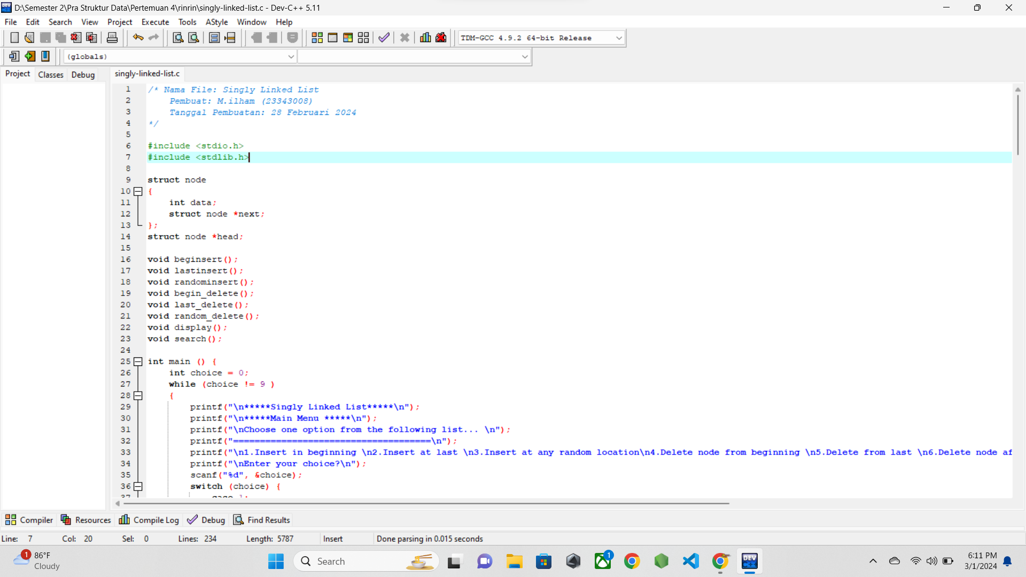

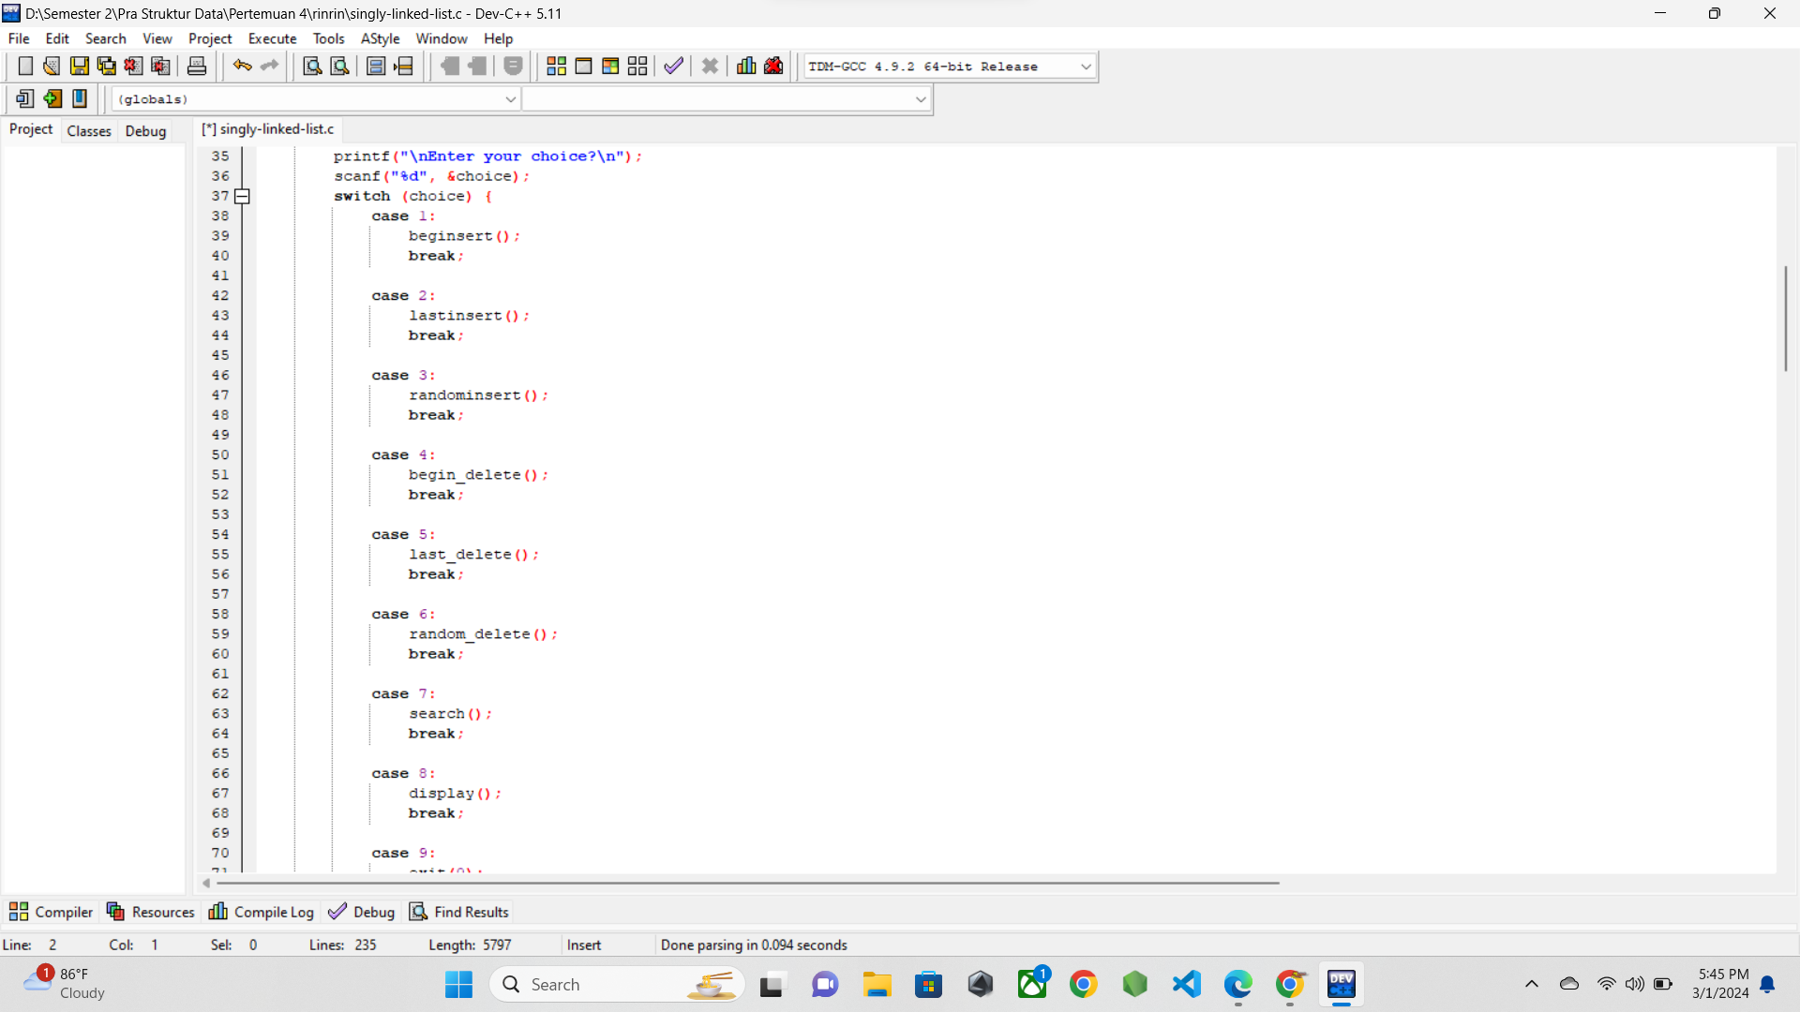

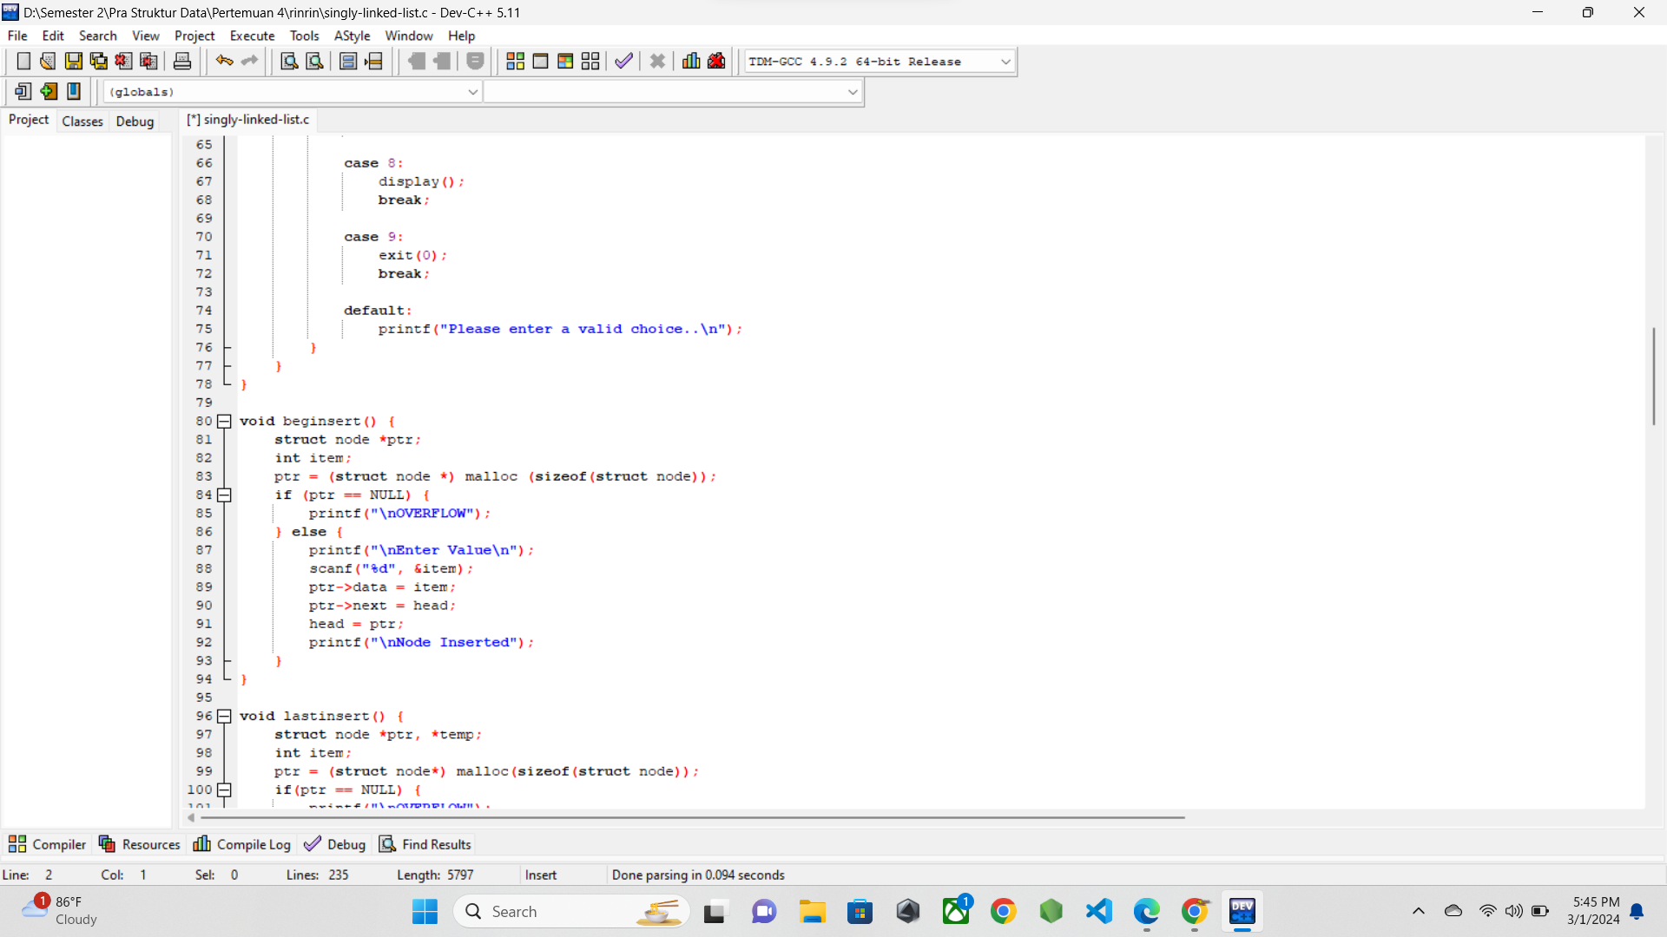

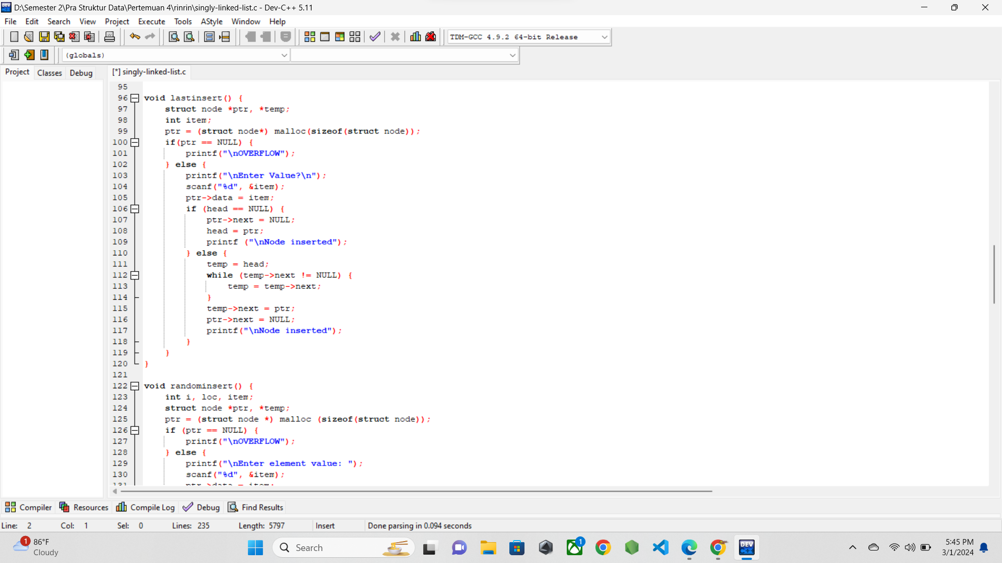

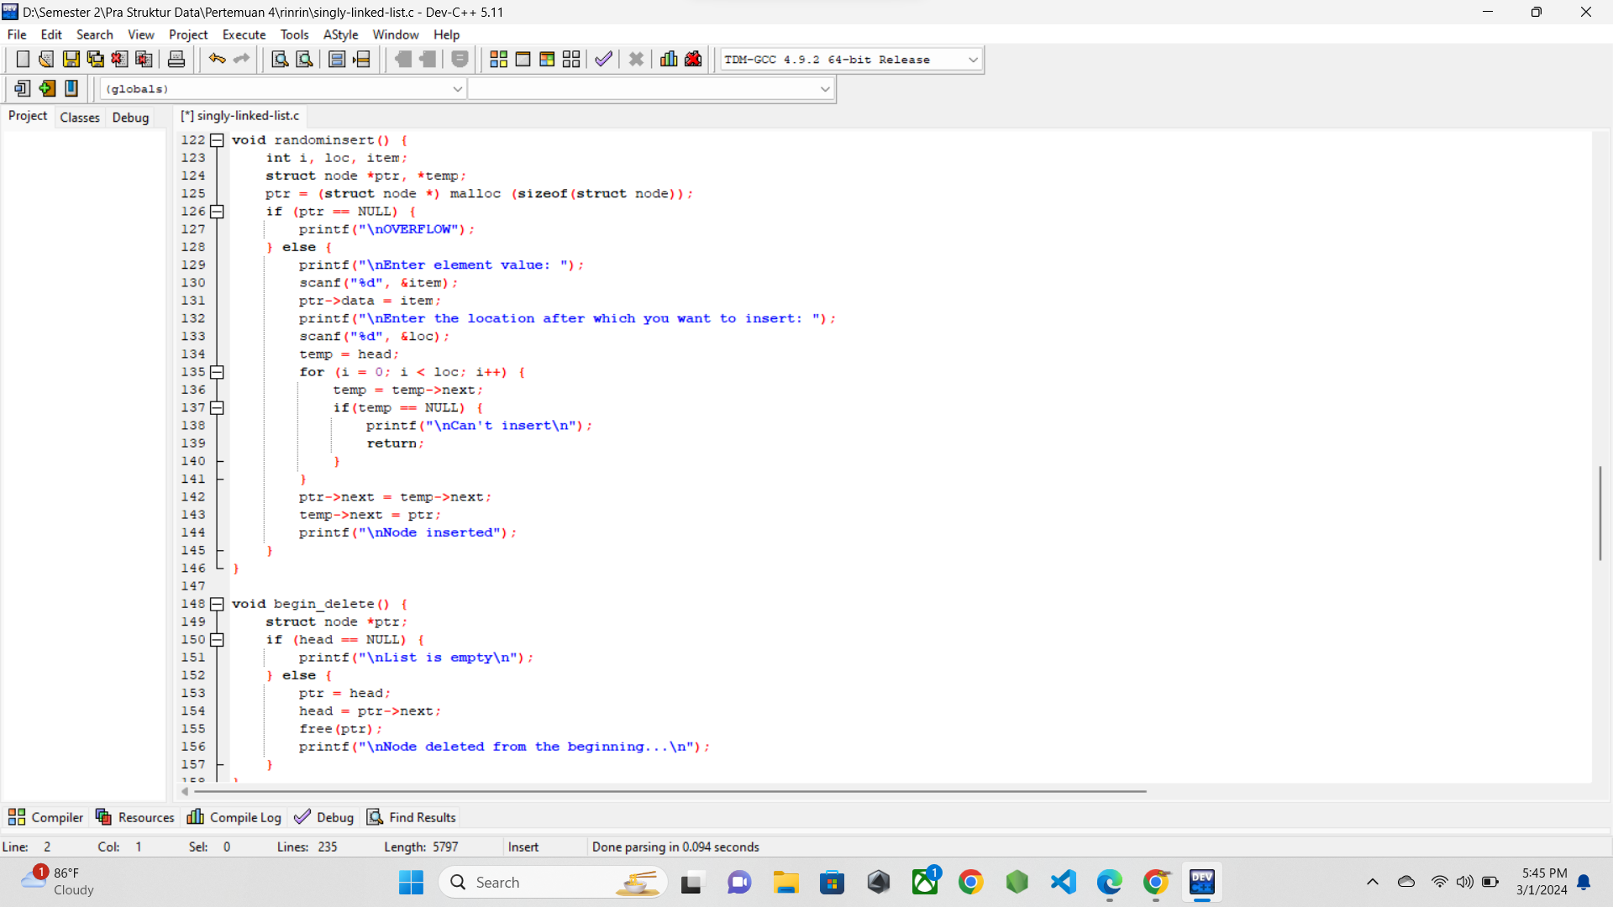

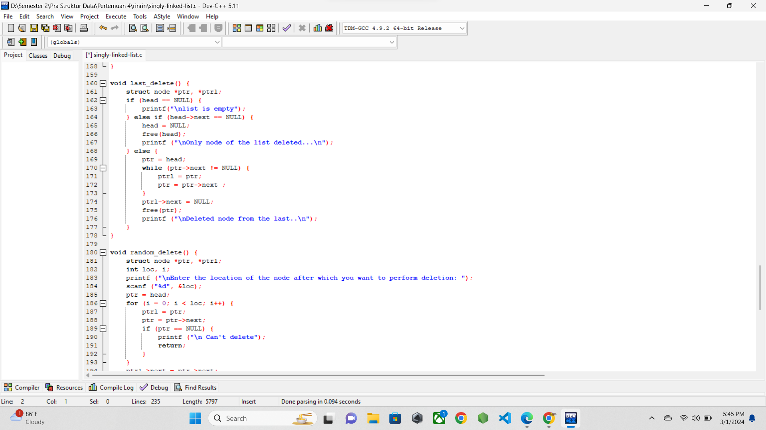

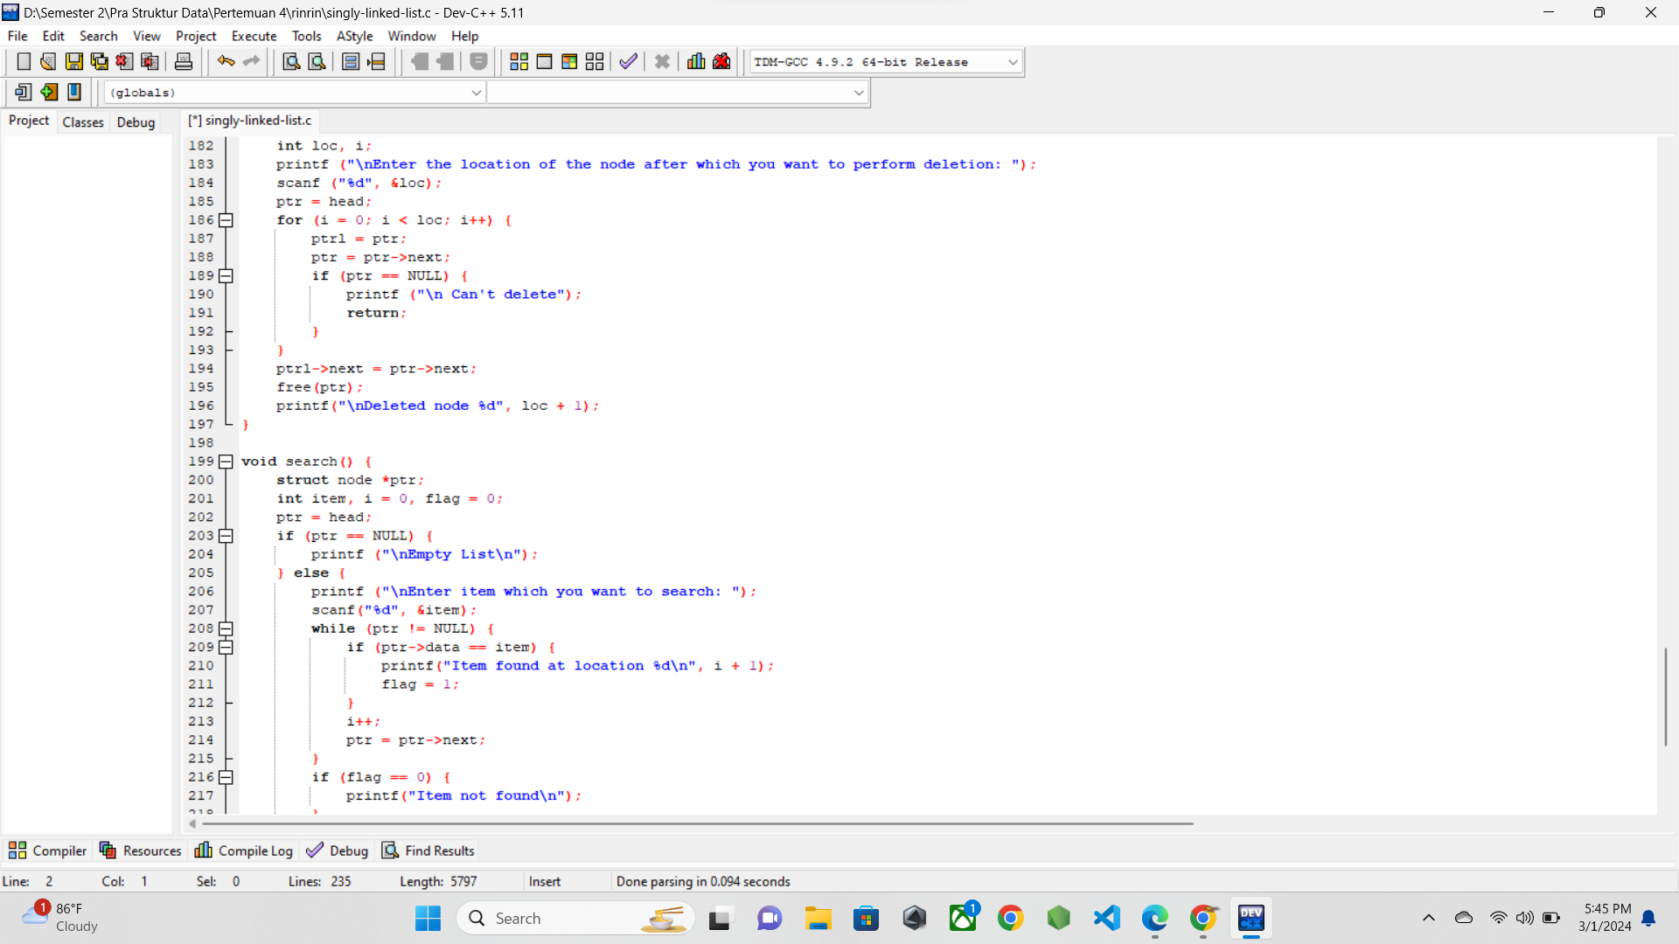

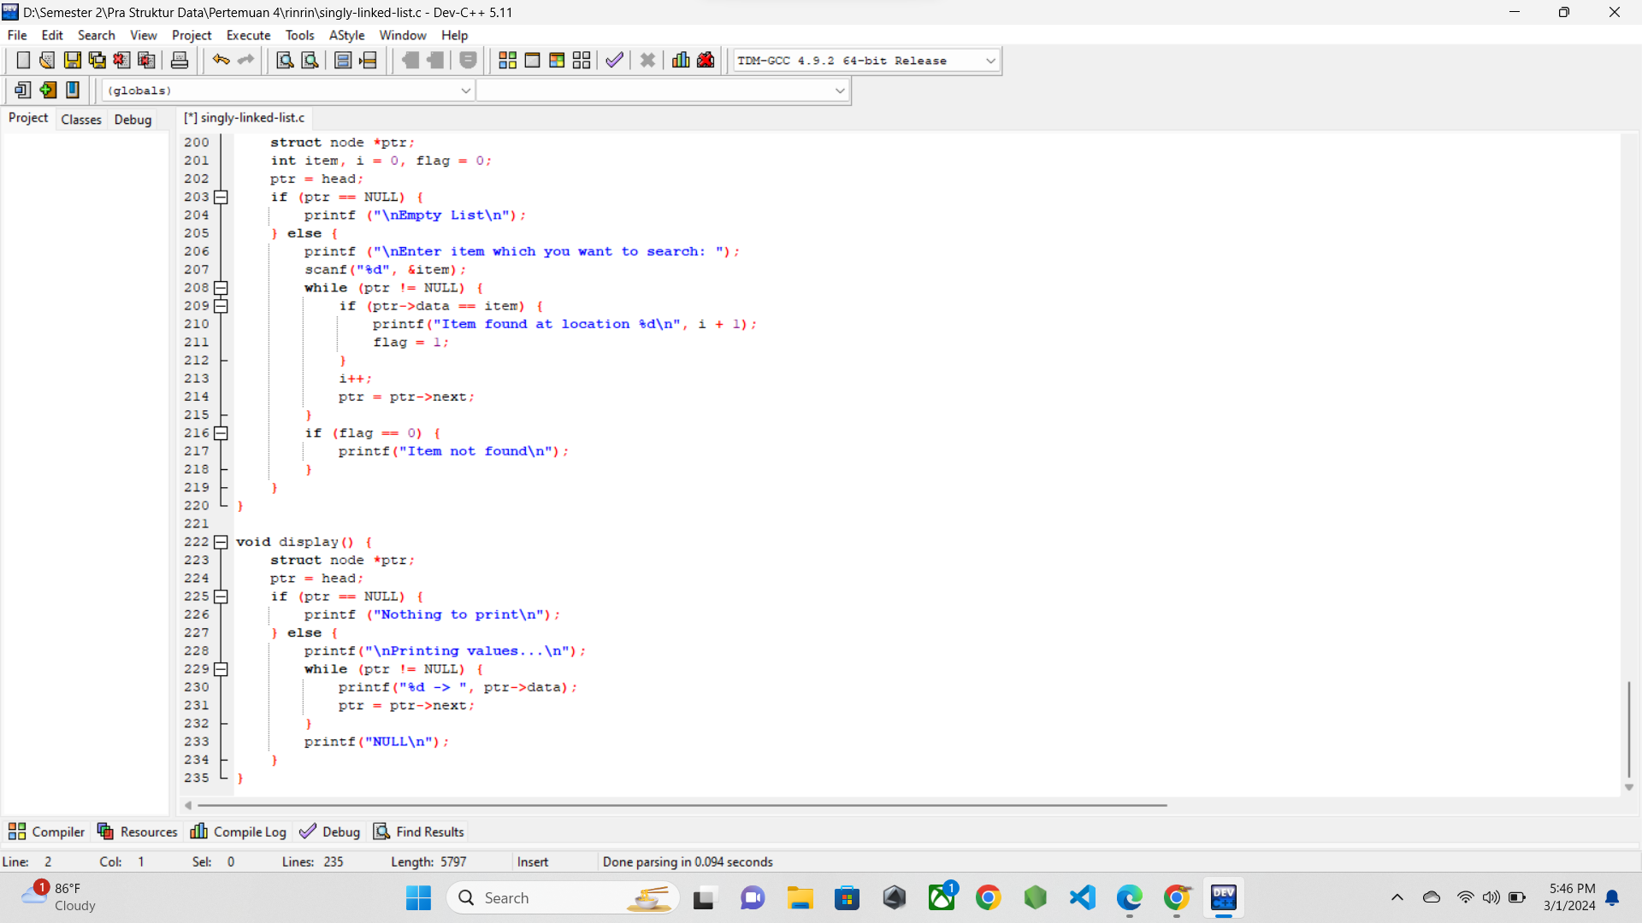

* 1. **SCREENSHOT OUTPUT**

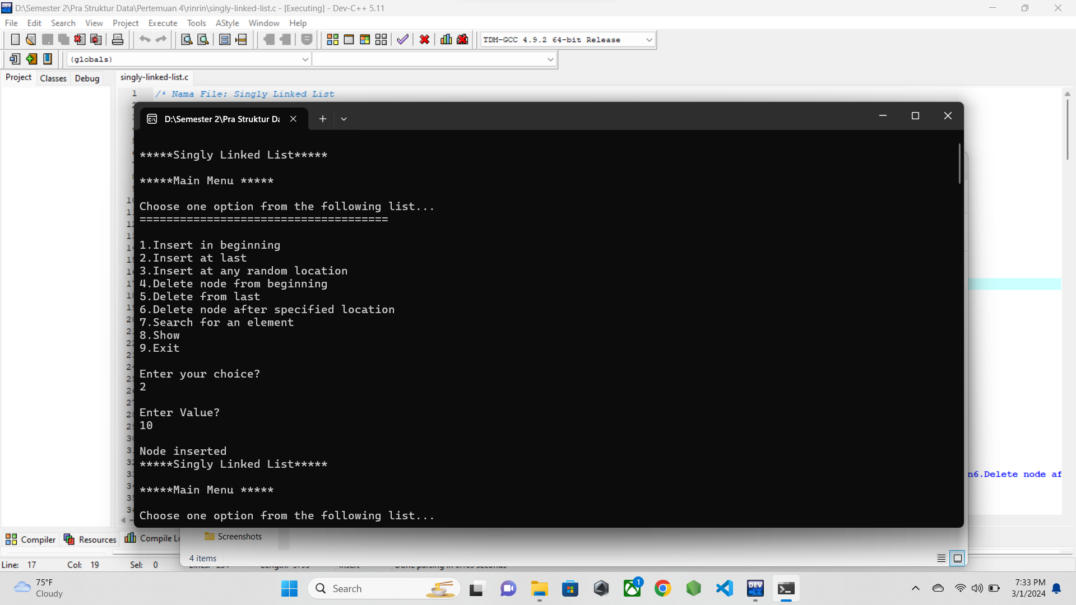

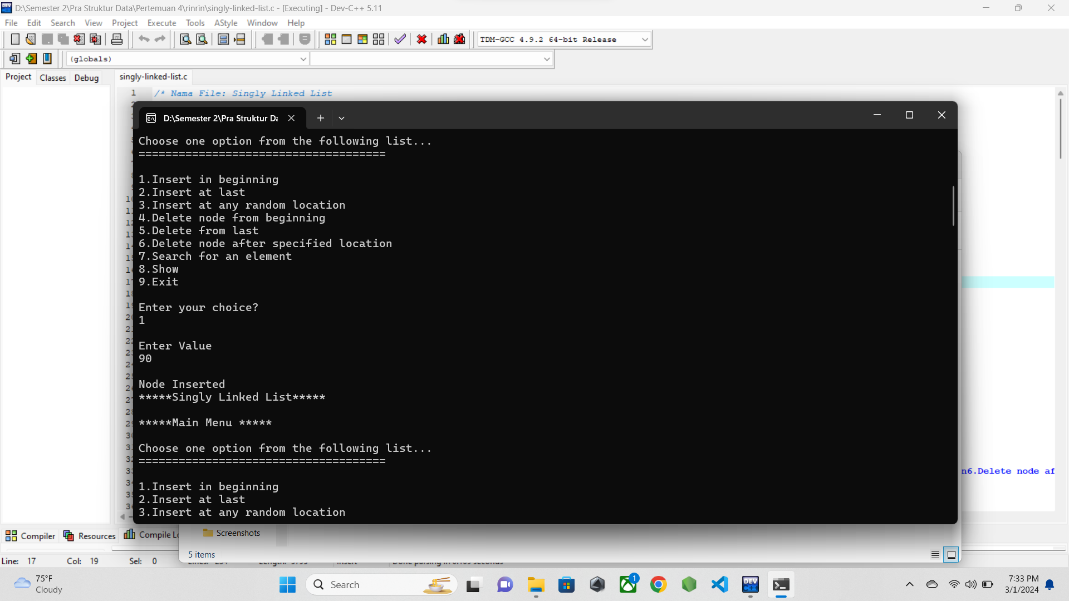

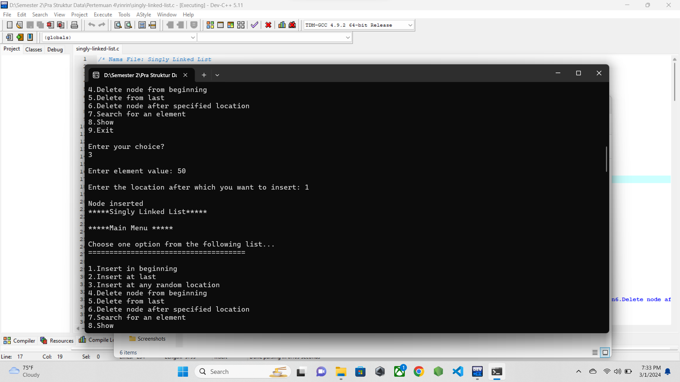

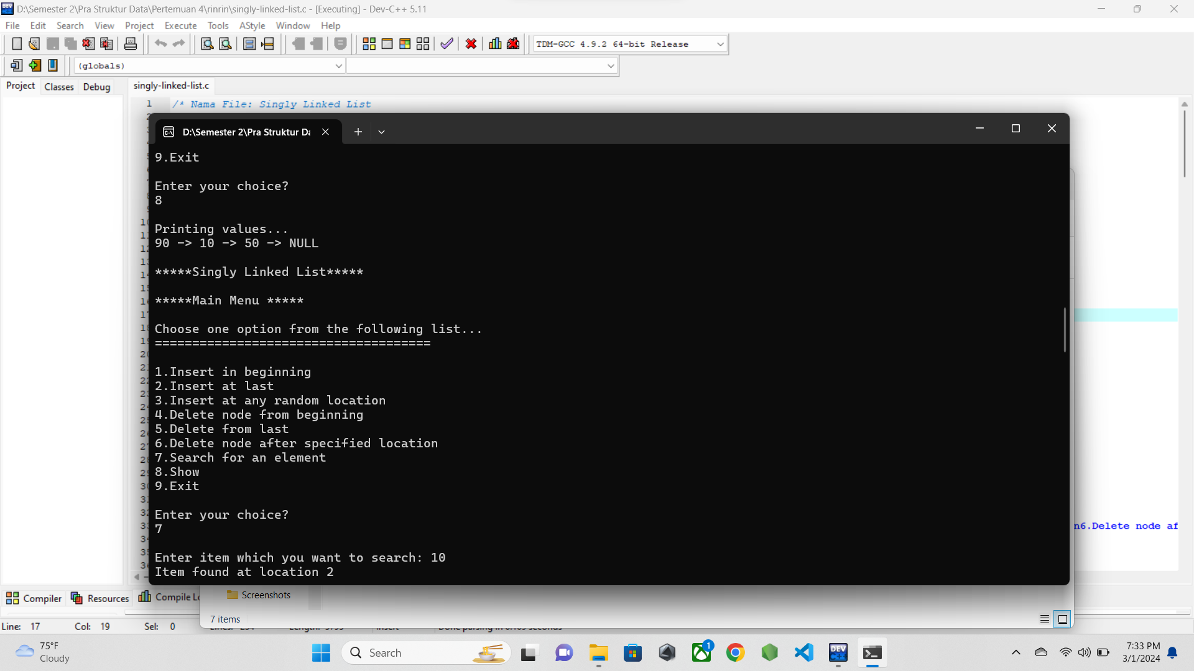

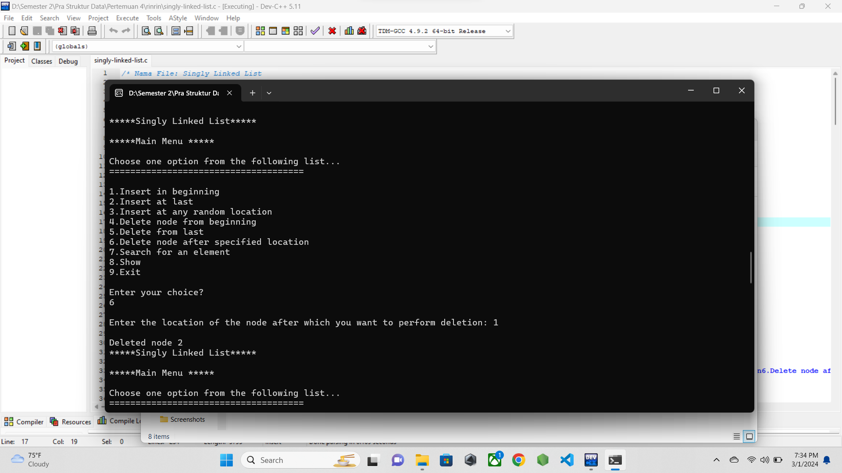

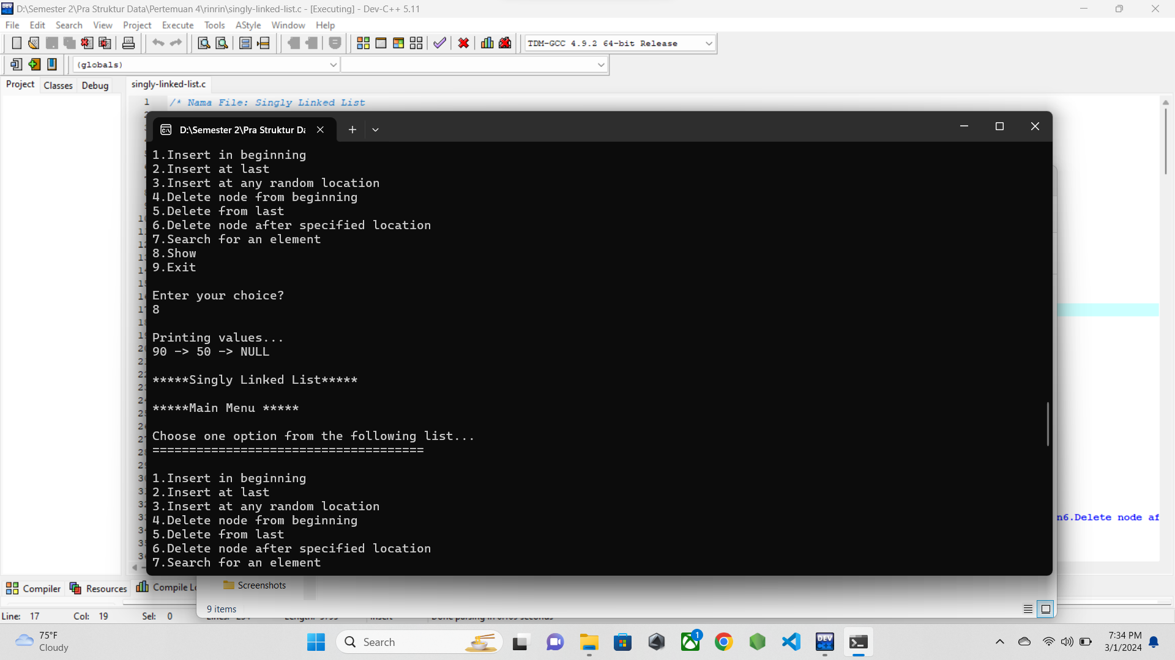

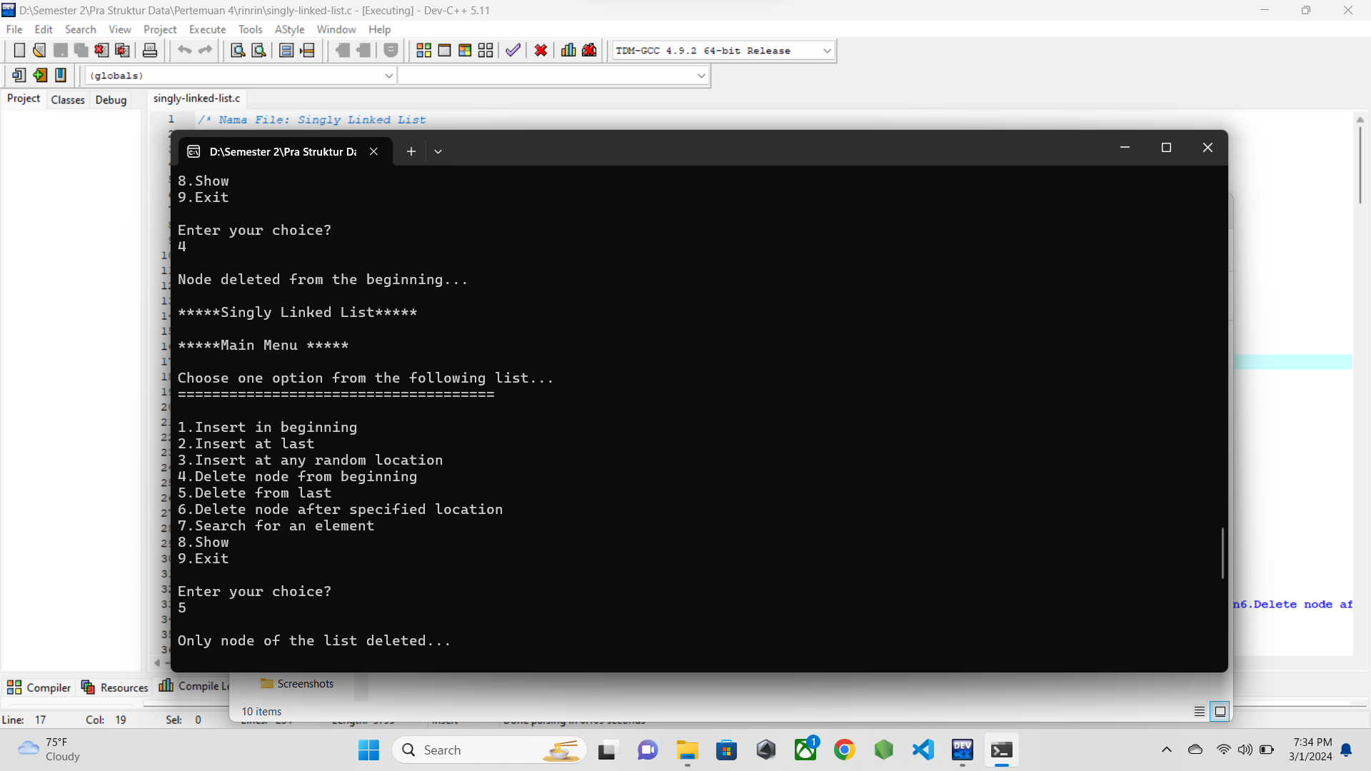

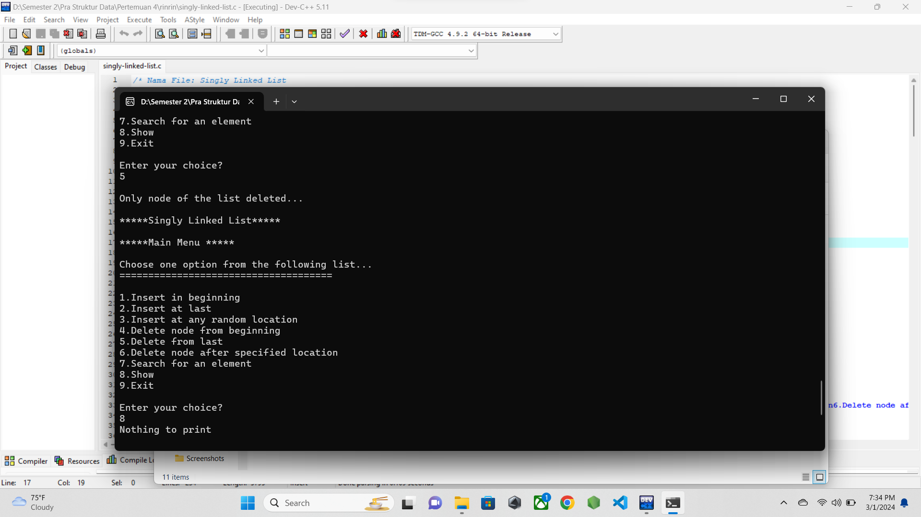

* 1. **PENJELASAN PROGRAM**

Pada program ini adalah konsep single linked list yang di implementasikan dengan setiap node yang memiliki satu data dan menunjuk ke node lain. Pada screnshoot, user akan di minta mau melakukan apa. Pada kasus ini, awalnya saya menginputkan data pada akhir node, lalu data selanjutnya pada awal node, lalu di tampilkan data yang sudah di masukkan.

Lalu saya mencoba menggunakan fitur search, setelah itu saya melakukan delete pada node pada node paling akhir, lalu node paling awal, lalu pada akhir program di tampilkan lagi apa saja data yang tersisa dan program berakhir.

1. **doubly-linked-list.c**
   1. **SOURCE CODE**

/* Nama File: Circular Doubly Linked List

Pembuat: M.ilham (23343008)

Tanggal Pembuatan: 28 Februari 2024

*/

#include <stdio.h>

#include <stdlib.h>

struct node

{

struct node *prev;

struct node *next;

int data;

};

struct node *head = NULL; // Inisialisasi head sebagai NULL

void insertion_beginning();

void insertion_last();

void insertion_specified();

void deletion_beginning();

void deletion_last();

void deletion_specified();

void display();

void search();

int main()

{

int choice = 0;

while (choice != 9)

{

printf("\n*****Doubly Linked List*****\n");

printf("\n*****Main Menu *****\n");

printf("\nChoose one option from the following list... \n");

printf("=====================================\n");

printf("\n1.Insert in beginning\n2.Insert at last\n3.Insert at any random location\n4.Delete from beginning\n5.Delete from last\n6.Delete the node after the given data\n7.Search\n8.Show\n9.Exit\n");

printf("\nEnter your choice?\n");

scanf("\n%d", &choice);

switch (choice)

{

case 1:

insertion_beginning();

break;

case 2:

insertion_last();

break;

case 3:

insertion_specified();

break;

case 4:

deletion_beginning();

break;

case 5:

deletion_last();

break;

case 6:

deletion_specified();

break;

case 7:

search();

break;

case 8:

display();

break;

case 9:

exit(0);

break;

default:

printf("Please enter a valid choice..\n");

}

}

}

void insertion_beginning()

{

struct node *ptr;

int item;

ptr = (struct node *)malloc(sizeof(struct node));

if (ptr == NULL)

{

printf("\nOVERFLOW");

}

else

{

printf("\nEnter Item Value\n");

scanf("%d", &item);

if (head == NULL)

{

ptr->next = NULL;

ptr->prev = NULL;

ptr->data = item;

head = ptr;

}

else

{

ptr->data = item;

ptr->prev = NULL;

ptr->next = head;

head->prev = ptr;

head = ptr;

}

printf("\nNode inserted\n");

}

}

void insertion_last()

{

struct node *ptr, *temp;

int item;

ptr = (struct node *)malloc(sizeof(struct node));

if (ptr == NULL)

{

printf("\nOVERFLOW");

}

else

{

printf("\nEnter Value?\n");

scanf("%d", &item);

ptr->data = item;

if (head == NULL)

{

ptr->next = NULL;

ptr->prev = NULL;

head = ptr;

}

else

{

temp = head;

while (temp->next != NULL)

{

temp = temp->next;

}

temp->next = ptr;

ptr->prev = temp;

ptr->next = NULL;

}

printf("\nNode inserted");

}

}

void insertion_specified()

{

struct node *ptr, *temp;

int item, loc, i;

ptr = (struct node *)malloc(sizeof(struct node));

if (ptr == NULL)

{

printf("\nOVERFLOW");

}

else

{

temp = head;

printf("\nEnter the location?\n");

scanf("%d", &loc);

for (i = 0; i < loc; i++)

{

temp = temp->next;

if (temp == NULL)

{

printf("\n There are less than %d elements", loc);

return;

}

}

printf("\nEnter Value\n");

scanf("%d", &item);

ptr->data = item;

ptr->next = temp->next;

ptr->prev = temp;

temp->next = ptr;

if (ptr->next != NULL)

ptr->next->prev = ptr;

printf("\nnode inserted");

}

}

void deletion_beginning()

{

struct node *ptr;

if (head == NULL)

{

printf("\nUNDERFLOW");

}

else if (head->next == NULL)

{

head = NULL;

free(head);

printf("\nNode deleted\n");

}

else

{

ptr = head;

head = head->next;

head->prev = NULL;

free(ptr);

printf("\nNode deleted");

}

}

void deletion_last()

{

struct node *ptr;

if (head == NULL)

{

printf("\nUNDERFLOW");

}

else if (head->next == NULL)

{

head = NULL;

free(head);

printf("\nNode deleted\n");

}

else

{

ptr = head;

while (ptr->next != NULL)

{

ptr = ptr->next;

}

ptr->prev->next = NULL;

free(ptr);

printf("\nNode deleted");

}

}

void deletion_specified()

{

struct node *ptr, *temp;

int val;

printf("\nEnter the data after which the node is to be deleted: ");

scanf("%d", &val);

ptr = head;

while (ptr->data != val)

ptr = ptr->next;

if (ptr->next == NULL)

{

printf("\n Can't delete");

}

else if (ptr->next->next == NULL)

{

ptr->next = NULL;

}

else

{

temp = ptr->next;

ptr->next = temp->next;

temp->next->prev = ptr;

free(temp);

printf("\nnode deleted\n");

}

}

void display()

{

struct node *ptr;

printf("\n printing values...\n");

ptr = head;

while (ptr != NULL)

{

printf("%d\n", ptr->data);

ptr = ptr->next;

}

}

void search()

{

struct node *ptr;

int item, i = 0, flag;

ptr = head;

if (ptr == NULL)

{

printf("\nEmpty List\n");

}

else

{

printf("\nEnter item which you want to search?\n ");

scanf("%d", &item);

while (ptr != NULL)

{

if (ptr->data == item)

{

printf("Item found at location %d\n", i + 1);

flag = 0;

break;

}

else

{

flag = 1;

}

i++;

ptr = ptr->next;

}

if (flag == 1)

{

printf("Item not found\n");

}

}

}

* 1. **SCREENSHOT PROGRAM**

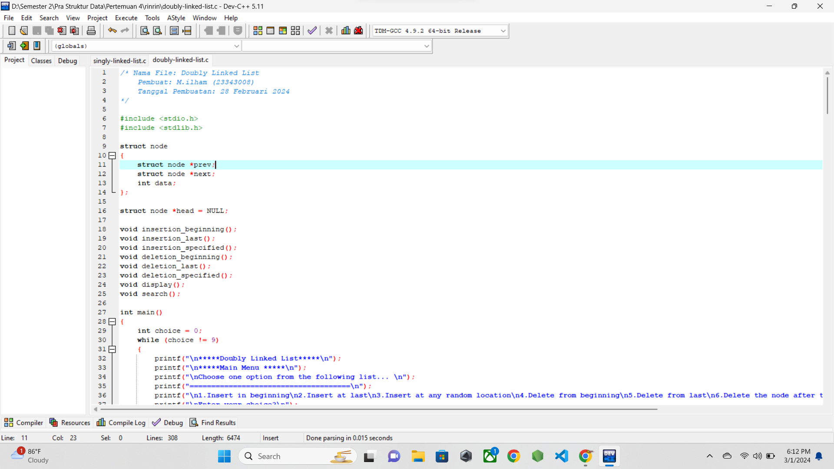

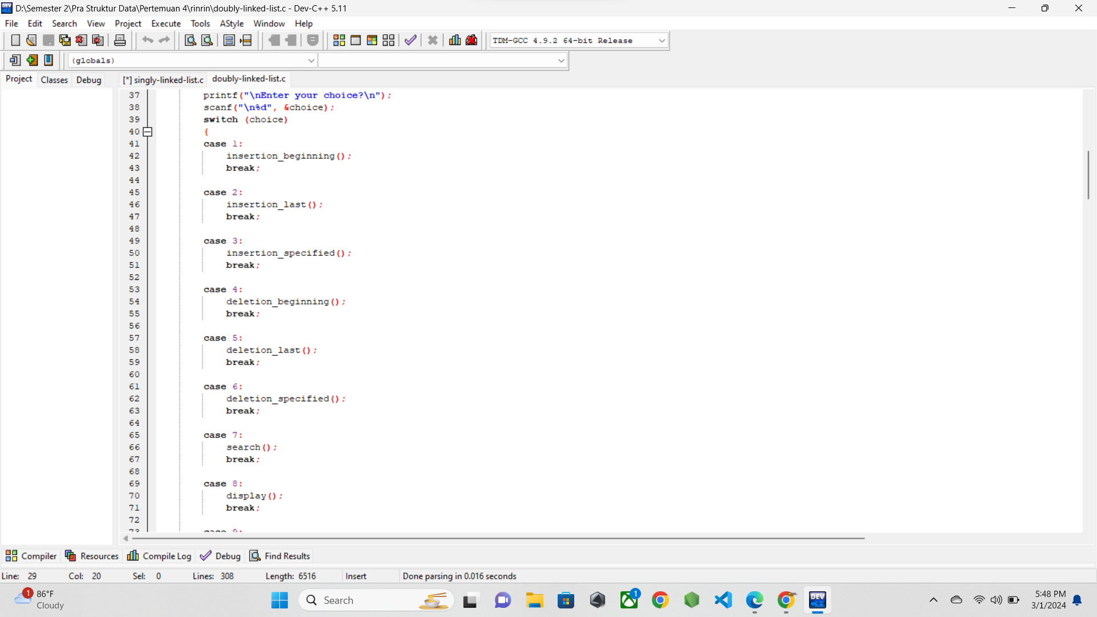

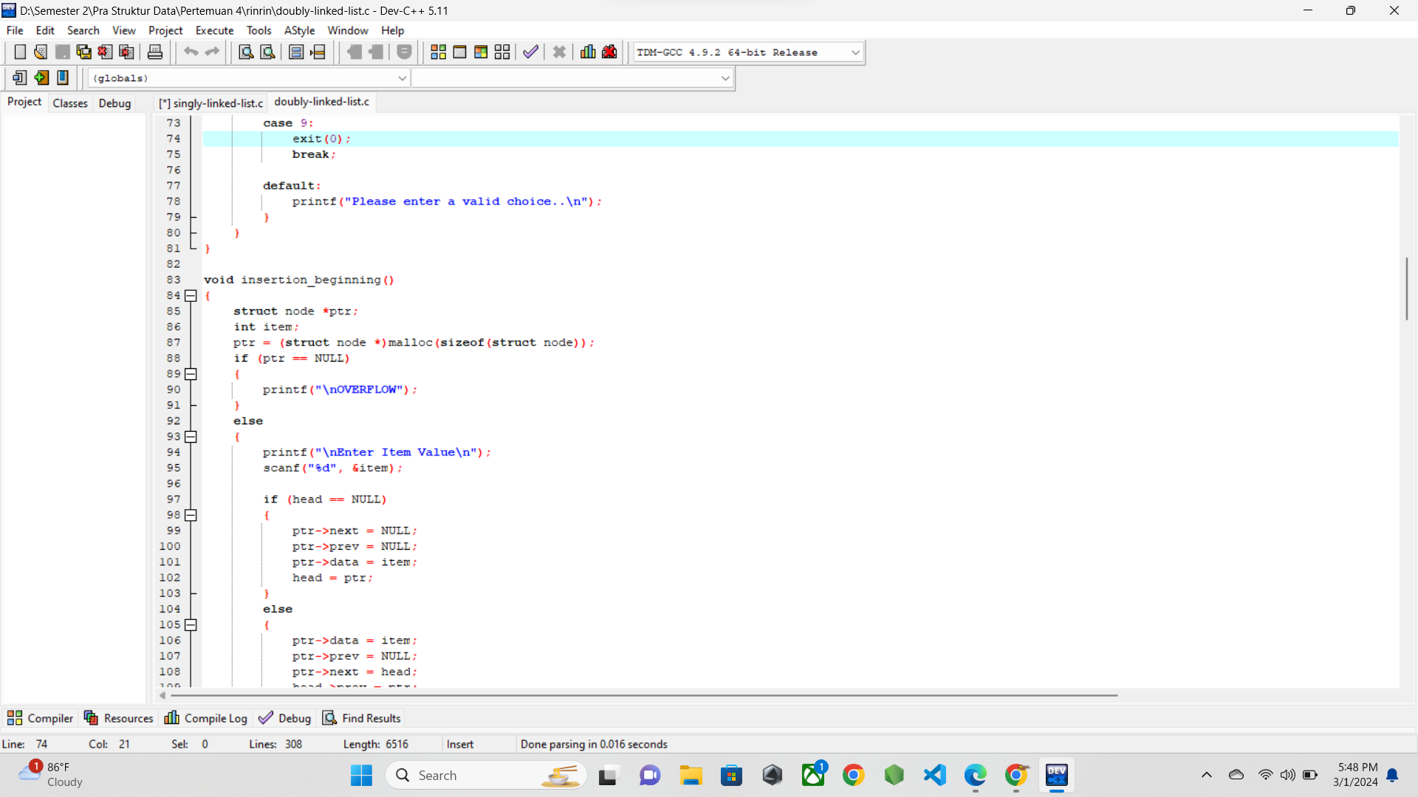

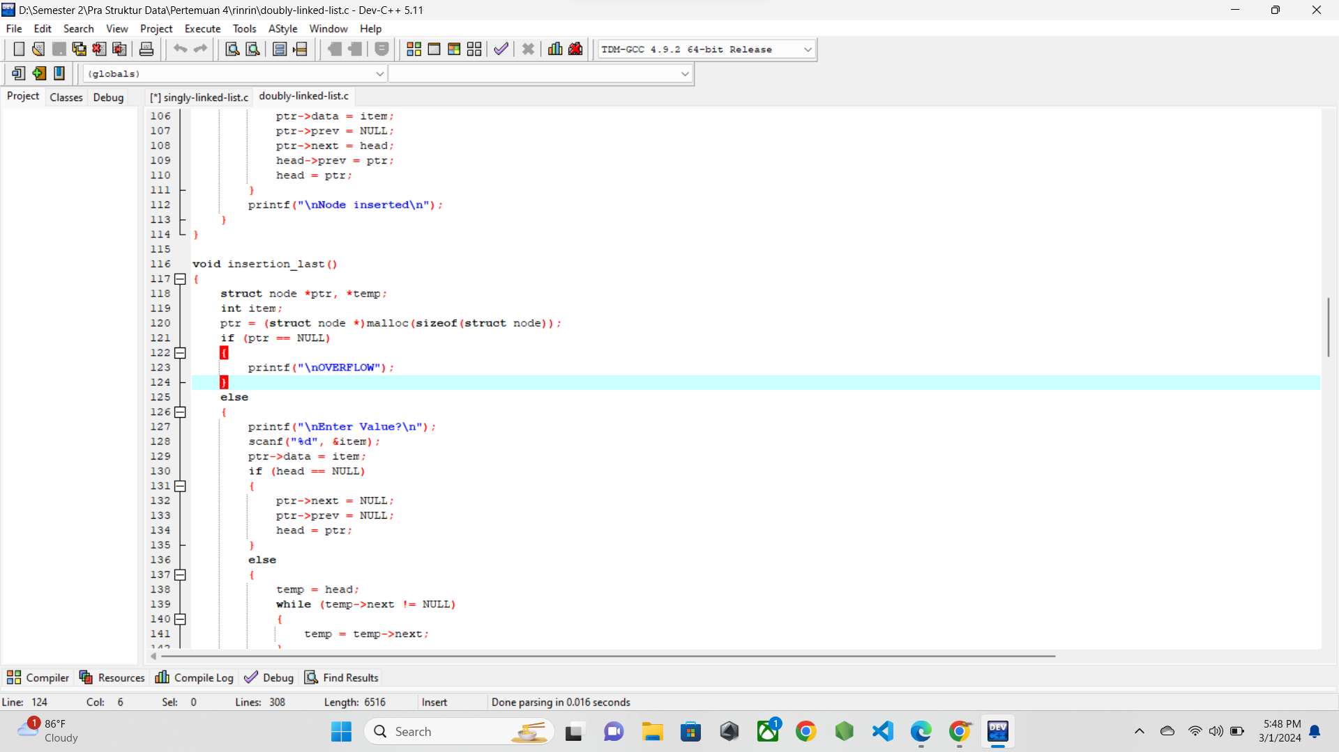

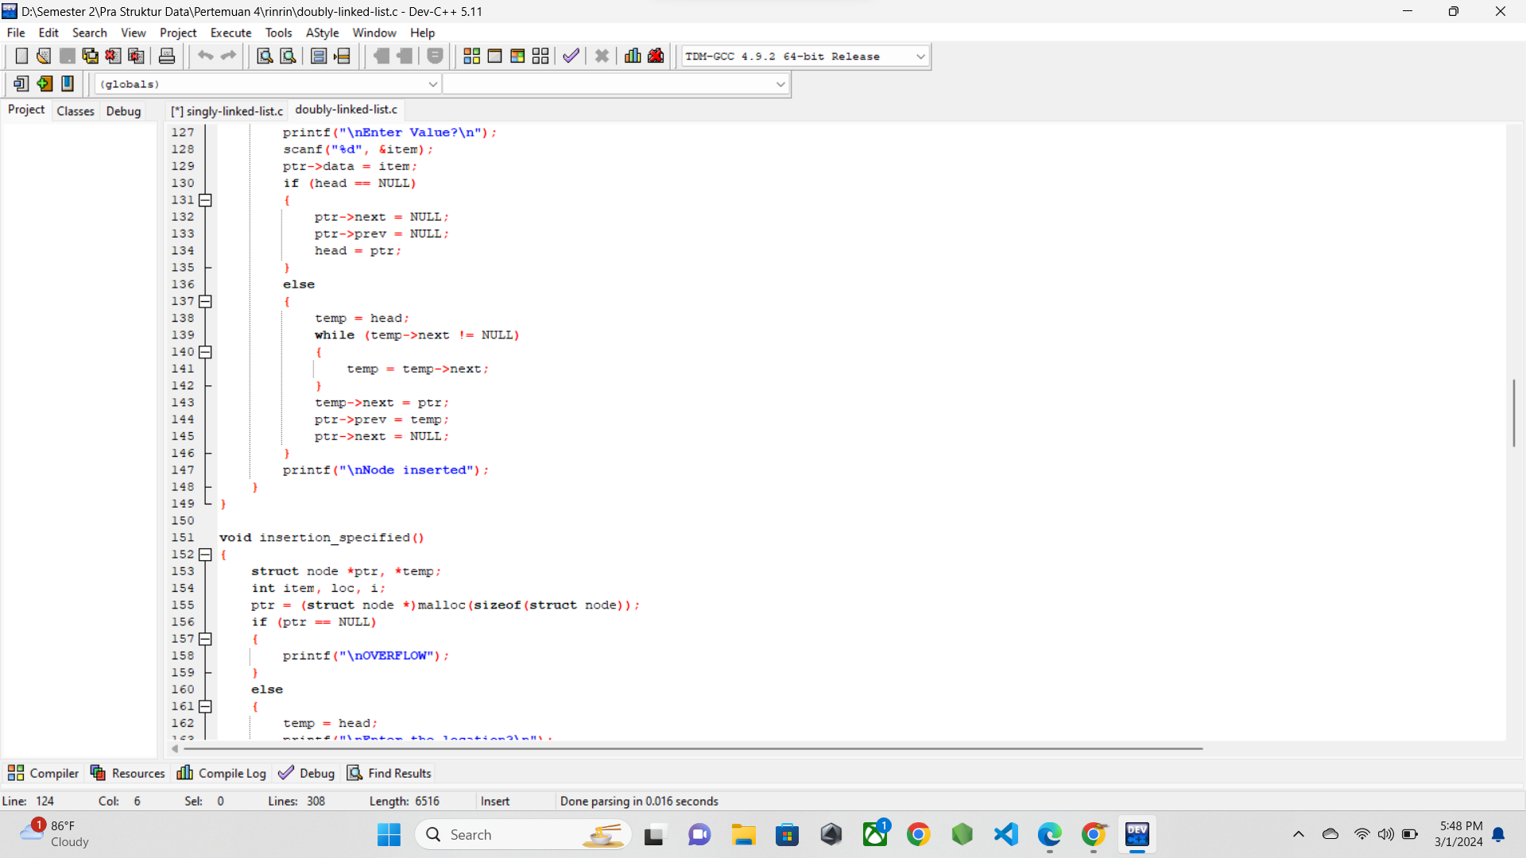

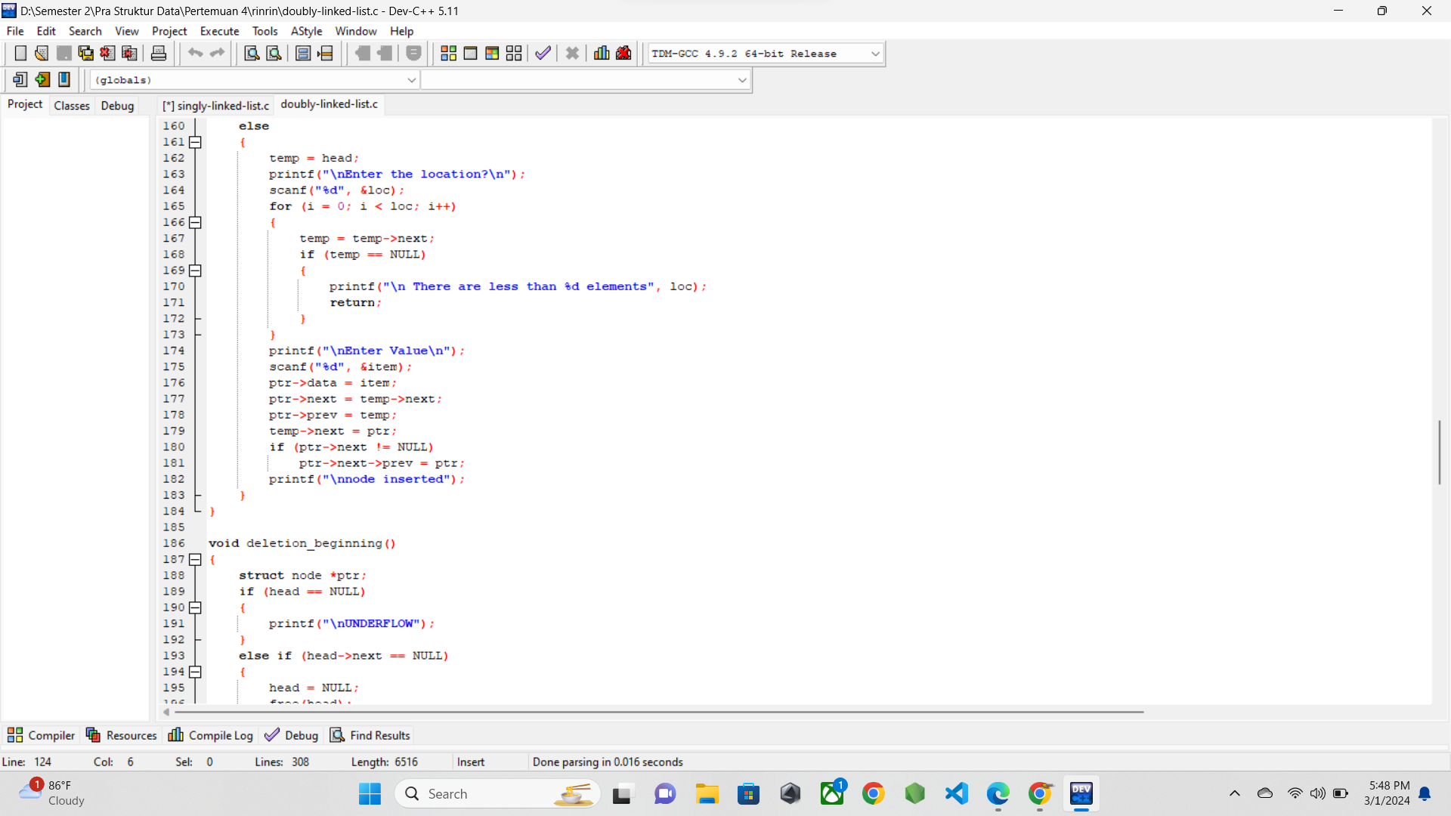

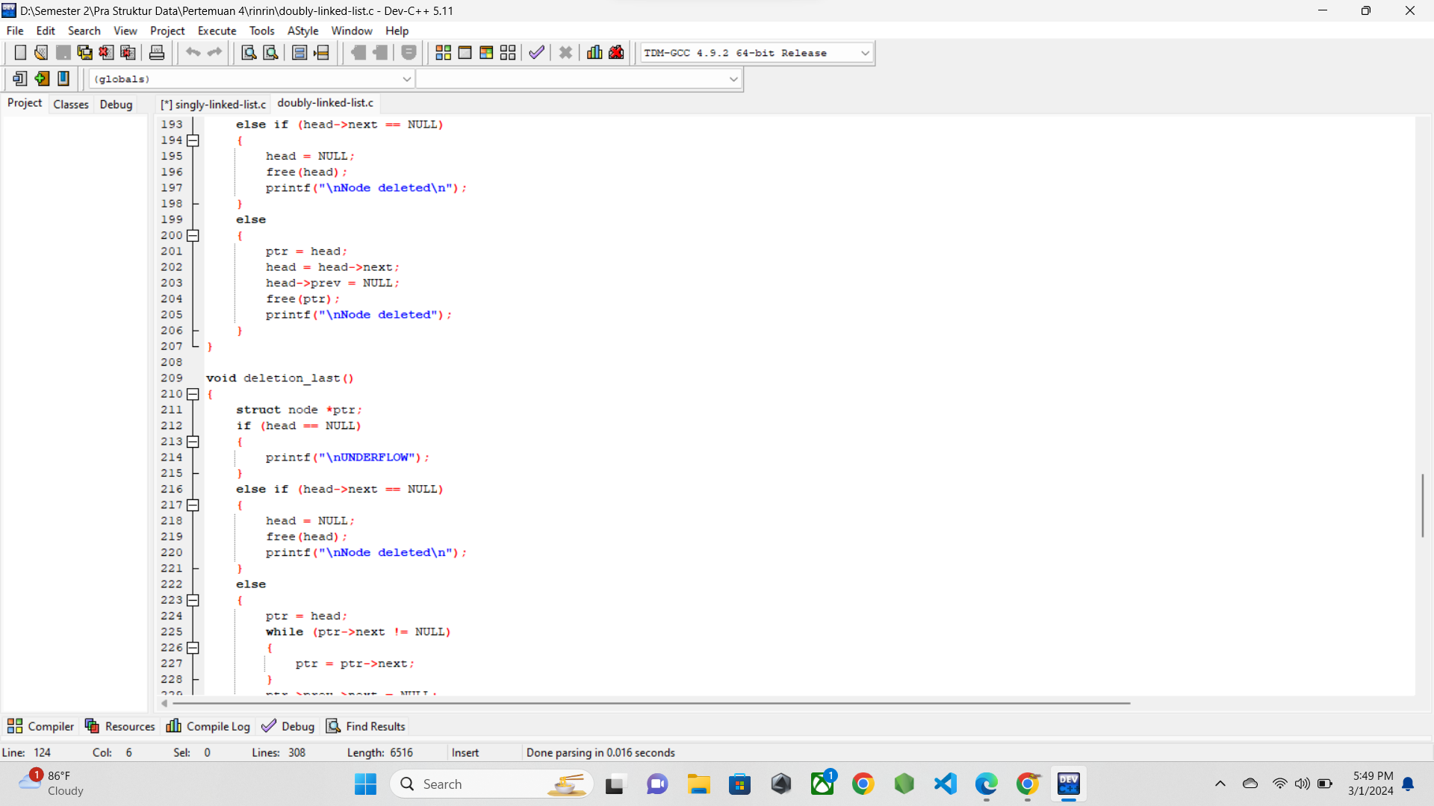

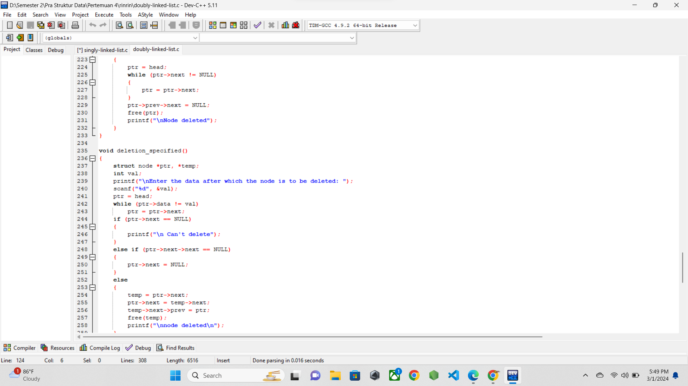

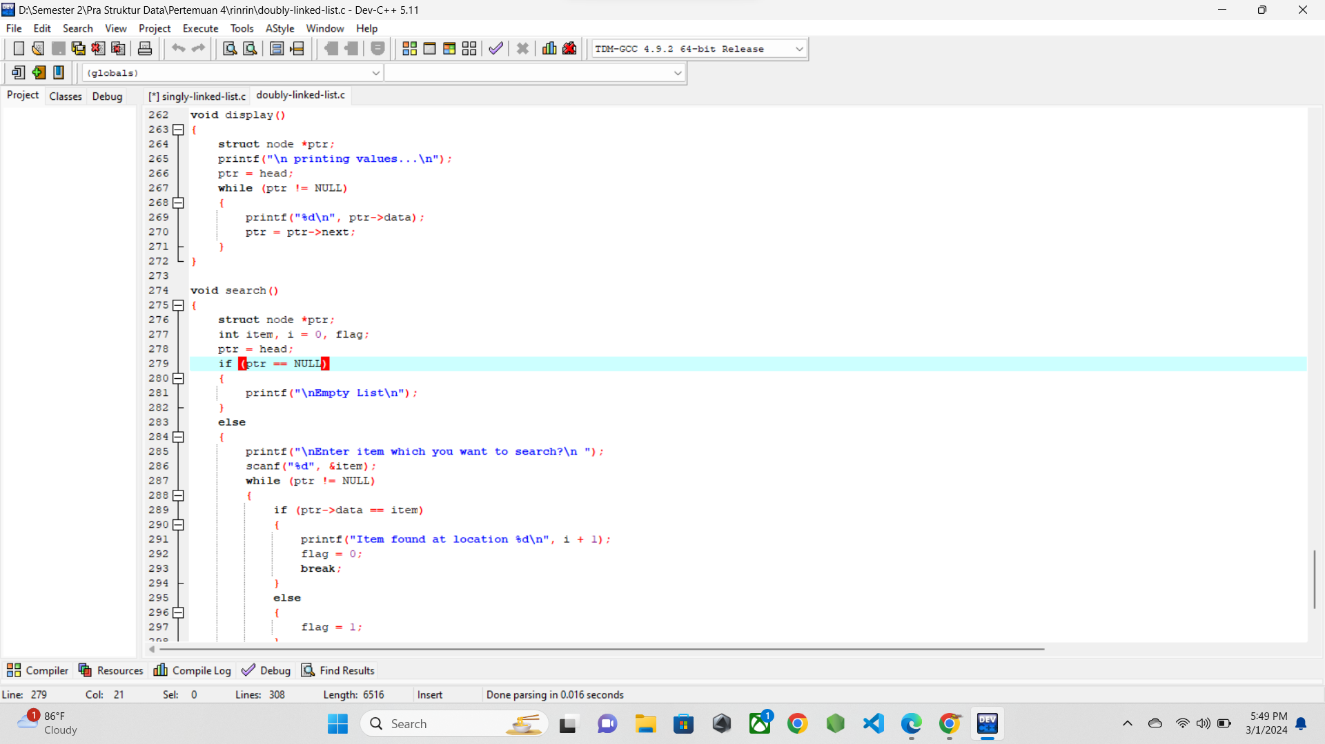

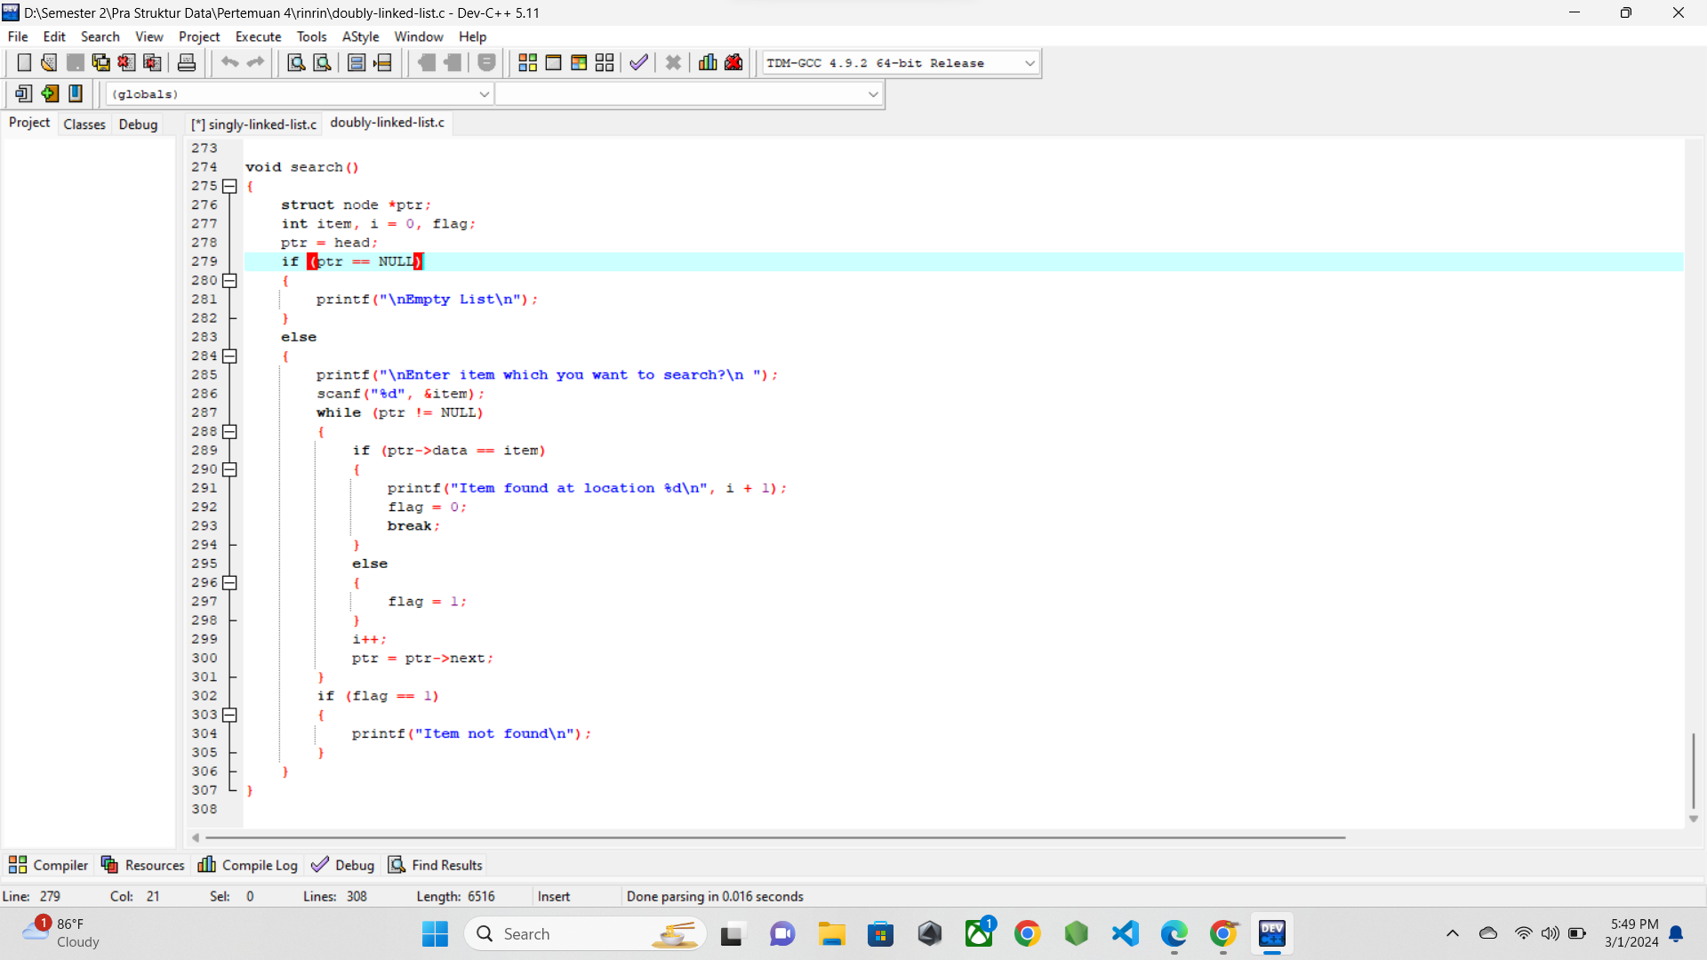

* 1. **SCREENSHOT OUTPUT**

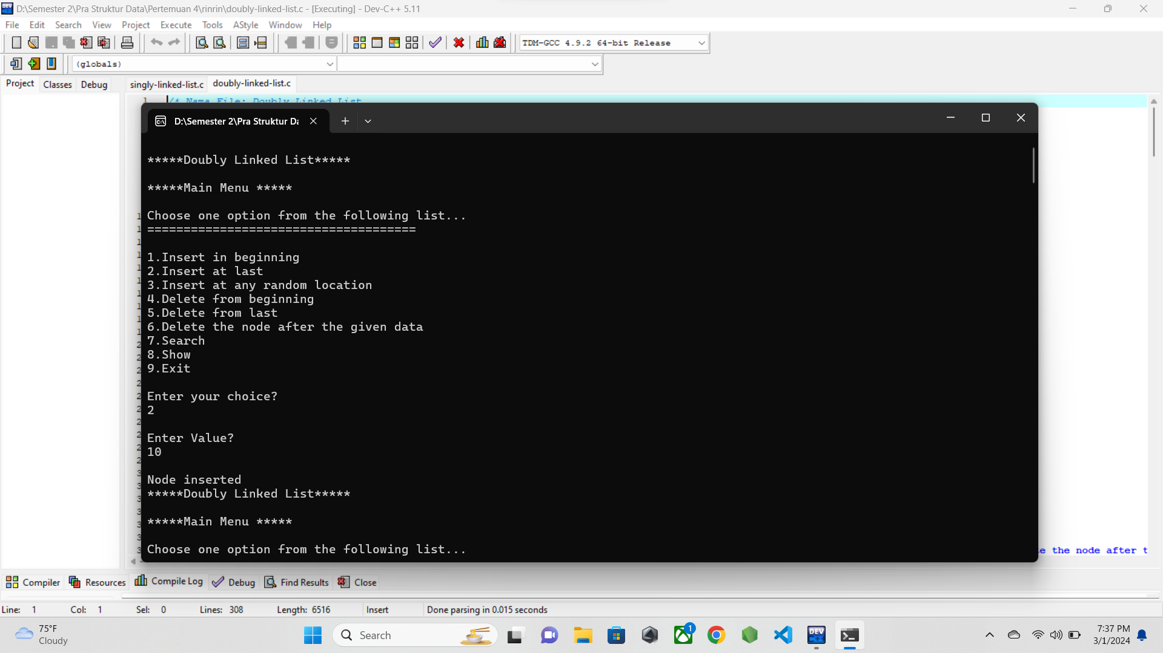

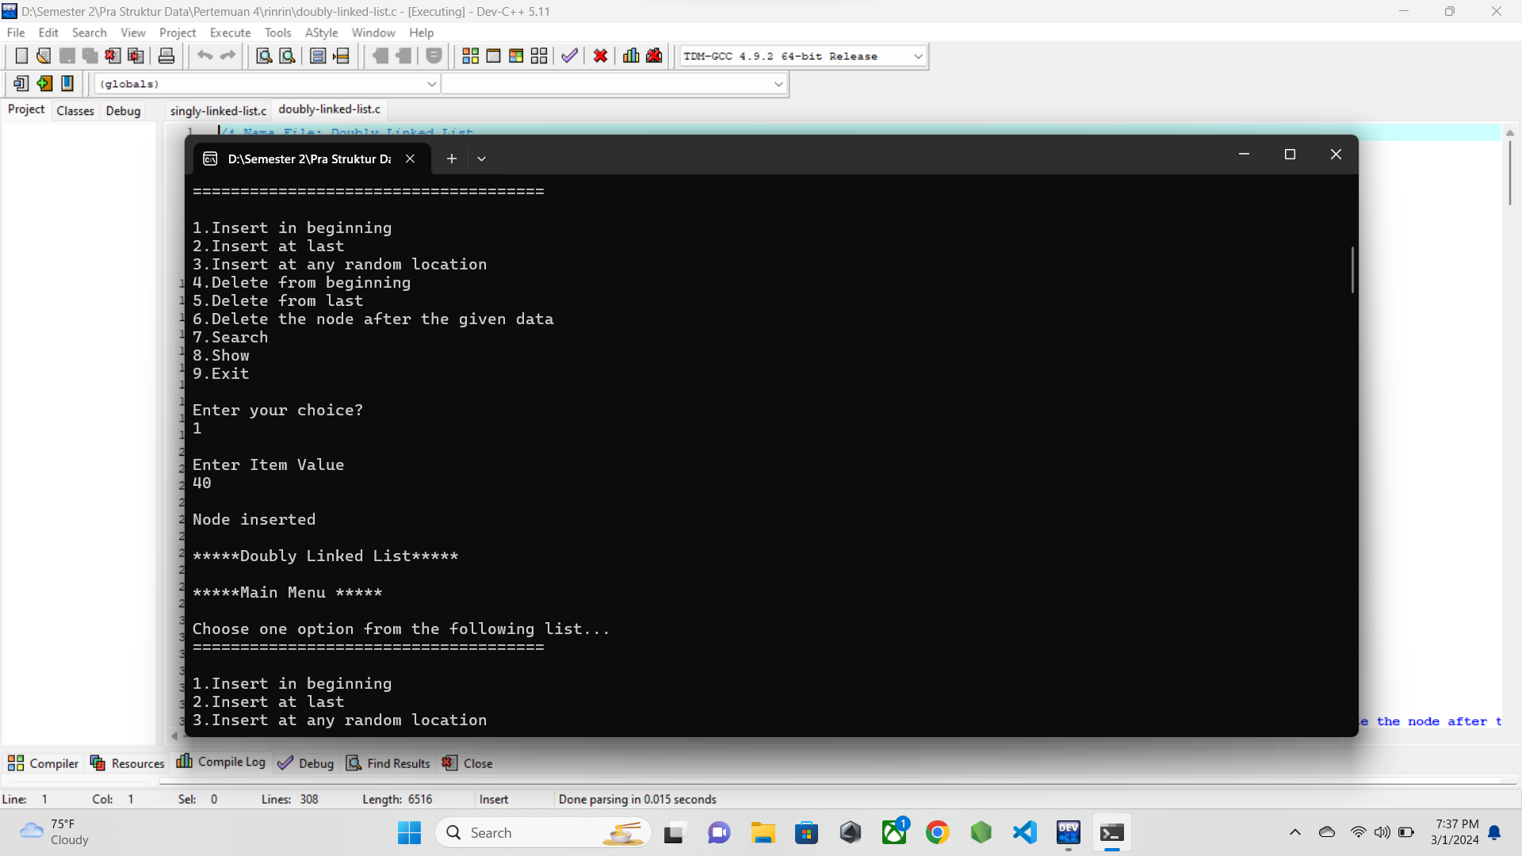

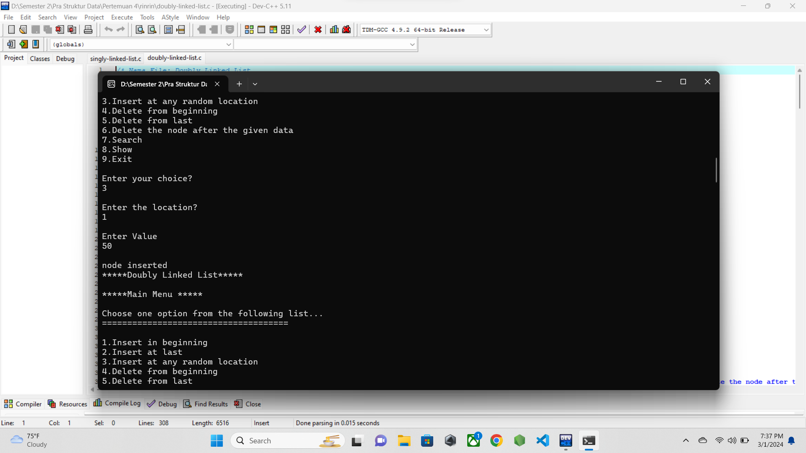

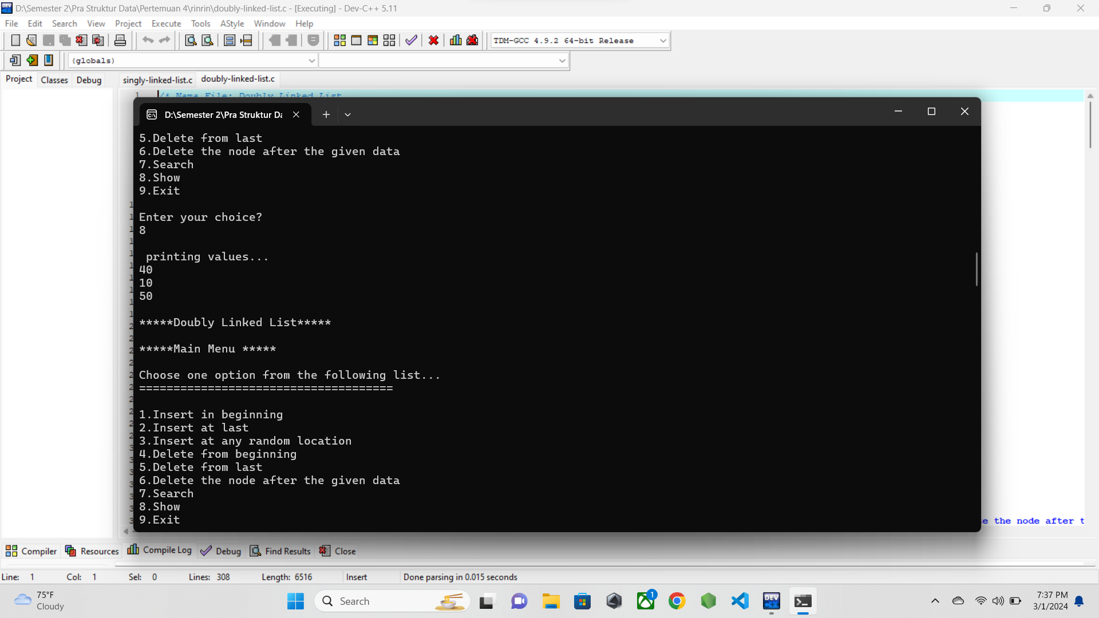

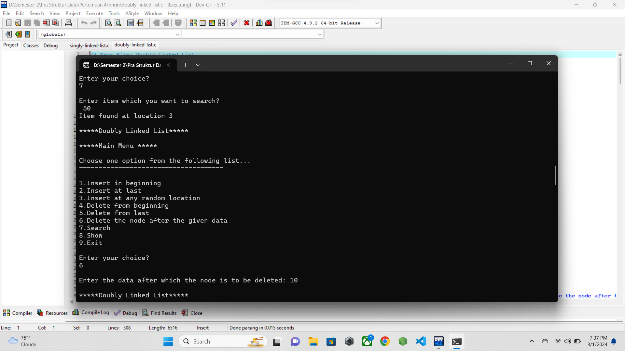

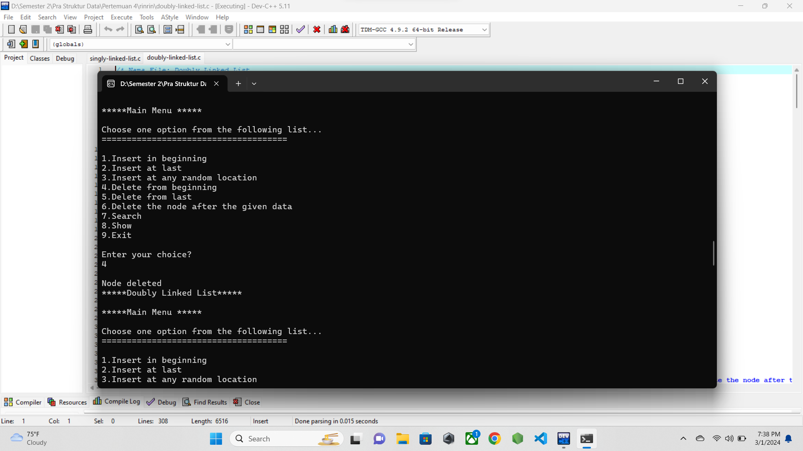

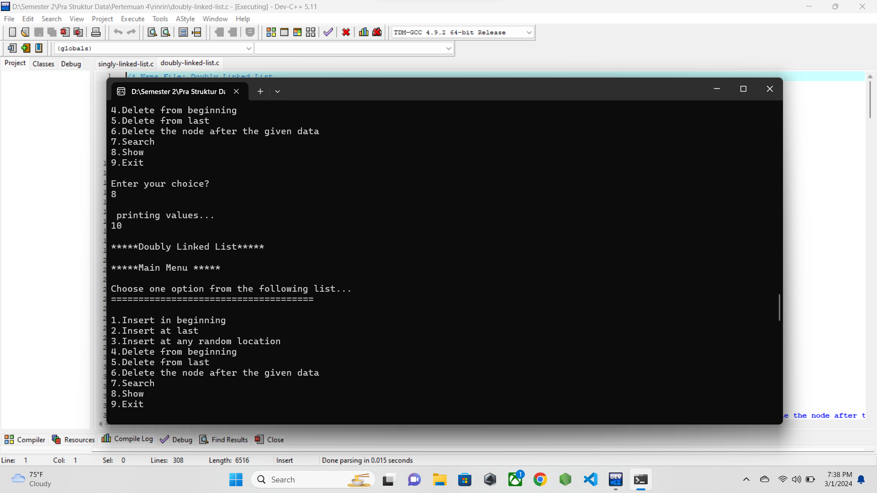

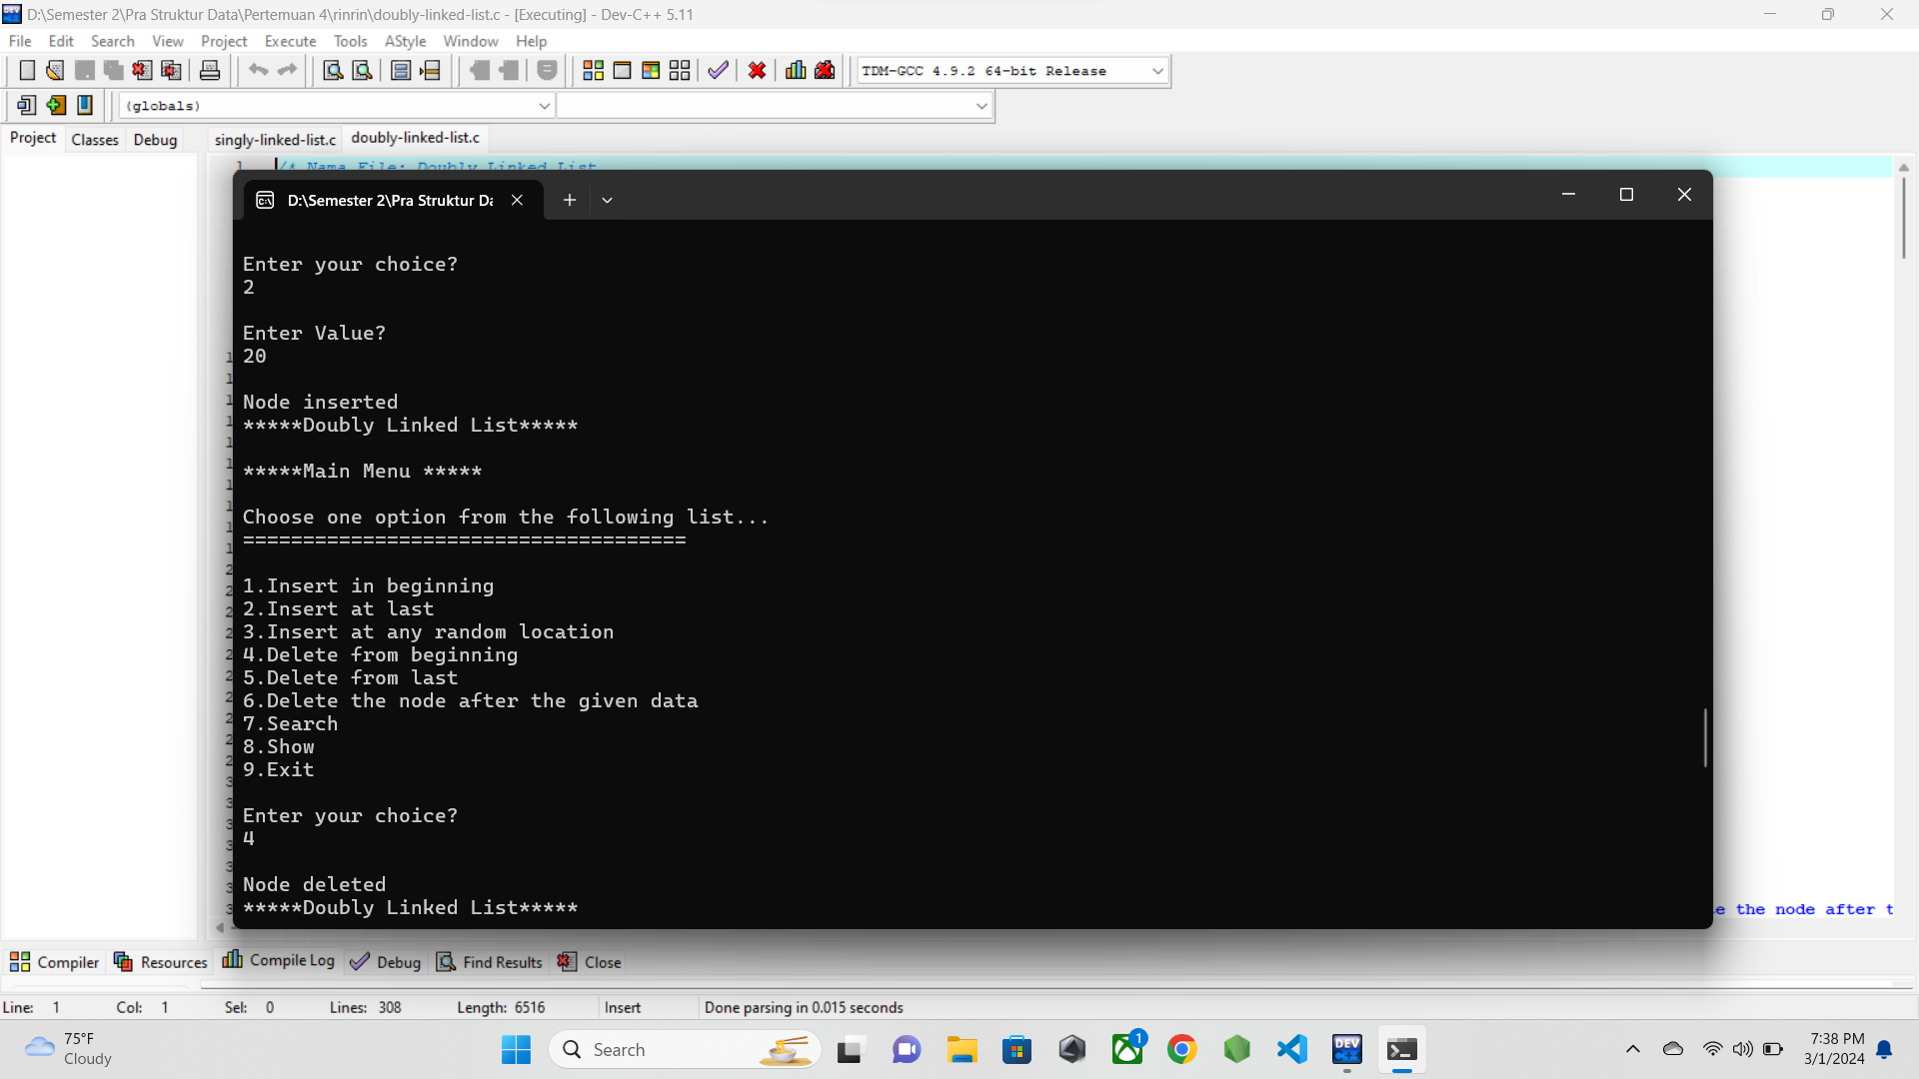

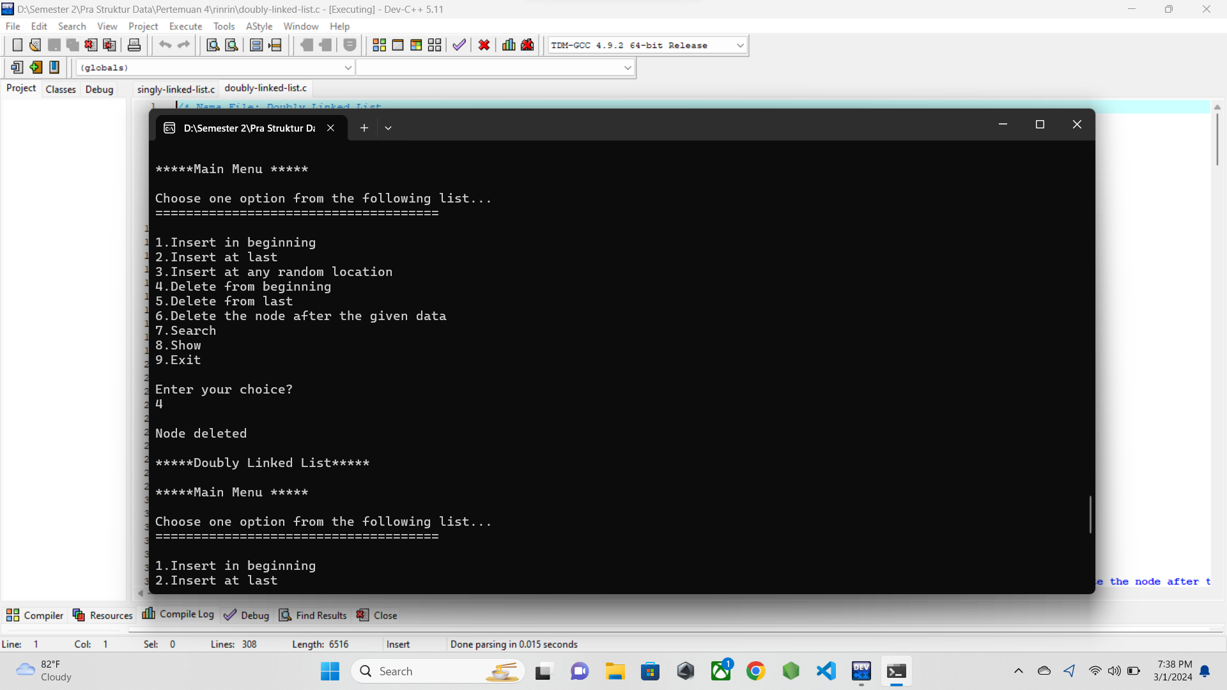

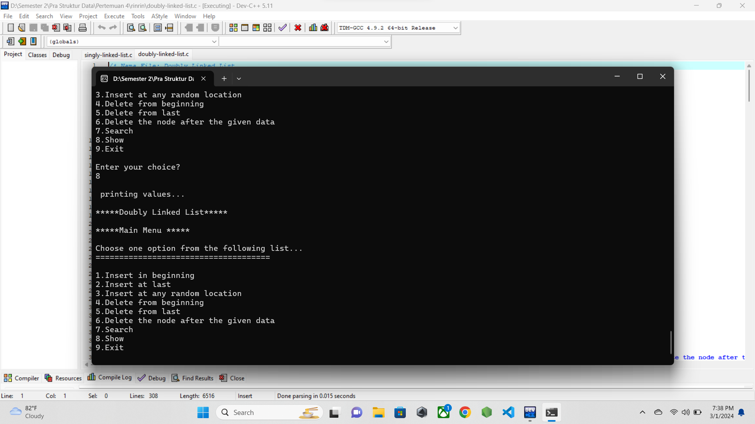

* 1. **PENJELASAN PROGRAM**

Pada program ini menggunakan konsep double linkedlist dimana setiap node saling menunjuk dengan node selanjutnya dan juga node sebelumnya, terkecuali node head yang node sebelumnya menunjuk null, dan juga node tail yang node selanjutnya menunjuk null.

Pada kasus yang saya coba, awalnya saya melakukan input data pada bagian akhir node, lalu diikuti input data pada bagian awal node, lalu menampilkan data data yang tersimpan dalam linkedlist.

Lalu setelah itu saya mencoba fitur search, dan kemudian menghapus node awal dan node akhir, lalu kembali menampilkan data yang tersisah pada linkedlist.

1. **circular-singly-linked-list.c**
   1. **SOURCE CODE**

/* Nama File: Circular Doubly Linked List

Pembuat: M.ilham (23343008)

Tanggal Pembuatan: 28 Februari 2024

*/

#include <stdio.h>

#include <stdlib.h>

struct node

{

int data;

struct node *next;

};

struct node *head = NULL;

void beginsert();

void lastinsert();

void begin_delete();

void last_delete();

void search();

void display();

int main()

{

int choice = 0;

while (choice != 7)

{

printf("\n*****Circular Singly Linked List*****\n");

printf("\n*****Main Menu *****\n");

printf("\nChoose one option from the following list... \n");

printf("=====================================\n");

printf("\n1.Insert in beginning \n2.Insert at last \n3.Delete From Beginning\n4.Delete from last\n5.Search for an element\n6.Show\n7.Exit\n");

printf("\nEnter your choice?\n");

scanf("%d", &choice);

switch (choice)

{

case 1:

beginsert();

break;

case 2:

lastinsert();

break;

case 3:

begin_delete();

break;

case 4:

last_delete();

break;

case 5:

search();

break;

case 6:

display();

break;

case 7:

exit(0);

break;

default:

printf("Please enter valid choice..\n");

}

}

}

void beginsert()

{

struct node *ptr, *temp;

int item;

ptr = (struct node *)malloc(sizeof(struct node));

if (ptr == NULL)

{

printf("\nOVERFLOW");

}

else

{

printf("\nEnter the node data\n");

scanf("%d", &item);

ptr->data = item;

if (head == NULL)

{

head = ptr;

ptr->next = head;

}

else

{

temp = head;

while (temp->next != head)

temp = temp->next;

ptr->next = head;

temp->next = ptr;

head = ptr;

}

printf("\nNode Inserted");

}

}

void lastinsert()

{

struct node *ptr, *temp;

int item;

ptr = (struct node *)malloc(sizeof(struct node));

if (ptr == NULL)

{

printf("\nOVERFLOW");

}

else

{

printf("\nEnter Data?\n");

scanf("%d", &item);

ptr->data = item;

if (head == NULL)

{

head = ptr;

ptr->next = head;

}

else

{

temp = head;

while (temp->next != head)

{

temp = temp->next;

}

temp->next = ptr;

ptr->next = head;

printf("\nNode inserted");

}

}

}

void begin_delete()

{

struct node *ptr;

if (head == NULL)

{

printf("\nUNDERFLOW");

}

else if (head->next == head)

{

free(head);

head = NULL;

printf("\nNode deleted\n");

}

else

{

ptr = head;

while (ptr->next != head)

ptr = ptr->next;

ptr->next = head->next;

free(head);

head = ptr->next;

printf("\nNode deleted\n");

}

}

void last_delete()

{

struct node *ptr, *preptr;

if (head == NULL)

{

printf("\nUNDERFLOW");

}

else if (head->next == head)

{

free(head);

head = NULL;

printf("\nNode deleted\n");

}

else

{

ptr = head;

while (ptr->next != head)

{

preptr = ptr;

ptr = ptr->next;

}

preptr->next = ptr->next;

free(ptr);

printf("\nNode deleted\n");

}

}

void search()

{

struct node *ptr;

int item, flag = 0, i = 0;

ptr = head;

if (ptr == NULL)

{

printf("\nEmpty List\n");

}

else

{

printf("\nEnter item which you want to search? ");

scanf("%d", &item);

if (ptr->data == item)

{

printf("Item found at location %d\n", i + 1);

flag = 1;

}

else

{

while (ptr->next != head)

{

if (ptr->data == item)

{

printf("Item found at location %d\n", i + 1);

flag = 1;

break;

}

i++;

ptr = ptr->next;

}

}

if (flag == 0)

printf("Item not found\n");

}

}

void display()

{

struct node *ptr;

ptr = head;

if (ptr == NULL)

{

printf("Nothing to print\n");

}

else

{

printf("\nPrinting values...\n");

while (ptr->next != head)

{

printf("%d\n", ptr->data);

ptr = ptr->next;

}

printf("%d\n", ptr->data);

}

}

* 1. **SCREENSHOT PROGRAM**

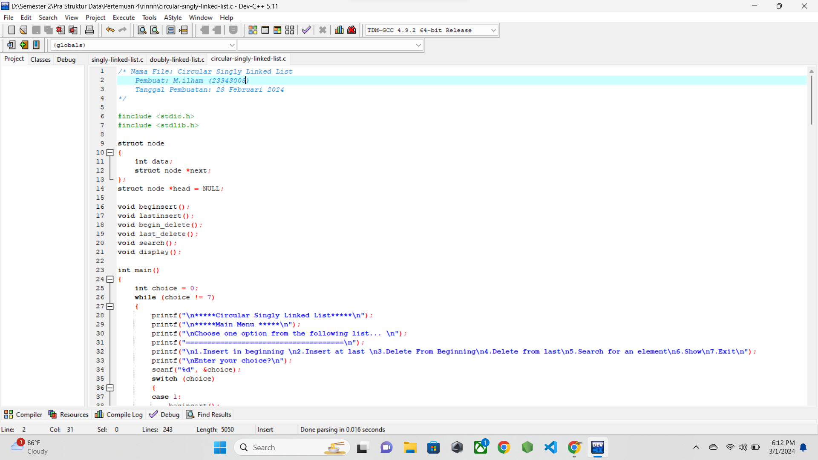

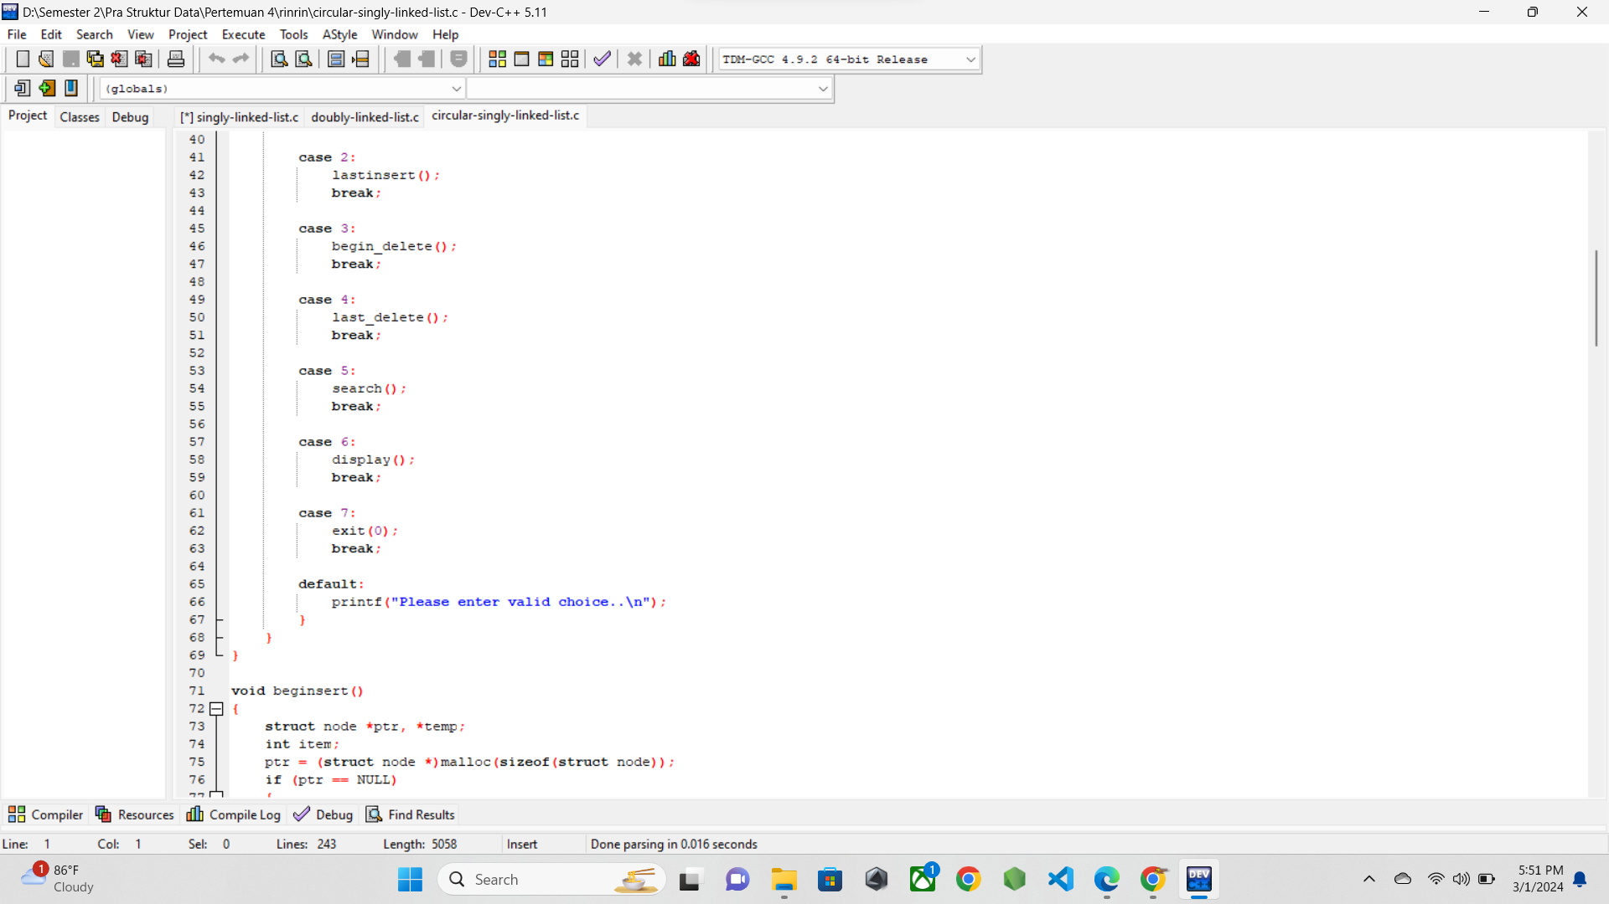

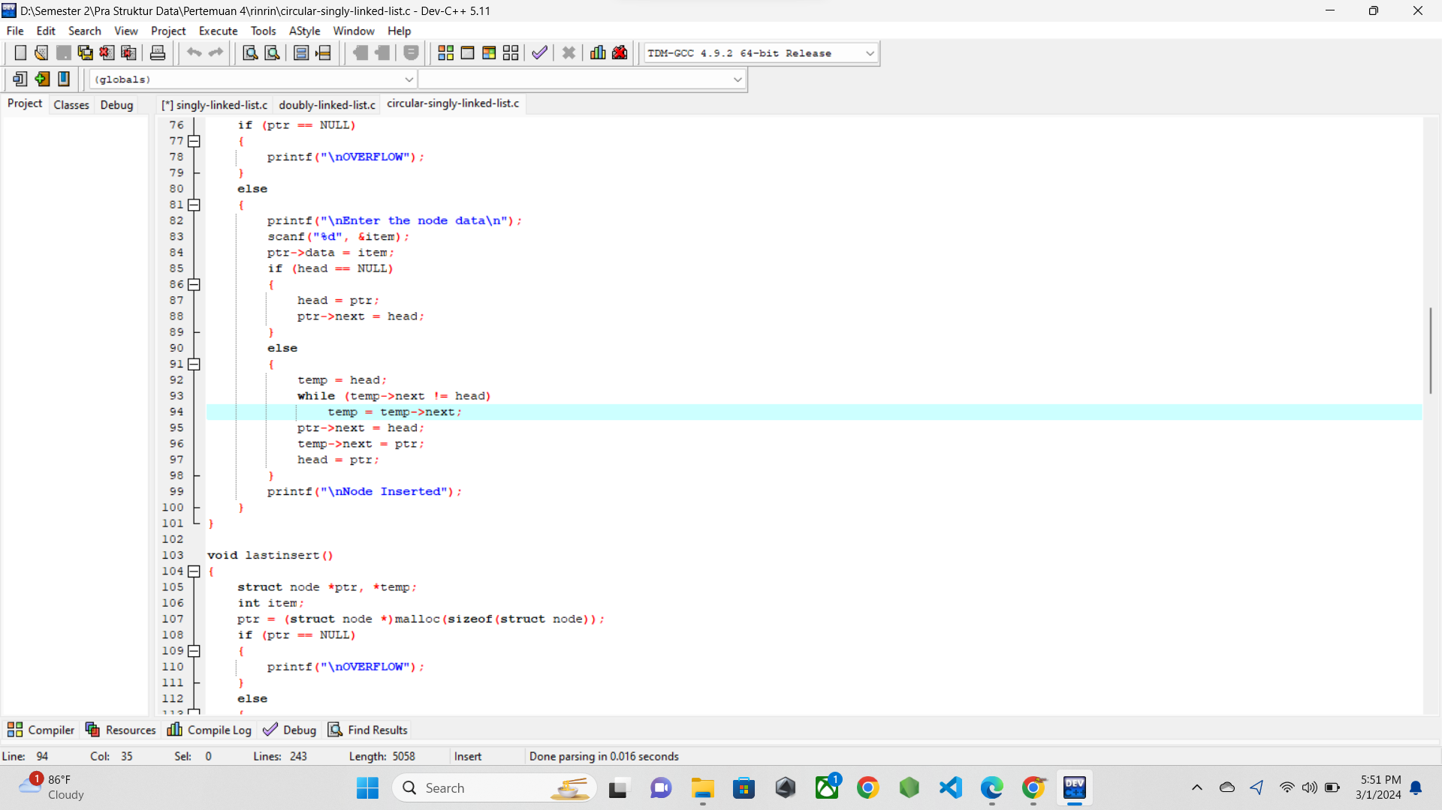

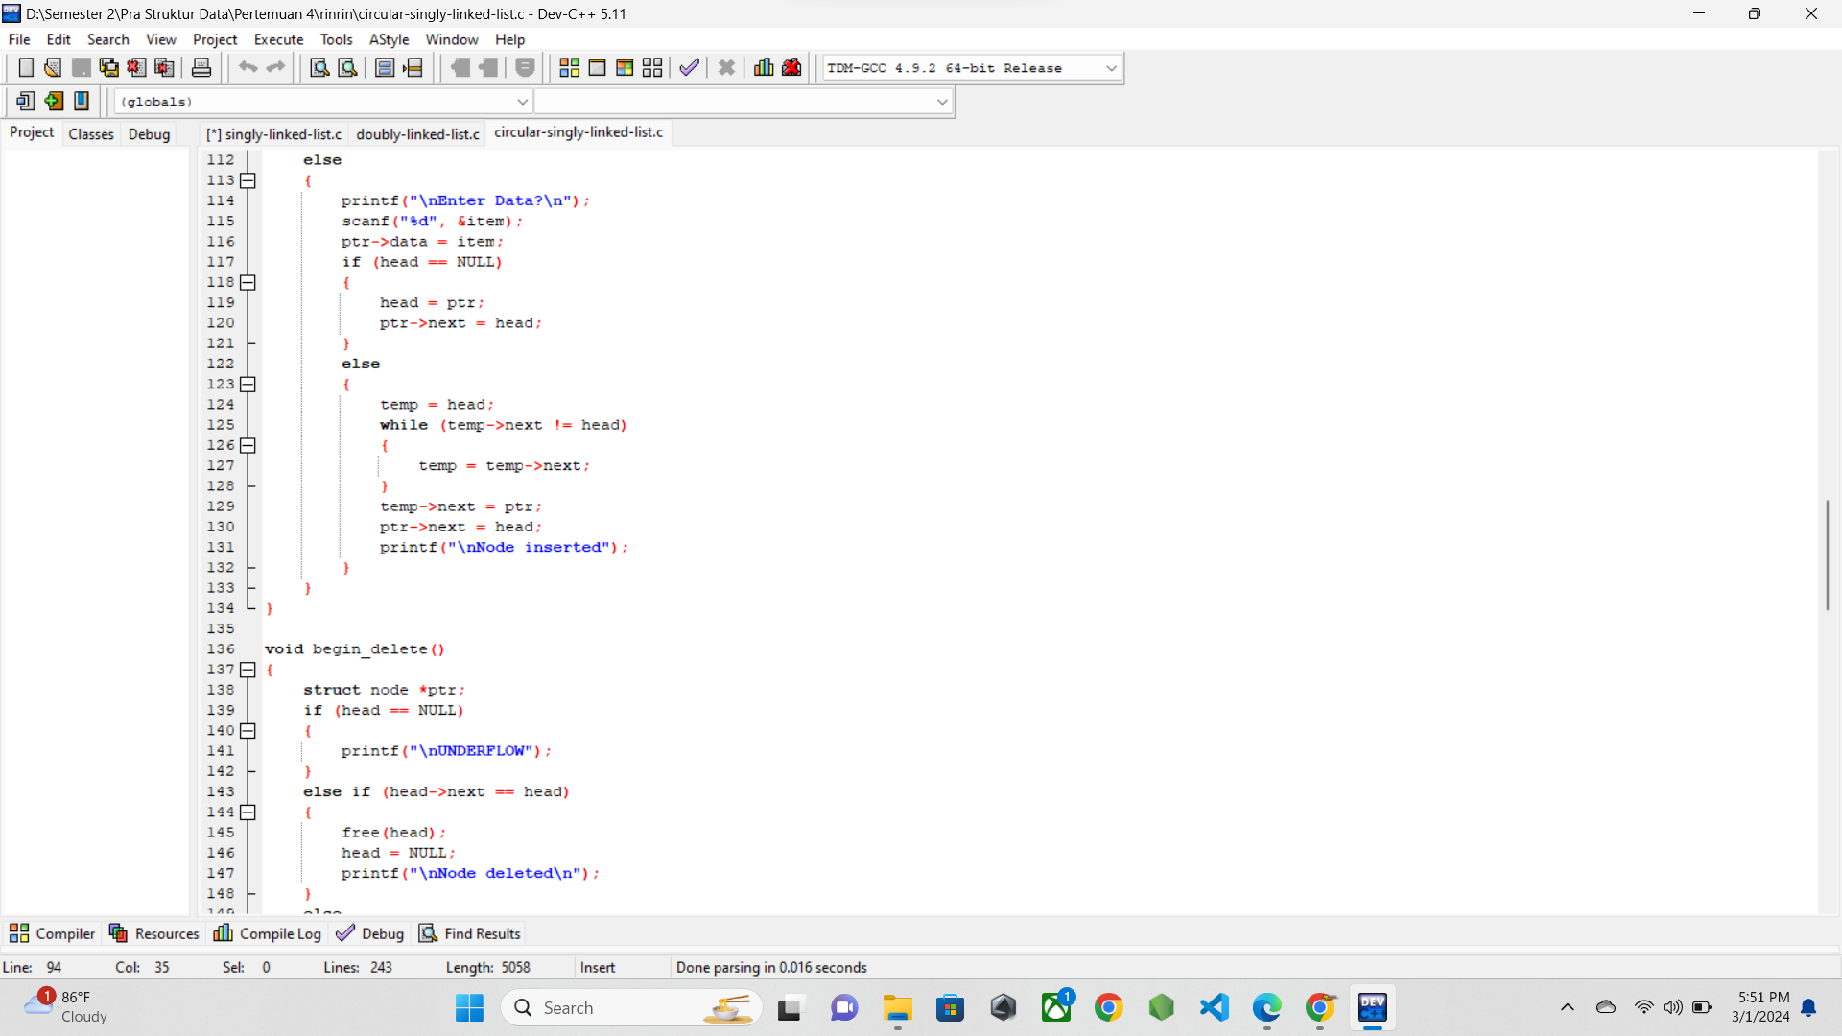

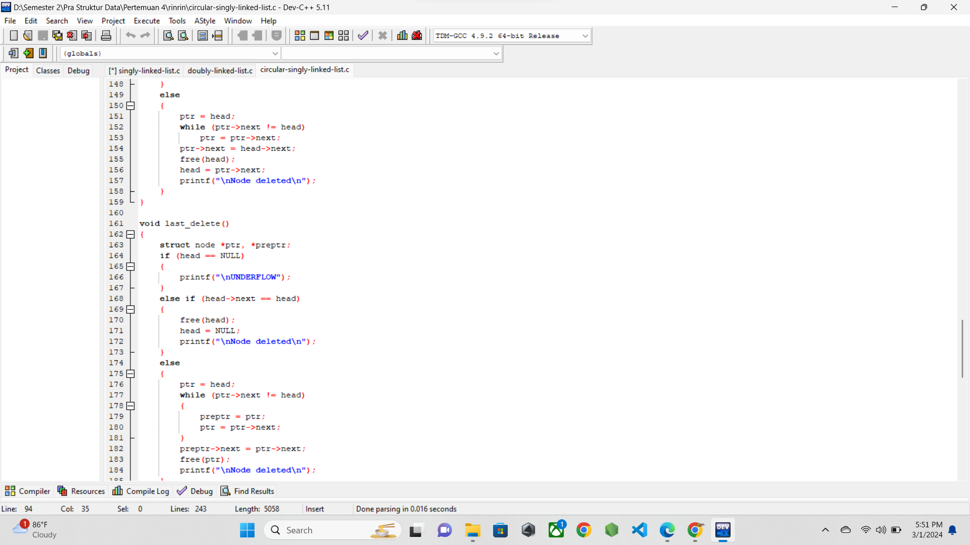

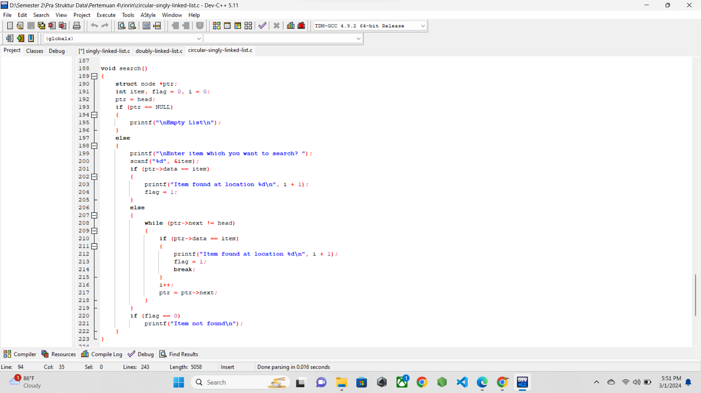

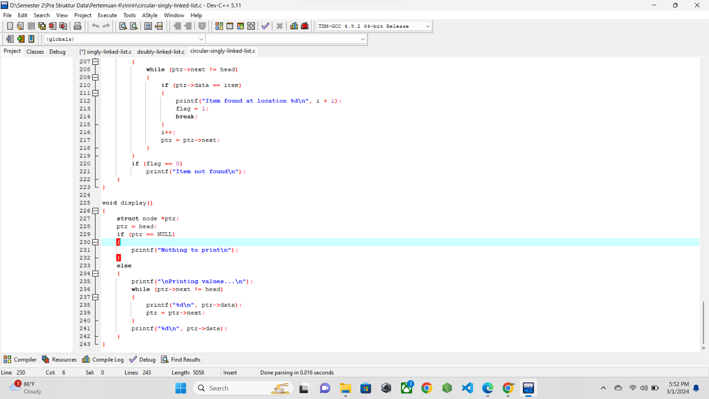

* 1. **SCREENSHOT OUTPUT**

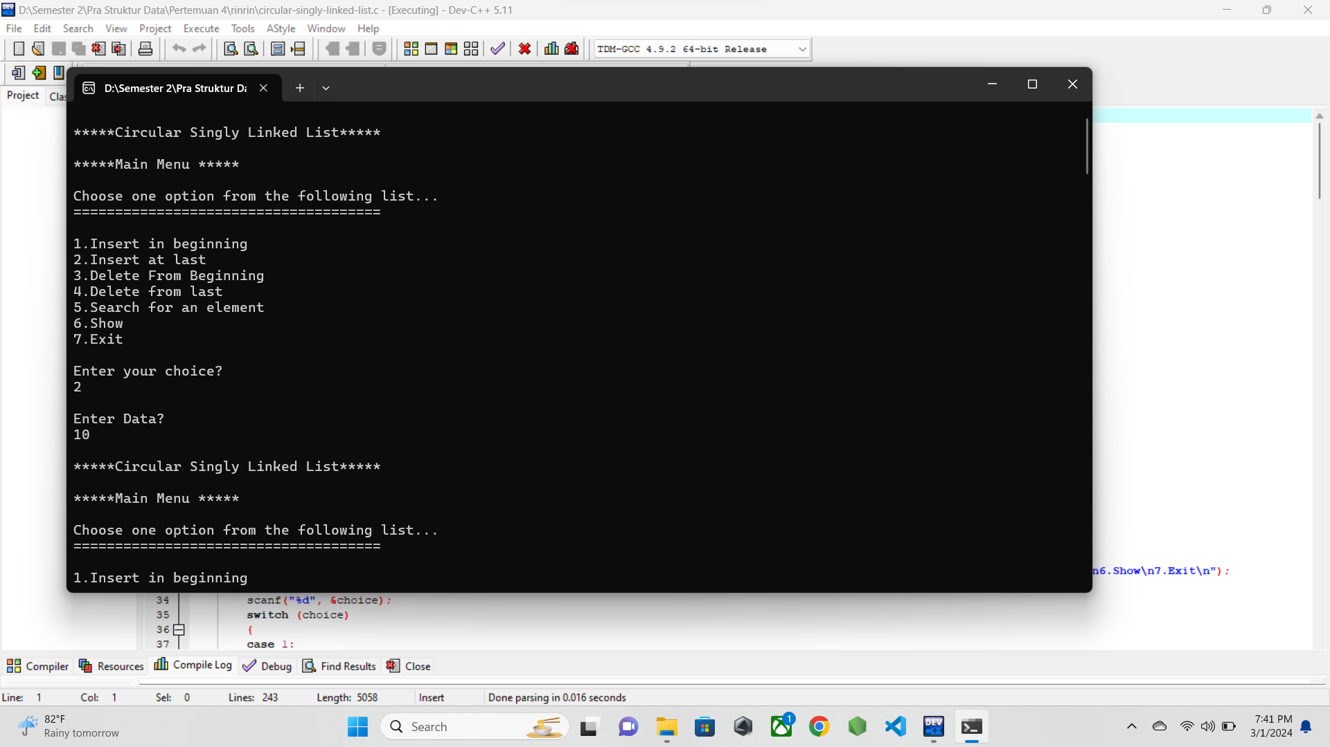

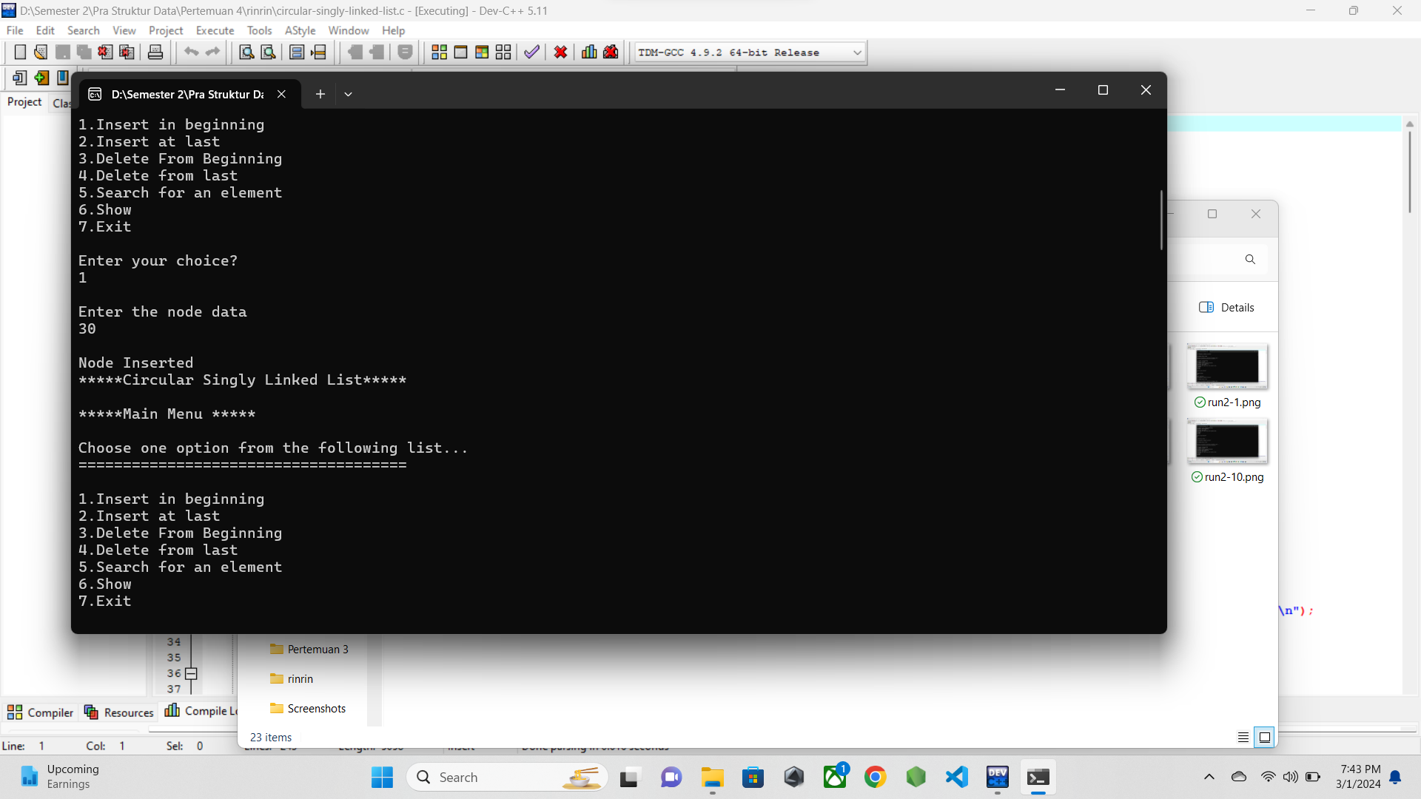

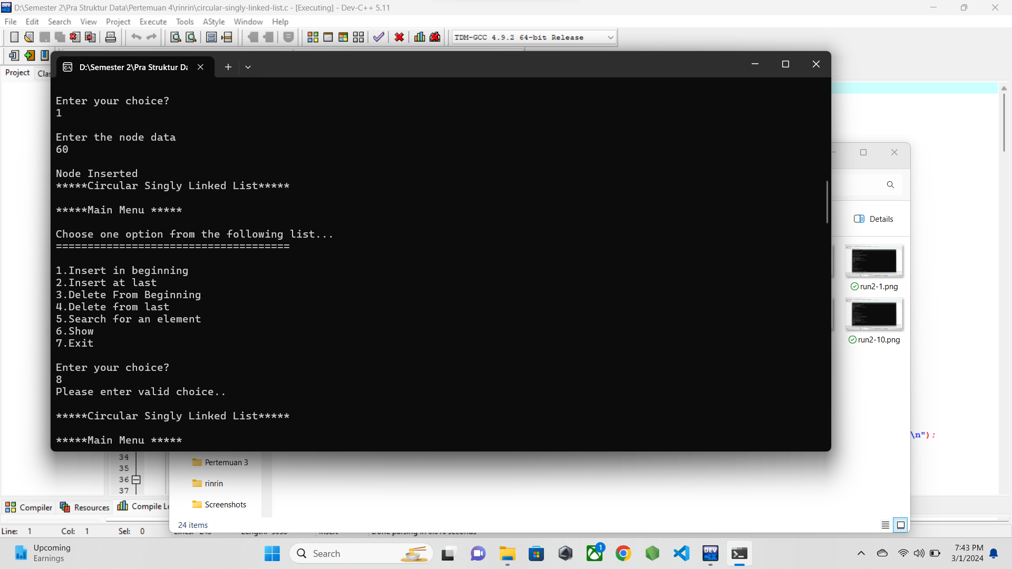

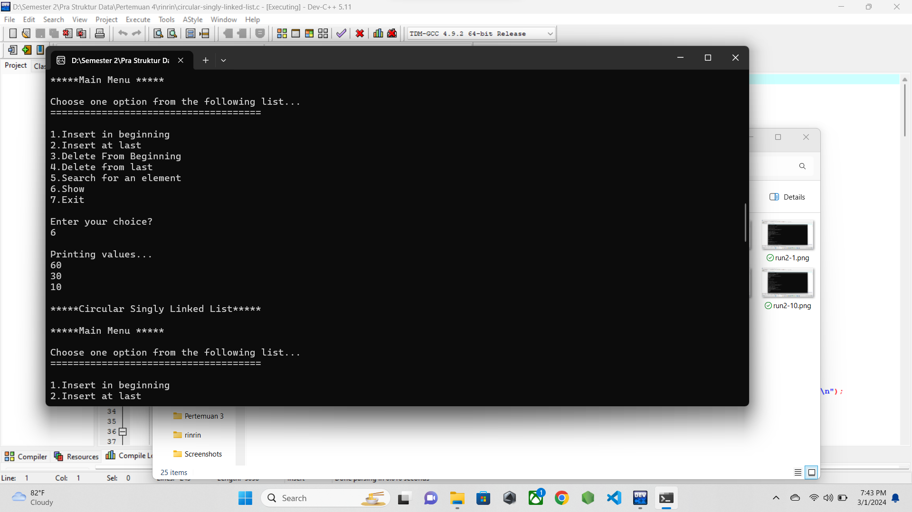

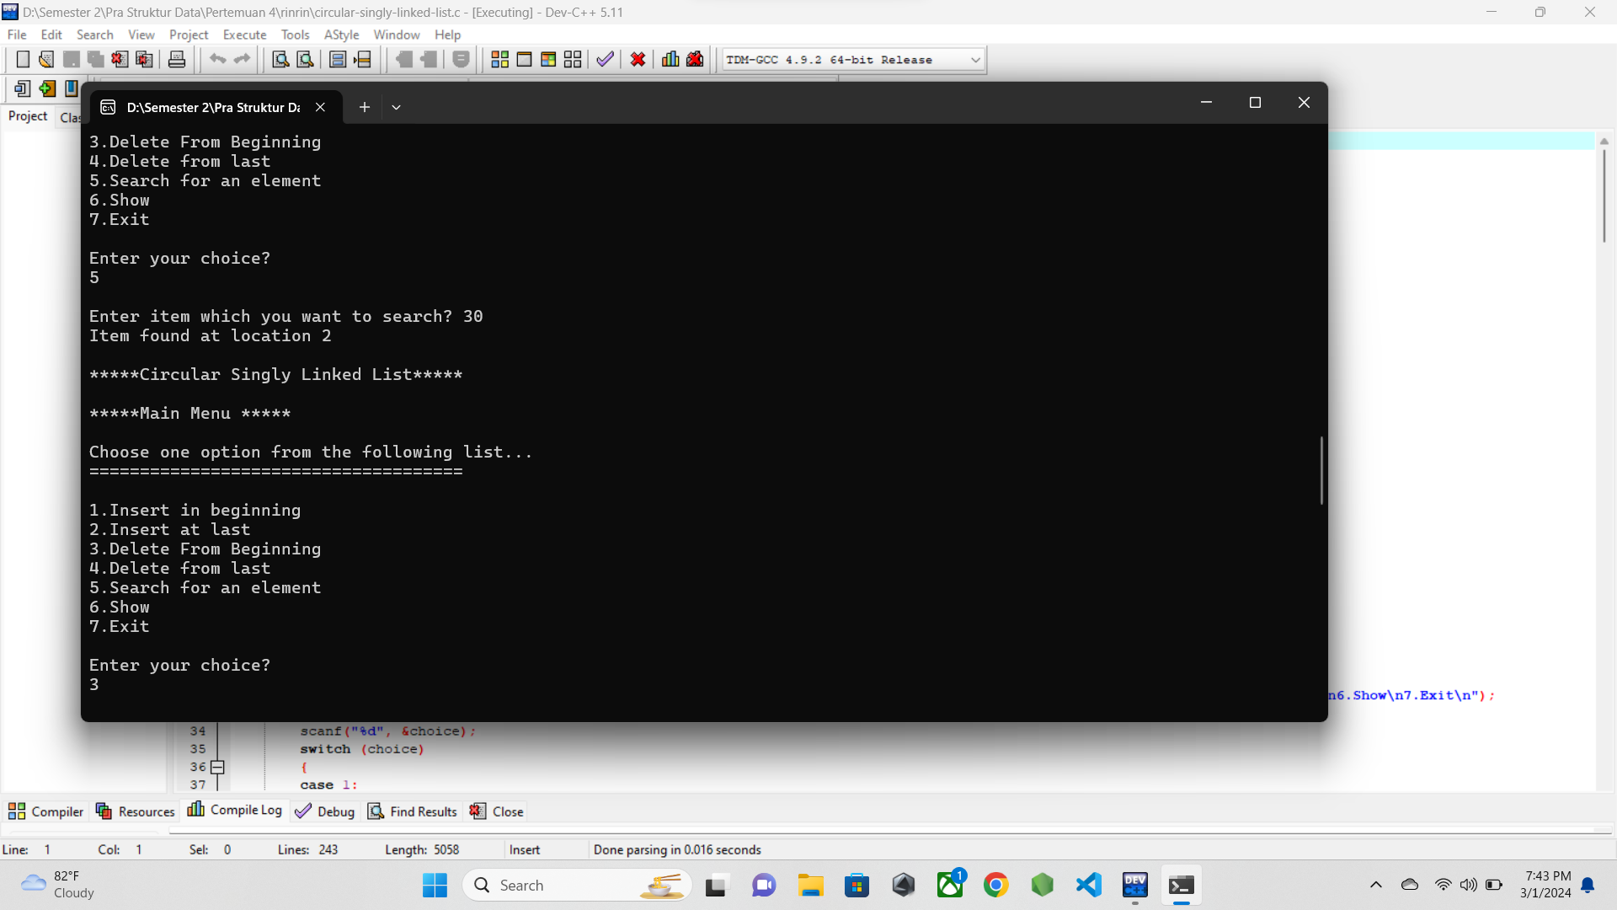

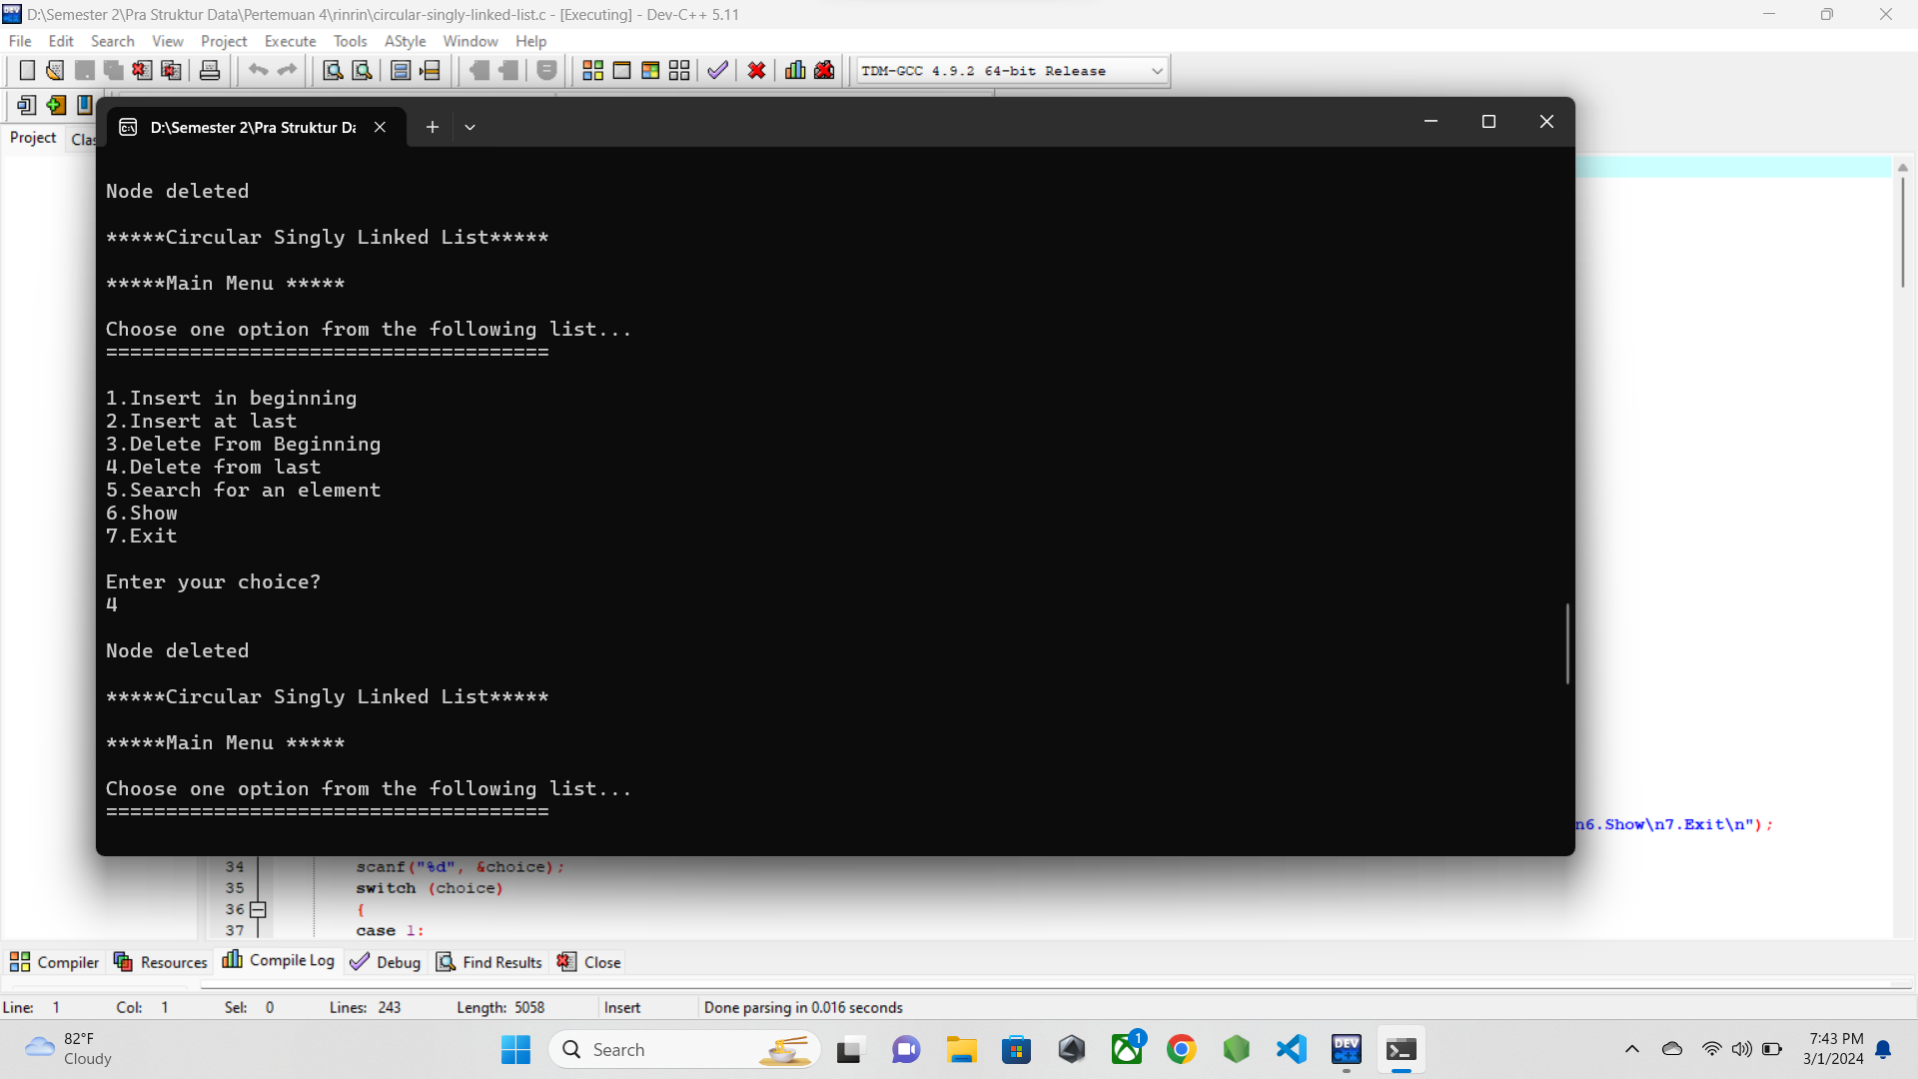

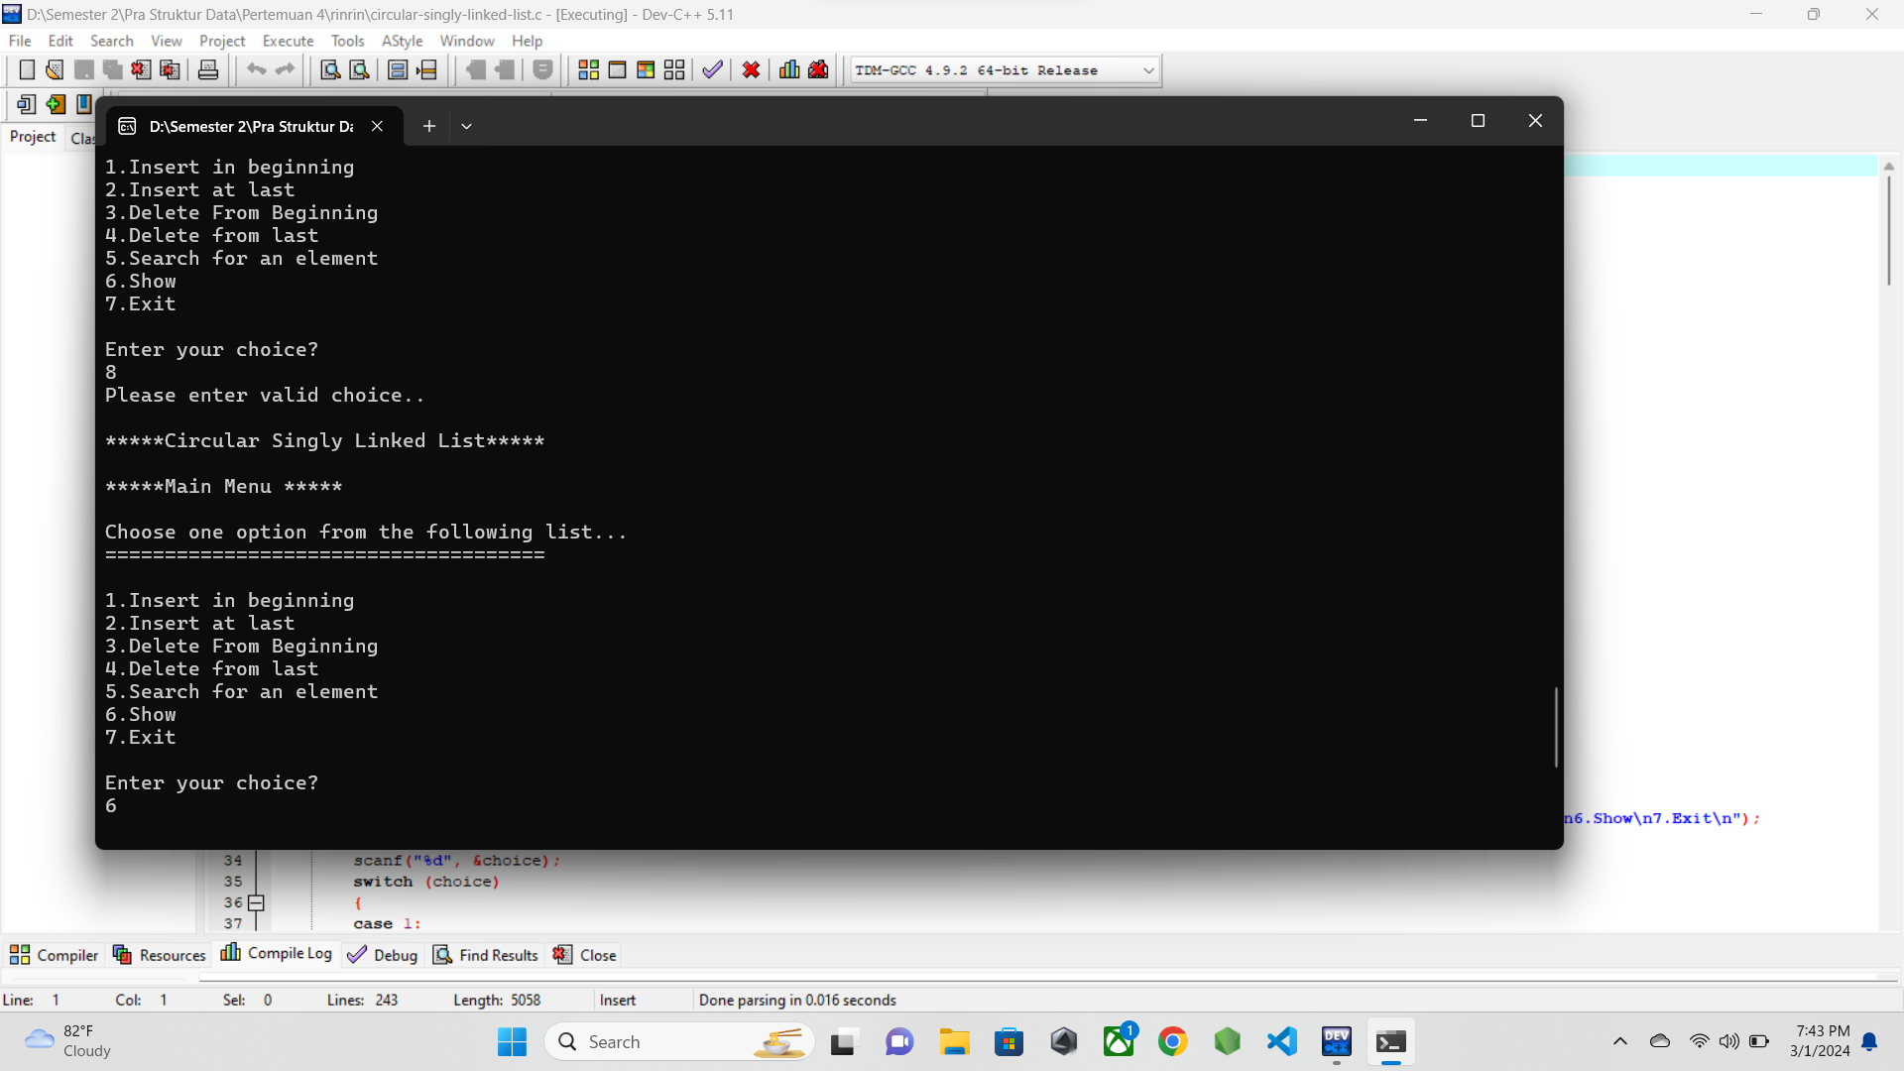

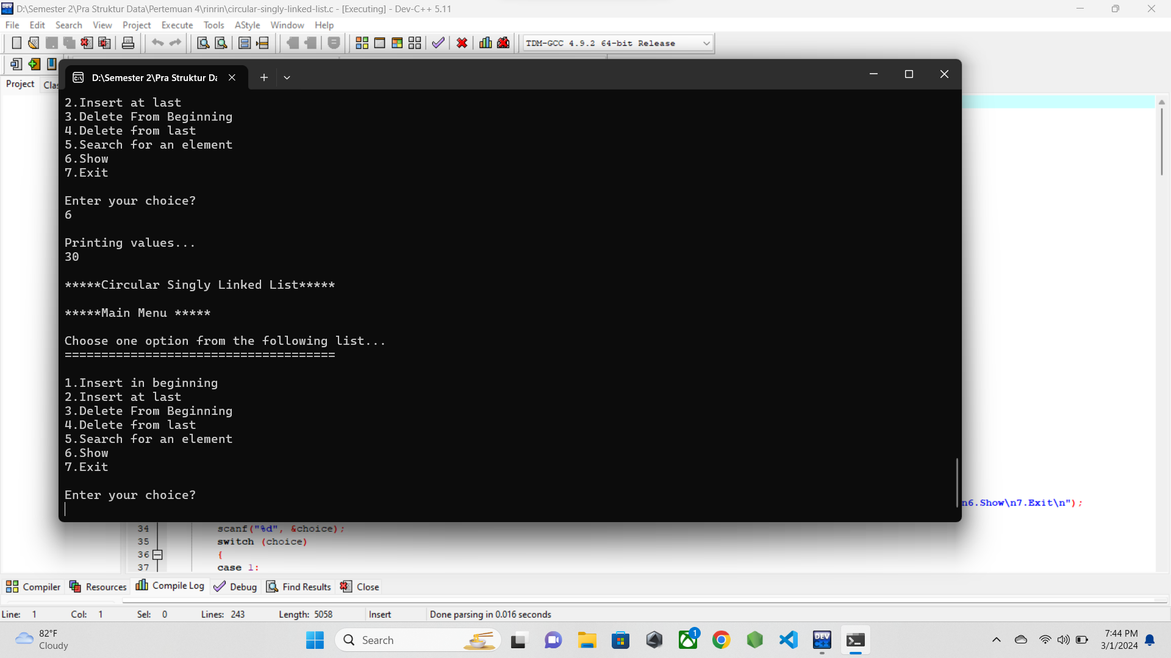

* 1. **PENJELASAN PROGRAM**

Pada program ini mengimplementasikan circular linkedlist namun hanya single alias hanya menggunakan satu penunjuk yaitu head. Perbedaannya dengan single linkedlist biasa adalah penunjuk pada tailnya menunjuk pada head sehingga perputaran data dapat terjadi di linkedlist ini.

Pada kasus saya, awalnya saya menginputkan data di belakang linkedlist, lalu diikuti input data di awal, lalu ditampilkan. Setelah itu saya mencoba fitur search, lalu diikuti dengan menghapus node awal dan akhir, lalu menampilkan kembali data yang tersisa pada linkedlist ini.

1. **circular-doubly-linked-list.c**
   1. **SOURCE CODE**

/* Nama File: Circular Doubly Linked List

Pembuat: M.ilham (23343008)

Tanggal Pembuatan: 28 Februari 2024

*/

#include <stdio.h>

#include <stdlib.h>

struct node

{

struct node *prev;

struct node *next;

int data;

};

struct node *head = NULL;

void insertion_beginning();

void insertion_last();

void deletion_beginning();

void deletion_last();

void display();

void search();

int main()

{

int choice = 0;

while (choice != 7)

{

printf("\n*****Circular Doubly Linked List*****\n");

printf("\n*****Main Menu *****\n");

printf("\nChoose one option from the following list... \n");

printf("=====================================\n");

printf("\n1.Insert in beginning\n2.Insert at last\n3.Delete from beginning\n4.Delete from last\n5.Search\n6.Show\n7.Exit\n");

printf("\nEnter your choice?\n");

scanf("\n%d", &choice);

switch (choice)

{

case 1:

insertion_beginning();

break;

case 2:

insertion_last();

break;

case 3:

deletion_beginning();

break;

case 4:

deletion_last();

break;

case 5:

search();

break;

case 6:

display();

break;

case 7:

exit(0);

break;

default:

printf("Please enter valid choice..\n");

}

}

}

void insertion_beginning()

{

struct node *ptr, *temp;

int item;

ptr = (struct node *)malloc(sizeof(struct node));

if (ptr == NULL)

{

printf("\nOVERFLOW");

}

else

{

printf("\nEnter Item Value\n");

scanf("%d", &item);

if (head == NULL)

{

head = ptr;

ptr->next = head;

ptr->prev = head;

}

else

{

temp = head;

while (temp->next != head)

{

temp = temp->next;

}

temp->next = ptr;

ptr->prev = temp;

head->prev = ptr;

ptr->next = head;

head = ptr;

}

printf("\nNode inserted\n");

}

}

void insertion_last()

{

struct node *ptr, *temp;

int item;

ptr = (struct node *)malloc(sizeof(struct node));

if (ptr == NULL)

{

printf("\nOVERFLOW");

}

else

{

printf("\nEnter Value?\n");

scanf("%d", &item);

ptr->data = item;

if (head == NULL)

{

head = ptr;

ptr->next = head;

ptr->prev = head;

}

else

{

temp = head;

while (temp->next != head)

{

temp = temp->next;

}

temp->next = ptr;

ptr->prev = temp;

head->prev = ptr;

ptr->next = head;

}

printf("\nNode inserted");

}

}

void deletion_beginning()

{

struct node *temp;

if (head == NULL)

{

printf("\nUNDERFLOW");

}

else if (head->next == head)

{

free(head);

head = NULL;

printf("\nNode deleted\n");

}

else

{

temp = head;

while (temp->next != head)

{

temp = temp->next;

}

temp->next = head->next;

head->next->prev = temp;

free(head);

head = temp->next;

}

}

void deletion_last()

{

struct node *ptr, *preptr;

if (head == NULL)

{

printf("\nUNDERFLOW");

}

else if (head->next == head)

{

free(head);

head = NULL;

printf("\nNode deleted\n");

}

else

{

ptr = head;

while (ptr->next != head)

{

preptr = ptr;

ptr = ptr->next;

}

preptr->next = ptr->next;

ptr->next->prev = preptr;

free(ptr);

printf("\nNode deleted");

}

}

void display()

{

struct node *ptr;

ptr = head;

if (head == NULL)

{

printf("\nNothing to print");

}

else

{

printf("\nPrinting values...\n");

do

{

printf("%d\n", ptr->data);

ptr = ptr->next;

} while (ptr != head);

}

}

void search()

{

struct node *ptr;

int item, flag = 0, i = 0;

ptr = head;

if (ptr == NULL)

{

printf("\nEmpty List\n");

}

else

{

printf("\nEnter item which you want to search?\n ");

scanf("%d", &item);

do

{

if (ptr->data == item)

{

printf("Item found at location %d\n", i + 1);

flag = 1;

break;

}

i++;

ptr = ptr->next;

} while (ptr != head);

if (flag == 0)

{

printf("Item not found\n");

}

}

}

* 1. **SCREENSHOT PROGRAM**

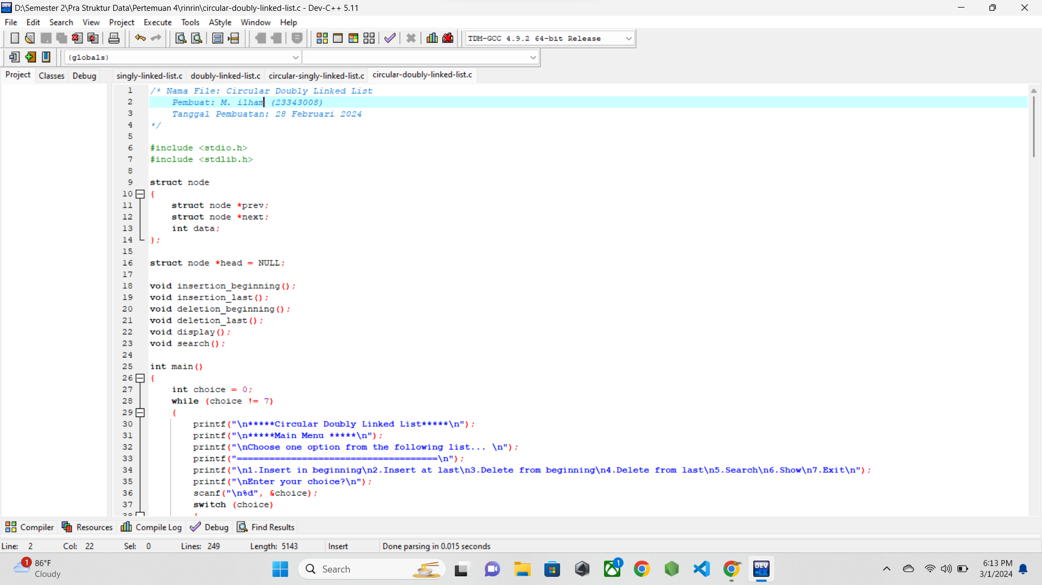

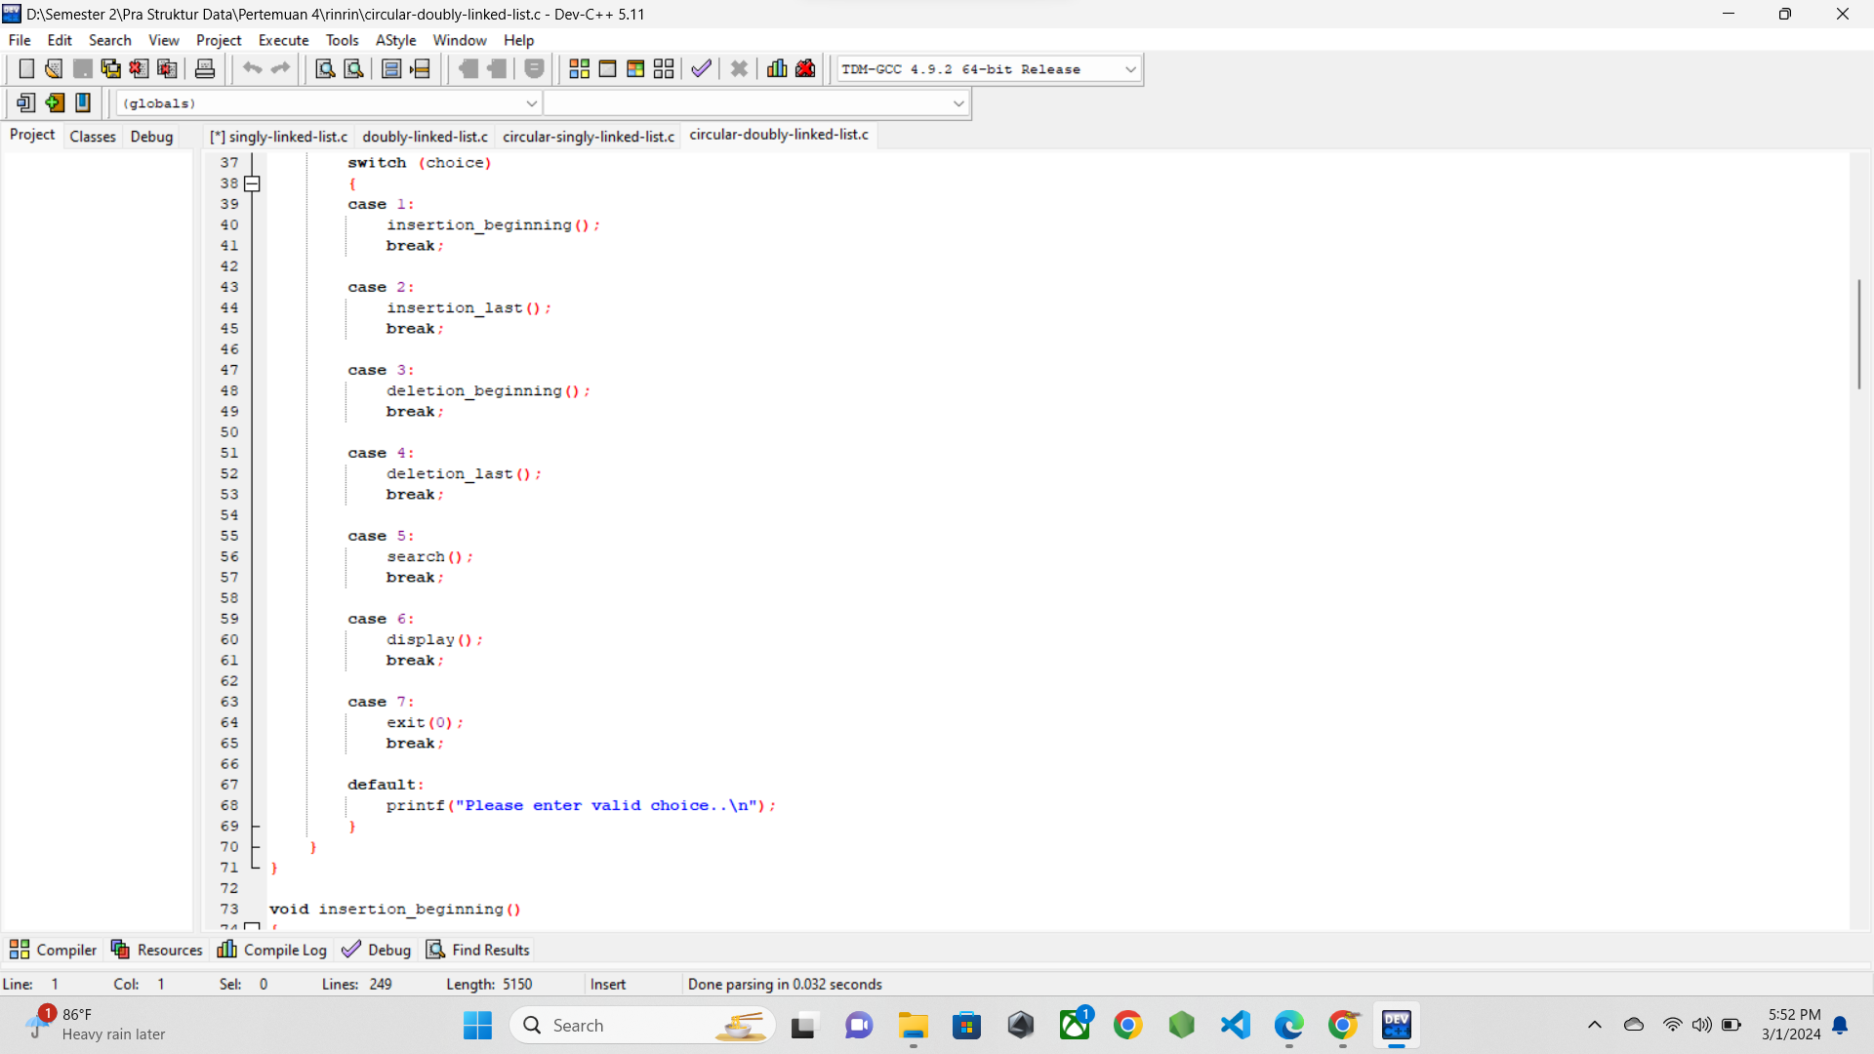

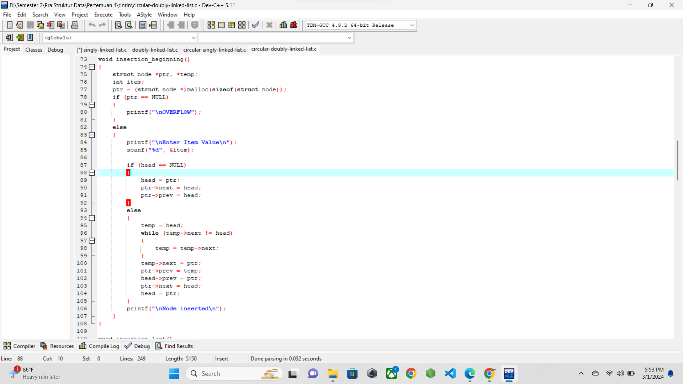

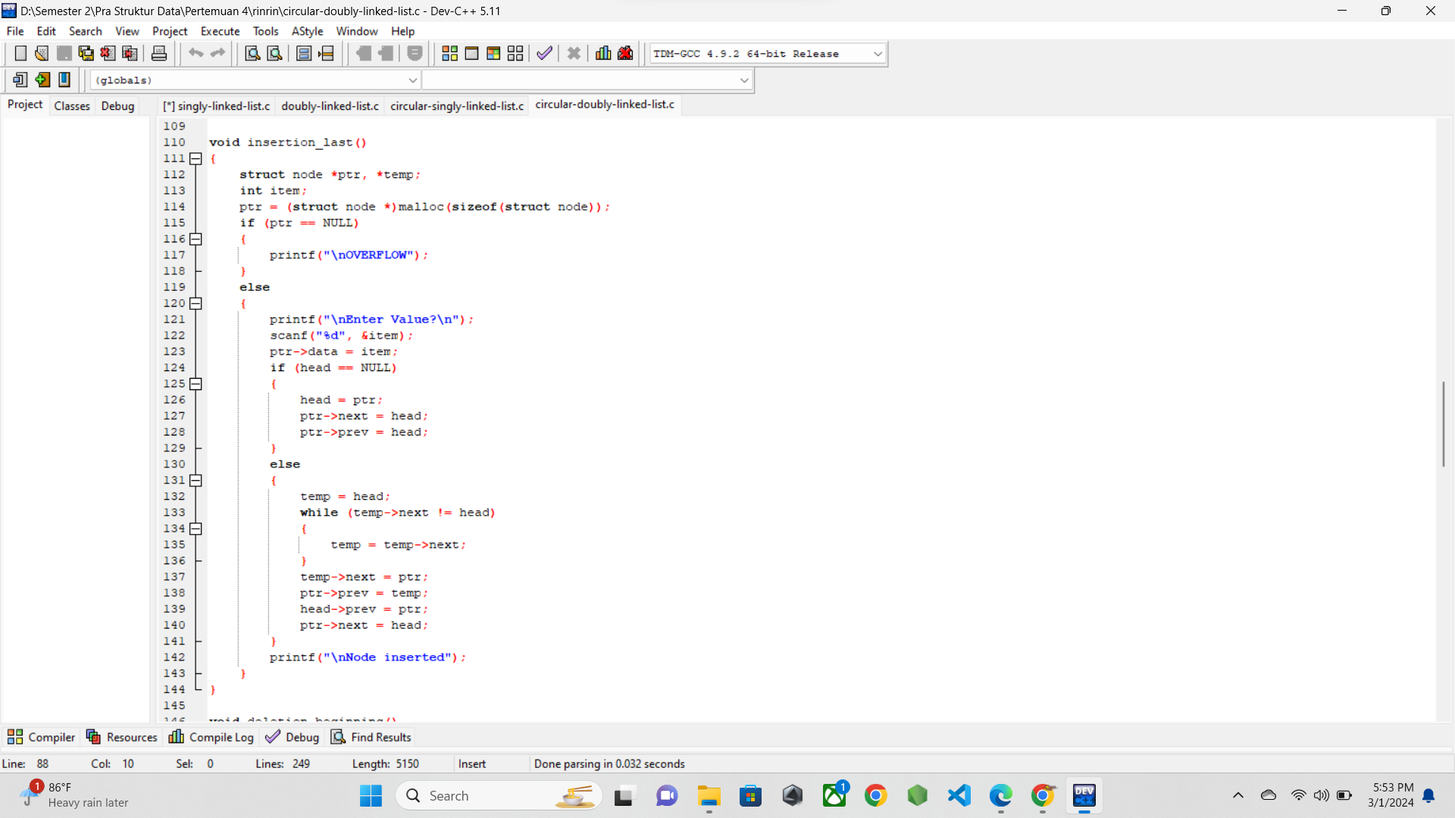

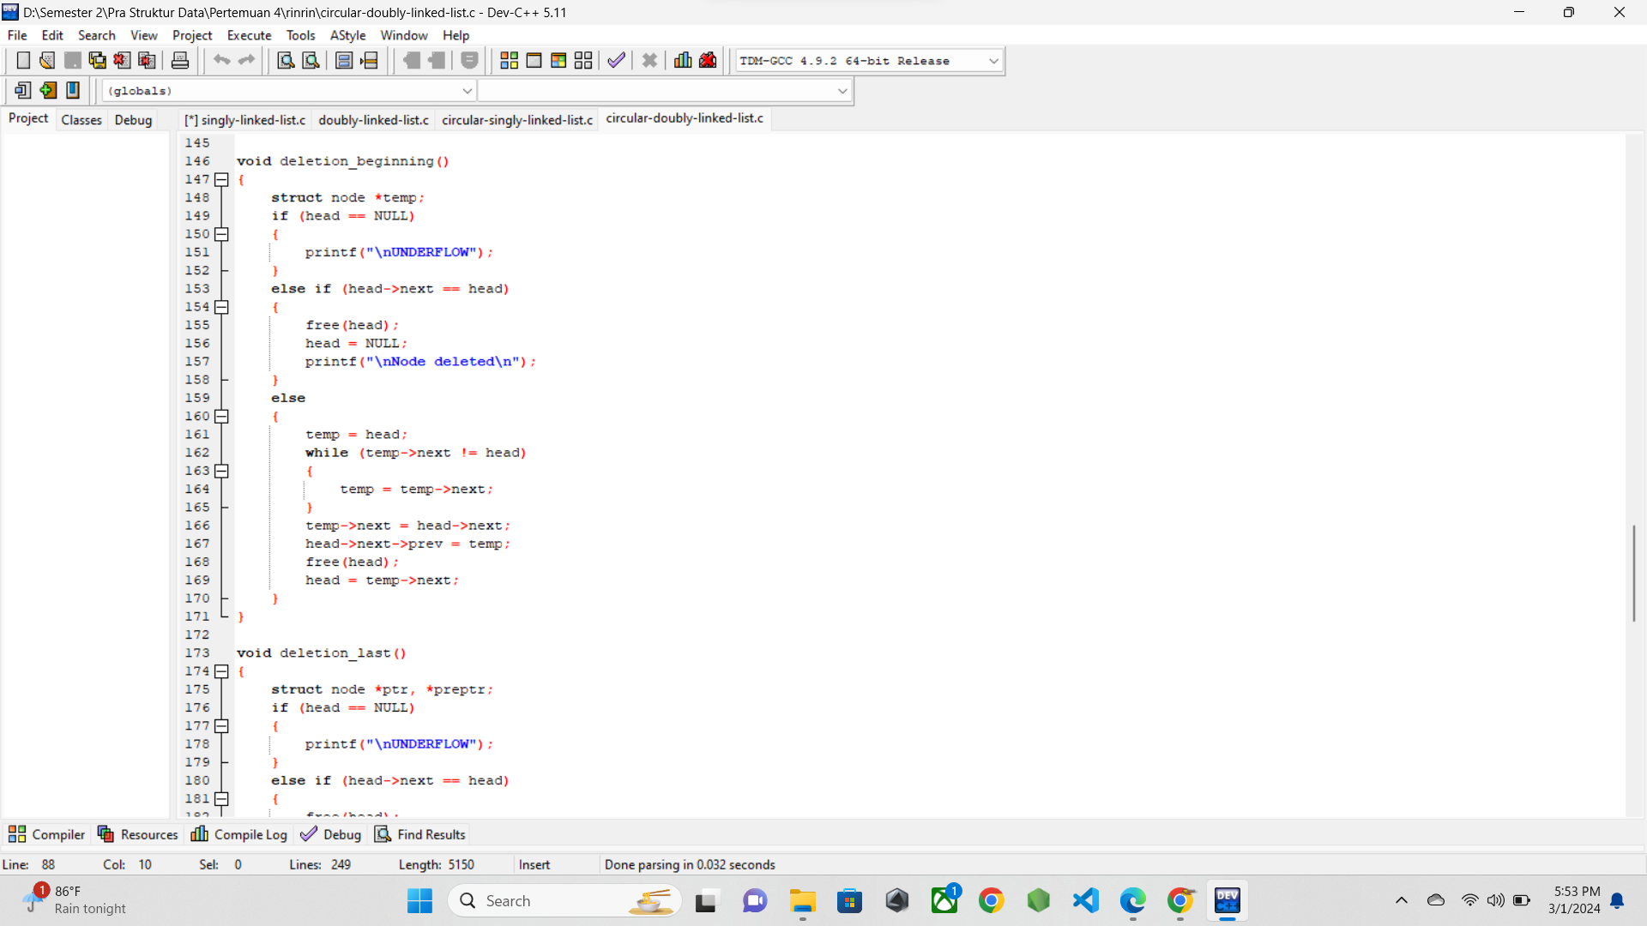

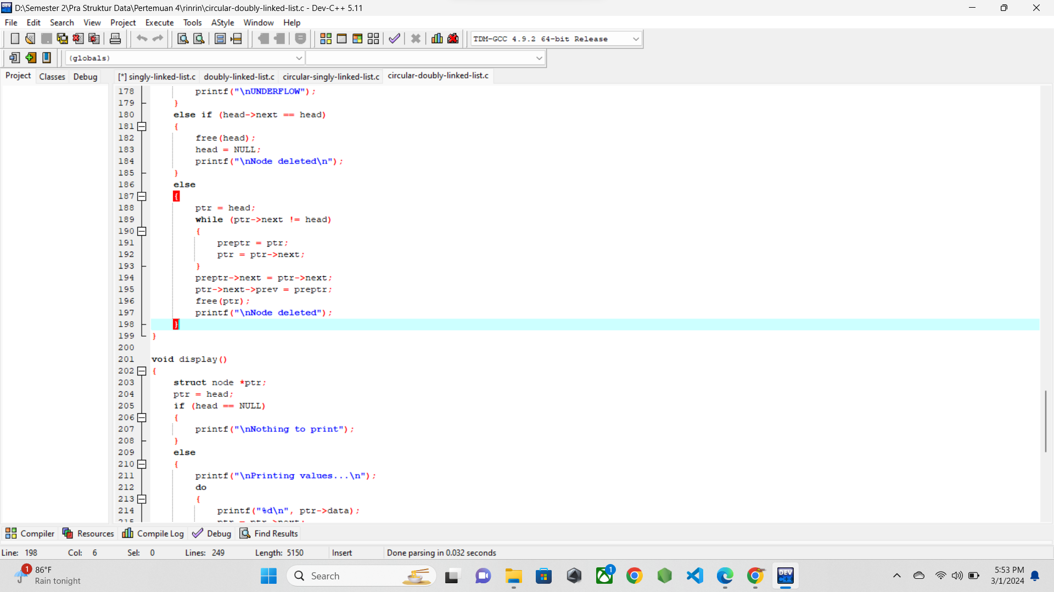

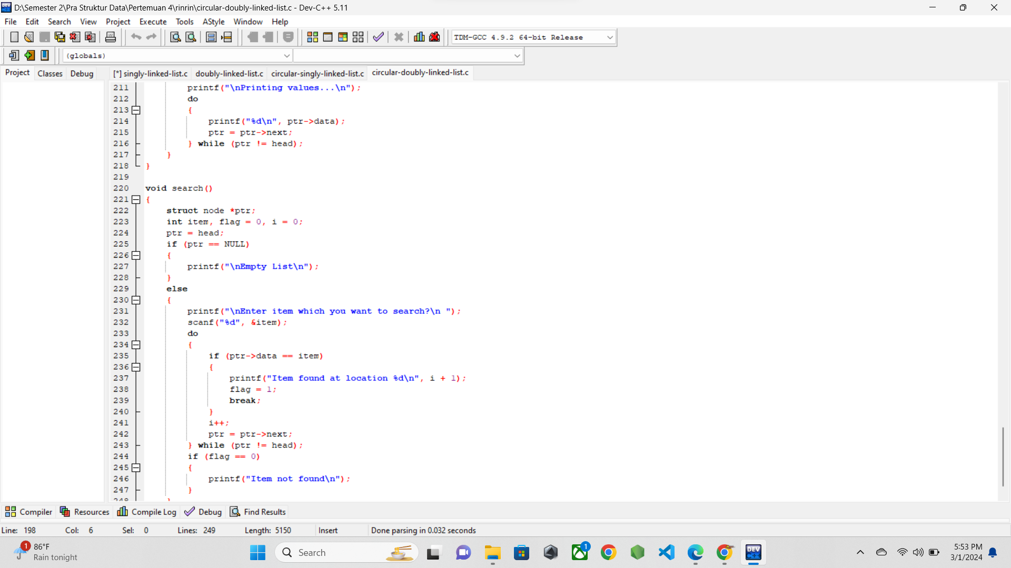

* 1. **SCREENSHOT OUTPUT**

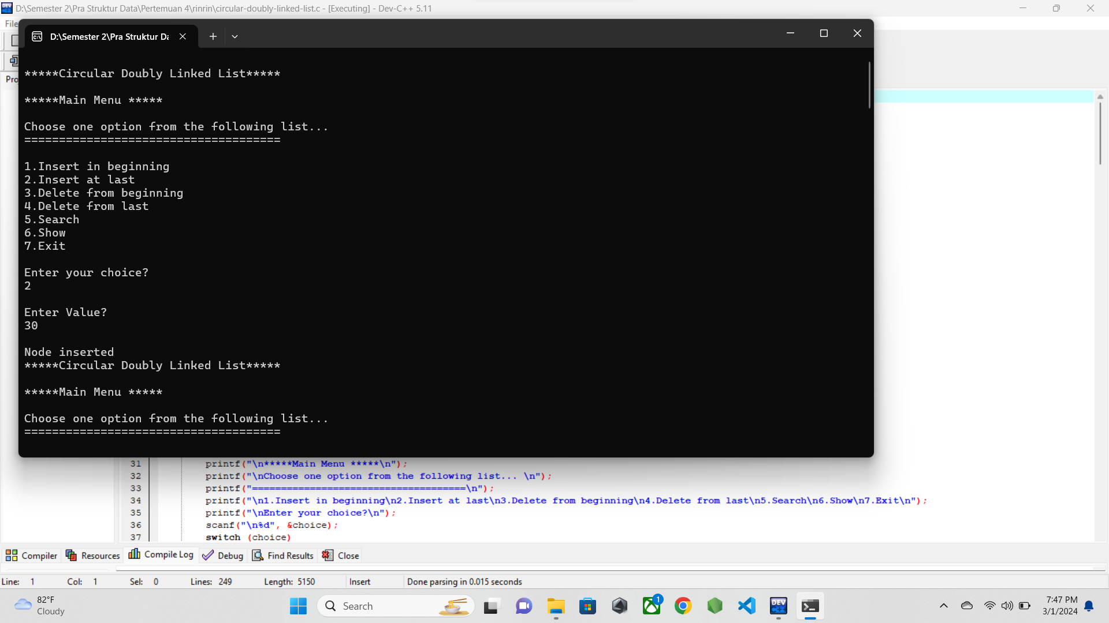

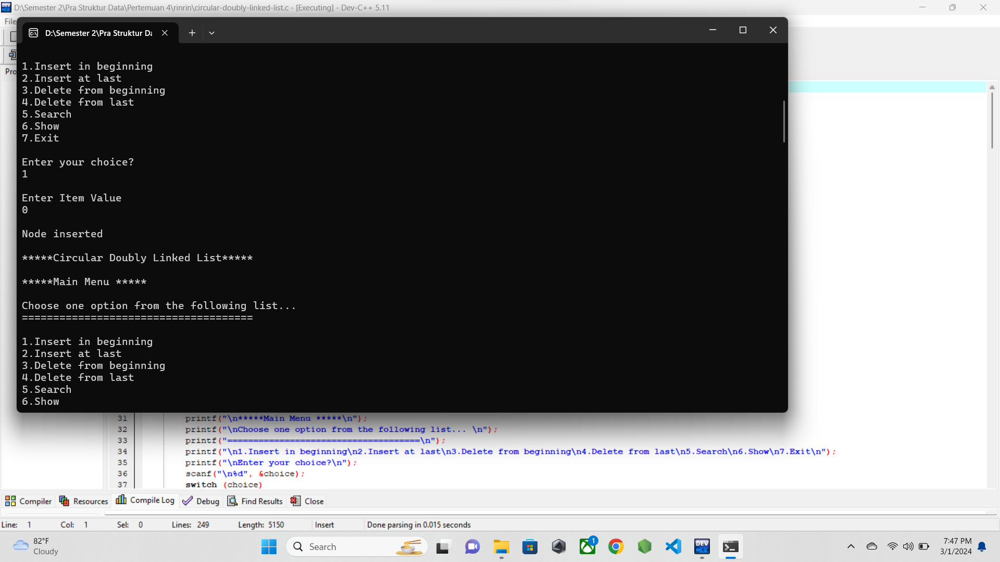

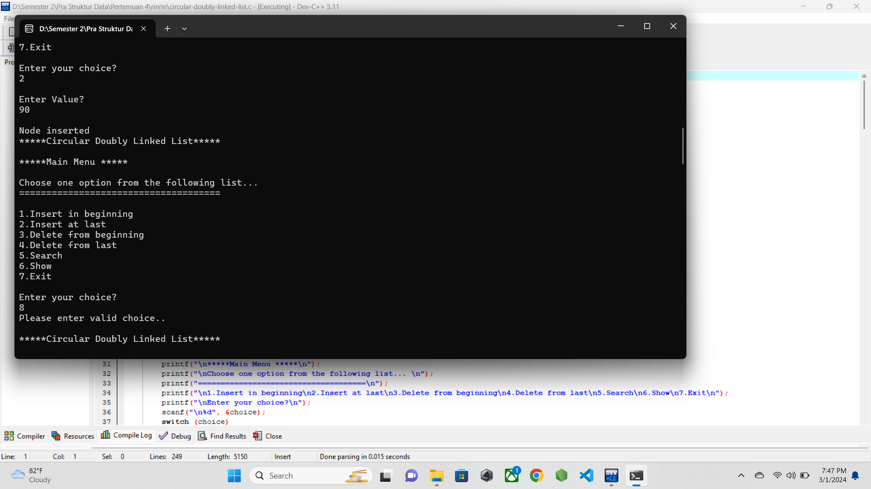

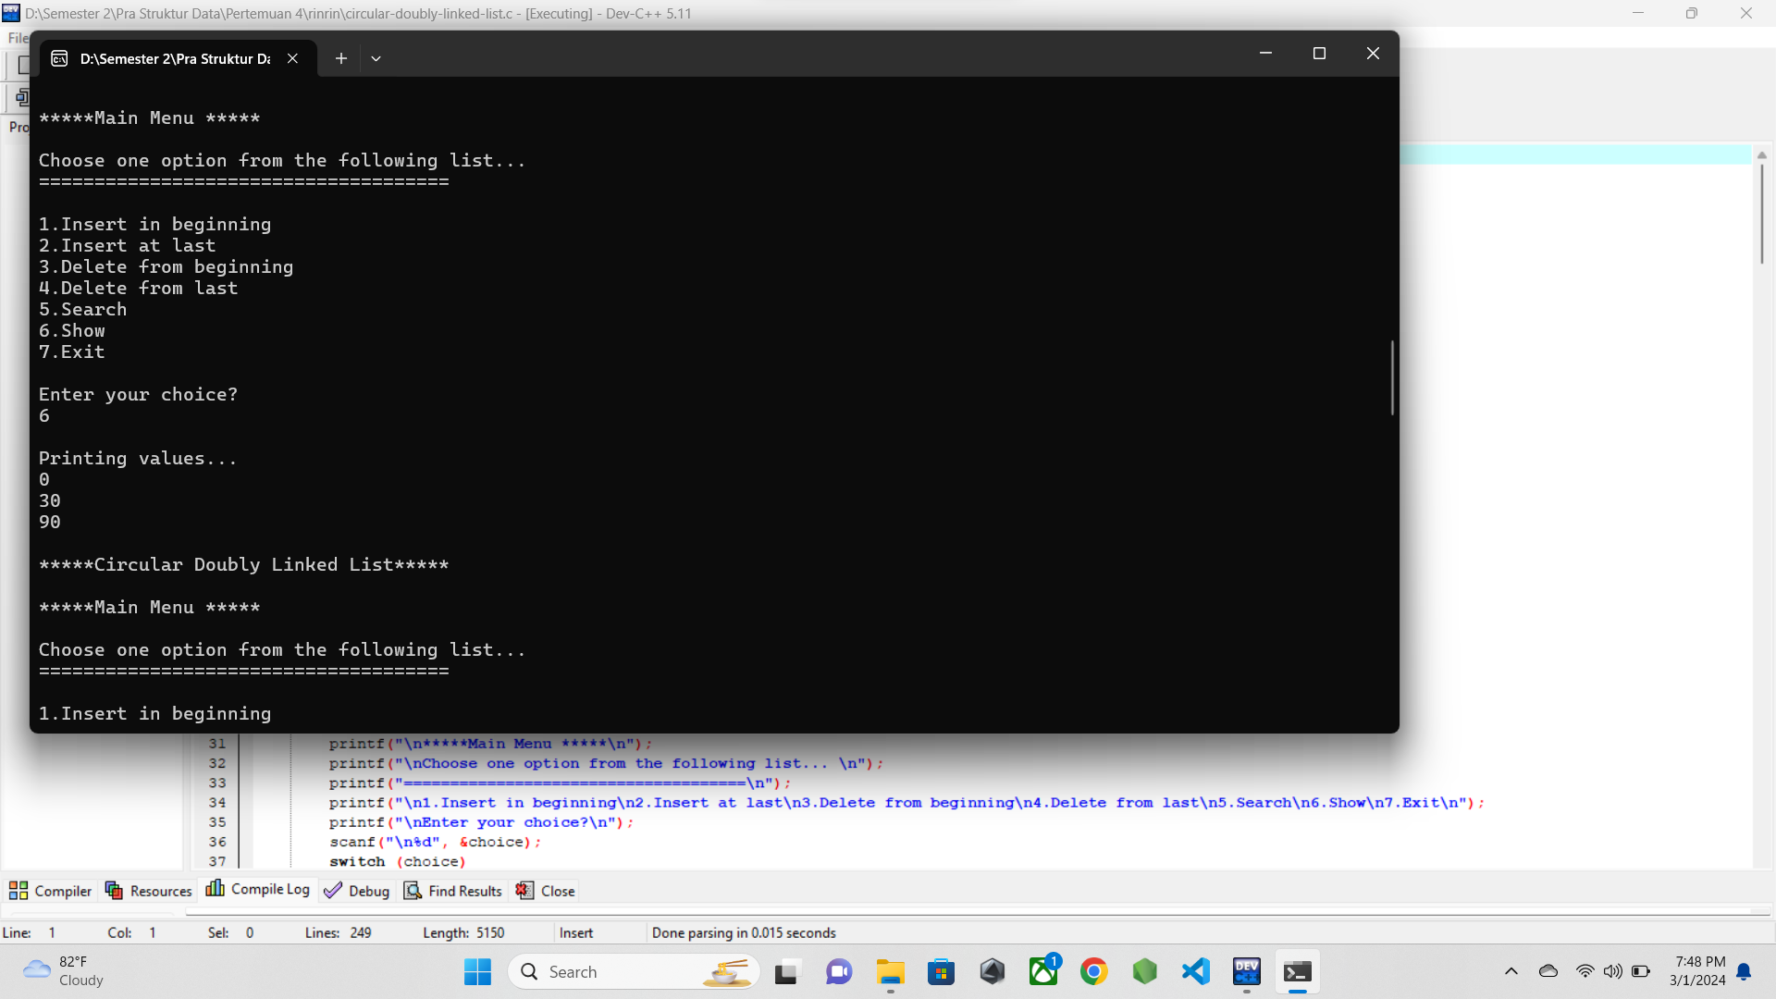

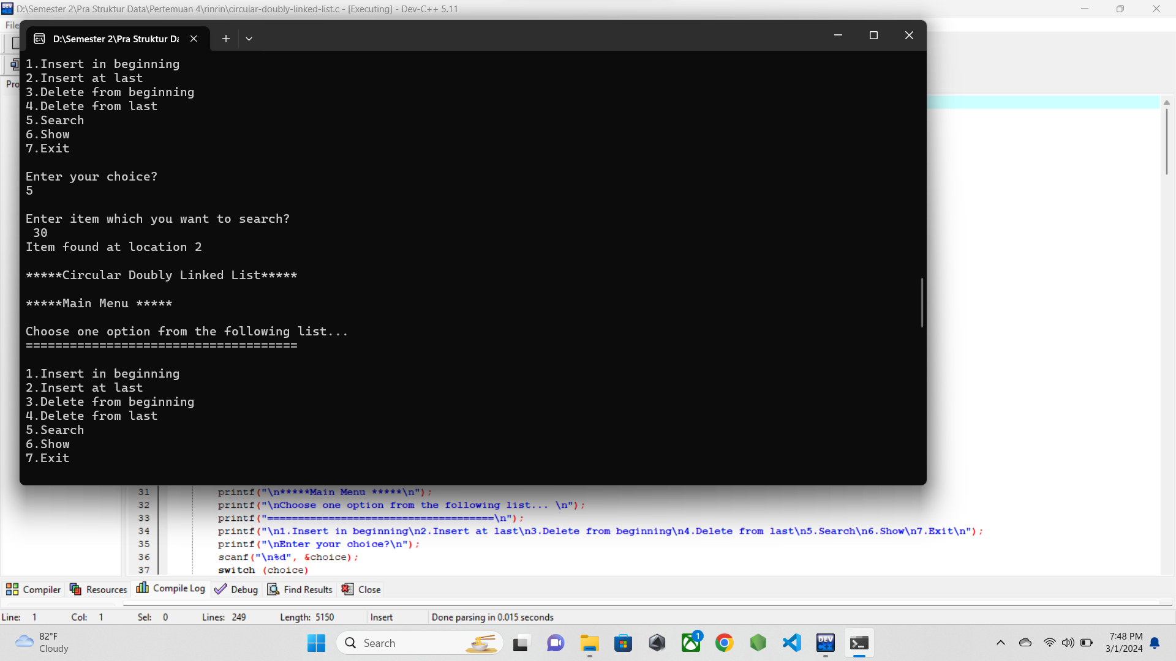

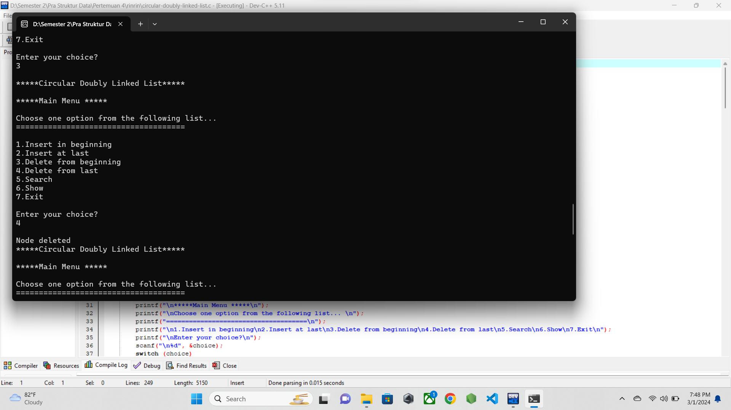

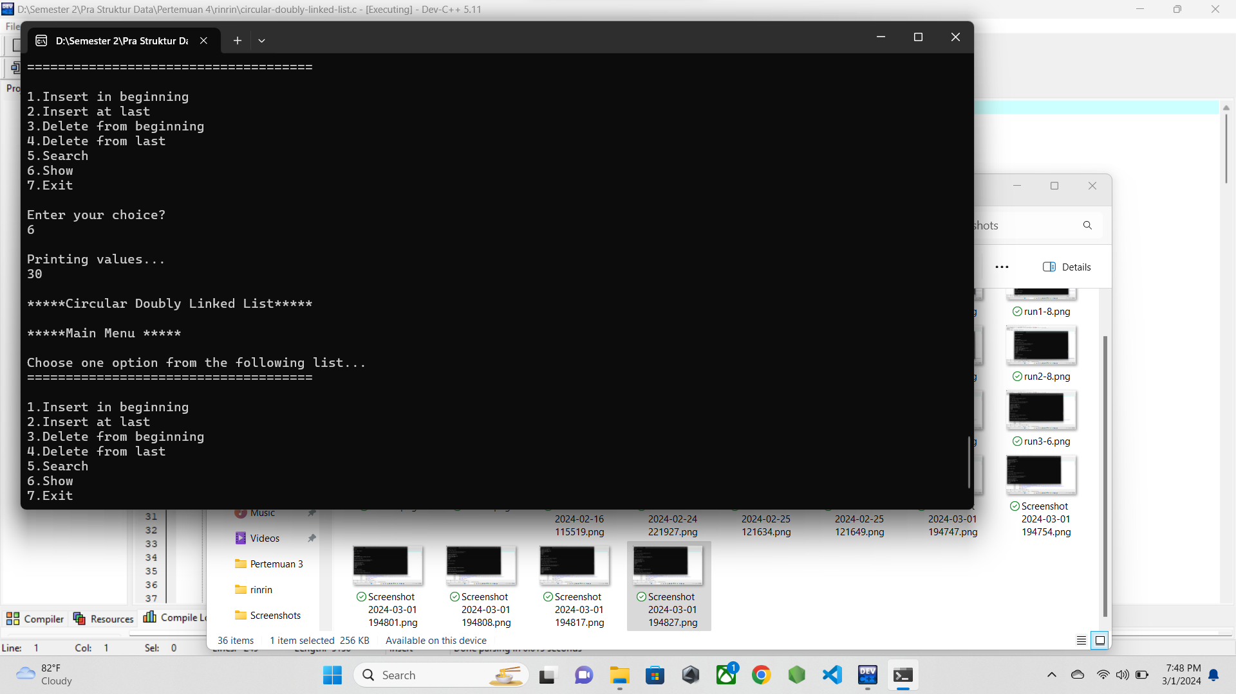

* 1. **PENJELASAN PROGRAM**

Pada program ini adalah implementasi dari circular doubly linkedlist. Yaitu linkedlist melingkar yang memiliki dua penunjuk yaitu node selanjutnya dan node sebelumnya. Perbedaan dengan linkedlist sebelumnya adalah pada node apa saja yang ditunjuk oleh setiap node.

Pada kasus saya, awalnya saya menginputkan data dinode akhir, lalu di node awal. Setelah itu saya tampilkan dan di lanjutkan dengan mencoba mencari data dalam node dengan fitur search.

Lalu setelah itu data yang ada di akhir node dan awal node dihapus dan ditampilkan data yang tersisa pada linkedlist.

1. **Struct-album.c**
   1. **SOURCE CODE**

/* Nama file : struct-album

Pembuat : M. Ilham 23343008

Tgl pembuatan : 26 February 2024*/

#include <stdio.h>

#include <stdlib.h>

#define MAXCHAR 30

struct Node {

int albumNum;

char albumName[MAXCHAR];

char date[MAXCHAR];

struct Node *next;

};

struct Node *head;

struct Node* input();

void unshift();

void pop();

void push();

void shift();

void display();

int main(){

int choice;

while(choice != 6){

printf("\n*********Circular Doubly Linked List*********\n");

printf("\n*********Main Menu*********\n");

printf("\nChoose one option from the following list...\n");

printf("\n==================================================\n");

printf("1. Insert at beginning\n");

printf("2. Insert at last\n");

printf("3. Delete at beginning\n");

printf("4. Delete at last\n");

printf("5. Display All\n");

printf("6. Exit\n");

printf("Number of option : ");

scanf("%d", &choice);

getchar();

switch (choice){

case 1:

unshift();

break;

case 2:

push();

break;

case 3:

shift();

break;

case 4:

pop();

break;

case 5:

display();

break;

case 6:

exit(0);

break;

default: printf("Your choice isn't valid");

}

}

return 0;

}

struct Node* input(){

struct Node *newNode;

newNode = (struct Node *)malloc(sizeof(struct Node));

printf("Masukkan nomor album : ");

scanf("%d", &newNode->albumNum);

getchar();

printf("Masukkan nama album : ");

fgets(&newNode->albumName, sizeof(newNode->albumName), stdin);

printf("Masukkan tanggal album : ");

fgets(&newNode->date, sizeof(newNode->date), stdin);

newNode->next = NULL;

return newNode;

}

void unshift(){

struct Node *newNode;

if(head == NULL) head = input();

else {

newNode = input();

newNode->next = head;

head = newNode;

}

}

void push(){

struct Node *newNode;

if(head == NULL) head = input();

else {

newNode = input();

head->next = newNode;

}

}

void shift(){

struct Node *del;

if(head == NULL) printf("Lagu masih kosong\n");

else {

del = head;

head = head->next;

free(del);

printf("Lagu paling awal berhasil di hapus!");

}

}

void pop(){

struct Node *del, *prevDel;

if(head == NULL) printf("Lagu masih kosong\n");

else {

del = head;

while(del->next != NULL) {

prevDel = del;

del = del->next;

}

prevDel->next = NULL;

free(del);

}

}

void display(){

struct Node *temp;

temp = head;

if(temp == NULL) printf("Album masih kosong!!\n");

else {

while(temp != NULL){

printf("No : %d\n", temp->albumNum);

printf("Name : %s", temp->albumName);

printf("Date : %s\n\n", temp->date);

temp = temp->next;

}

}

}

* 1. **SCREENSHOT PROGRAM**

Screenshot program terdiri dari screenshot layar penuh dan screenshot IDE. Gunakan: Snipping Tool atau PrtSc + Paint

Contoh:

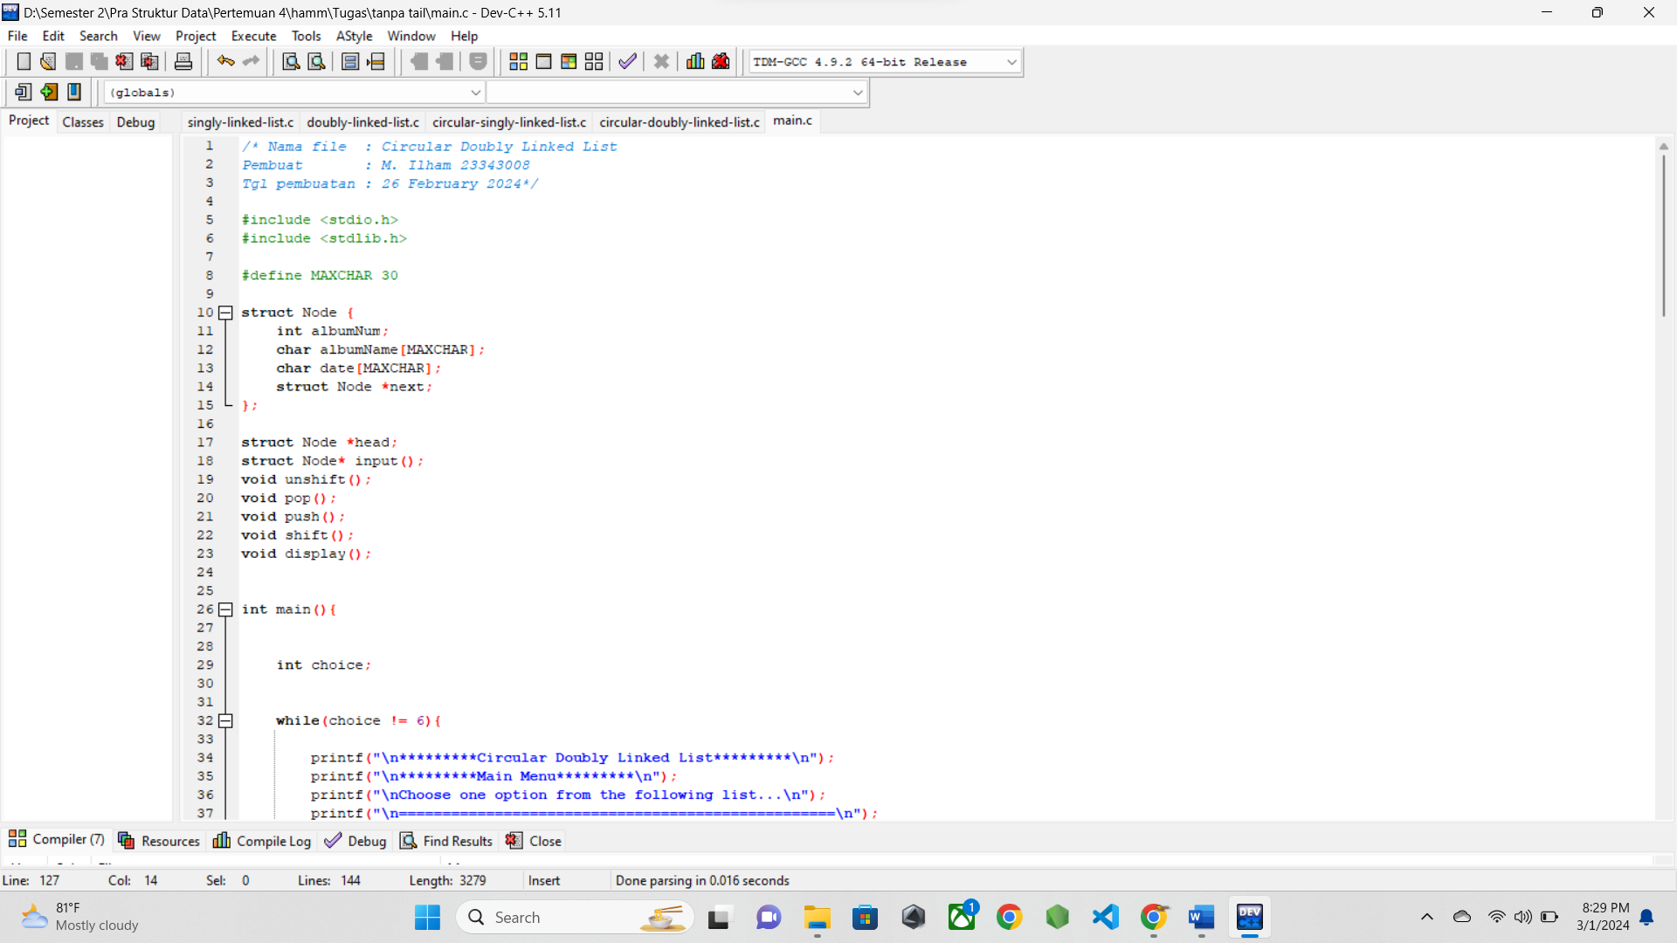

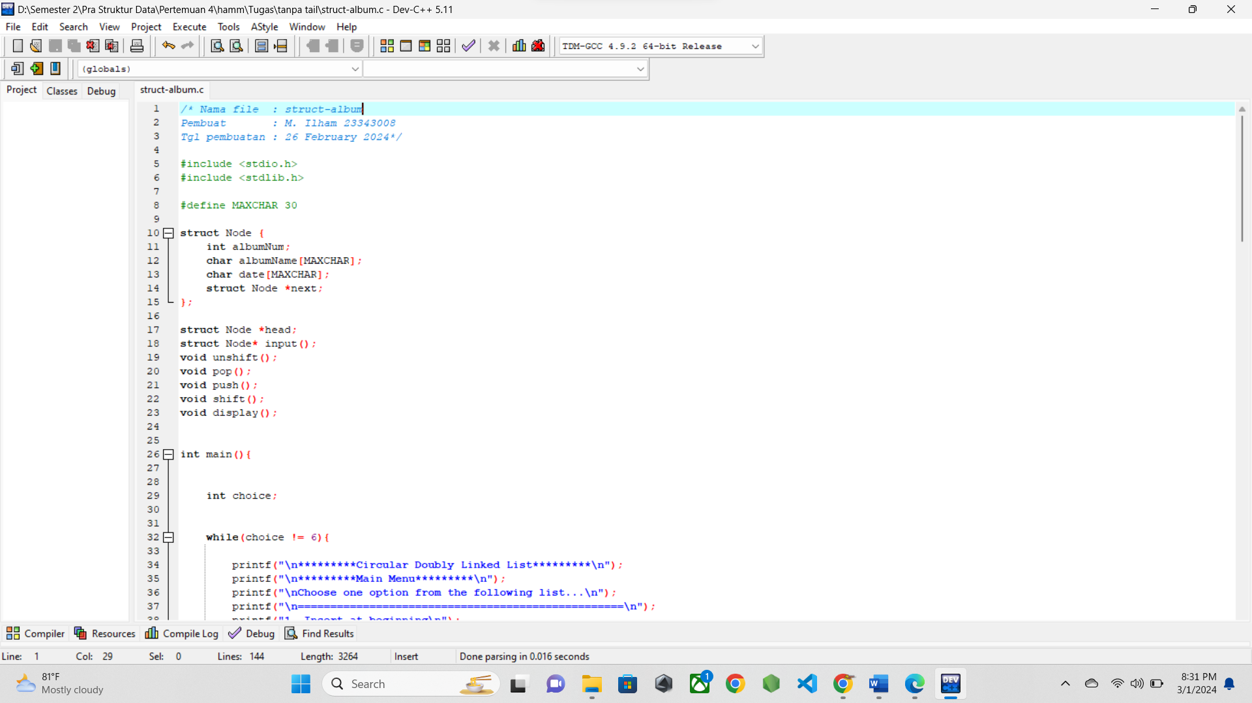

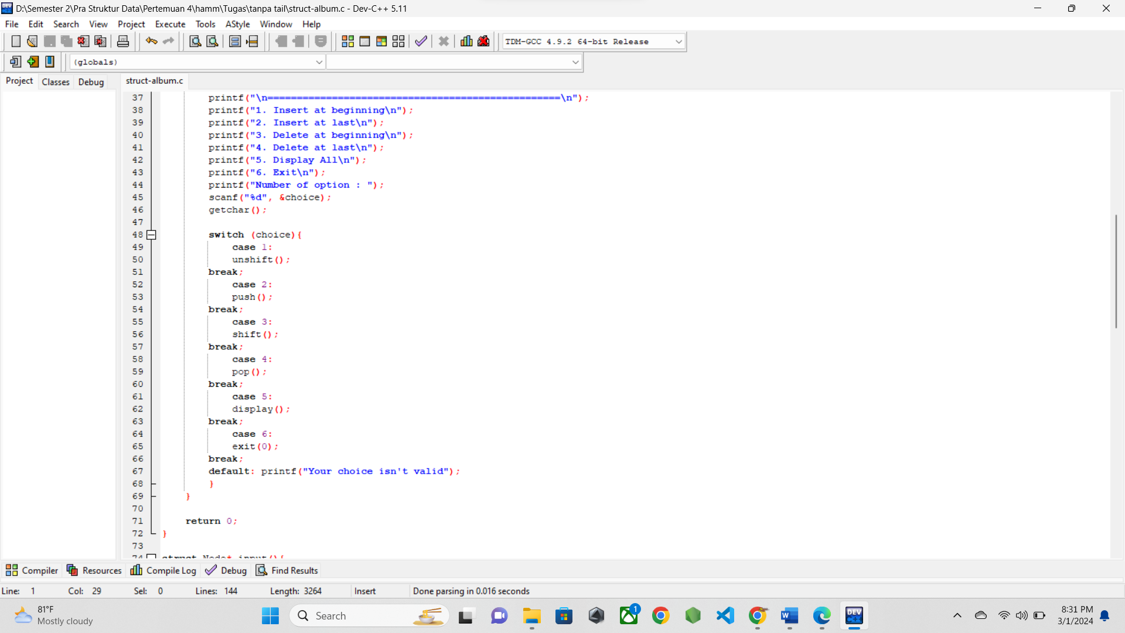

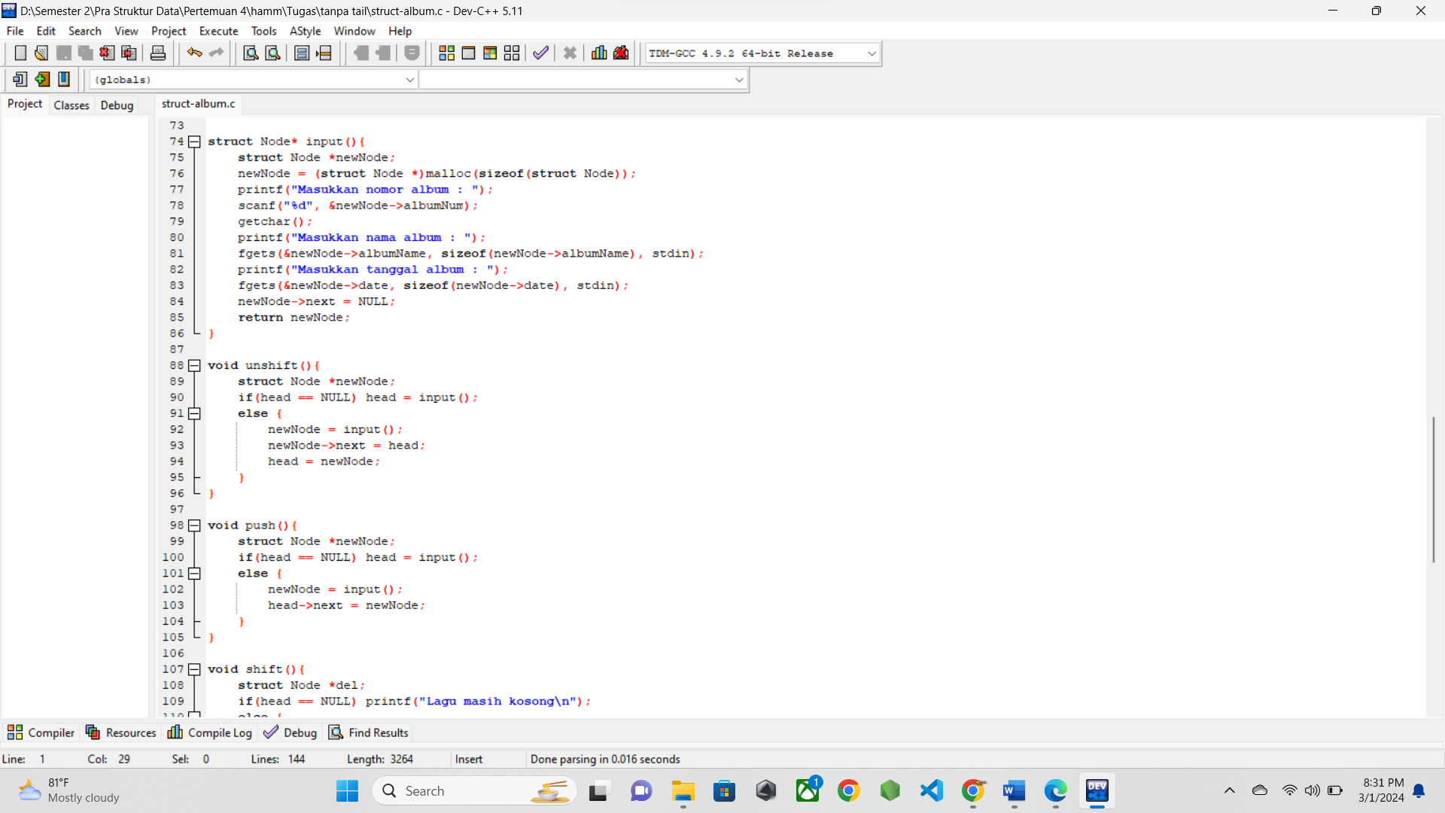

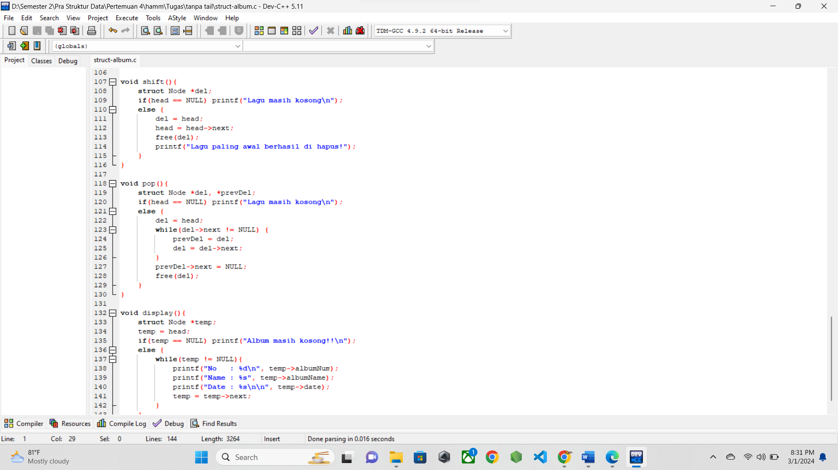

* 1. **SCREENSHOT OUTPUT**

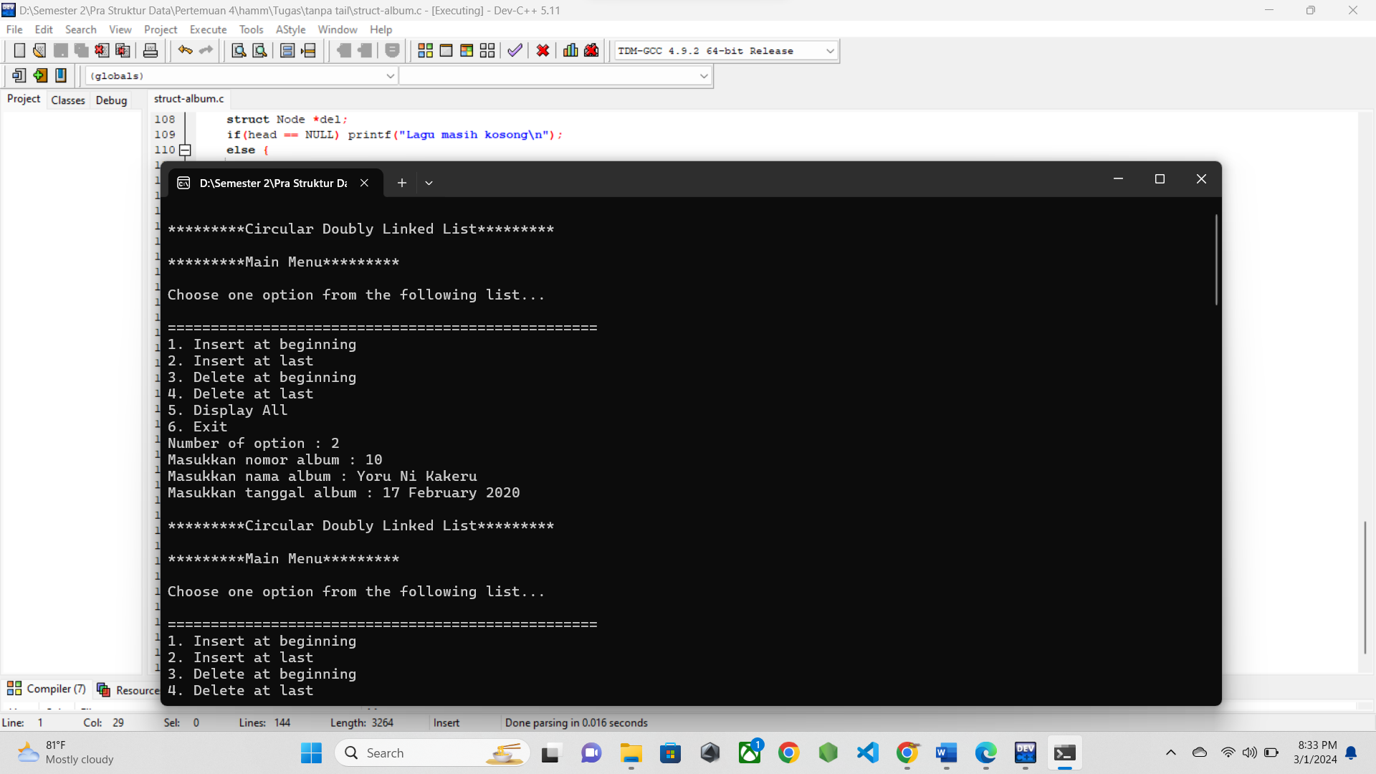

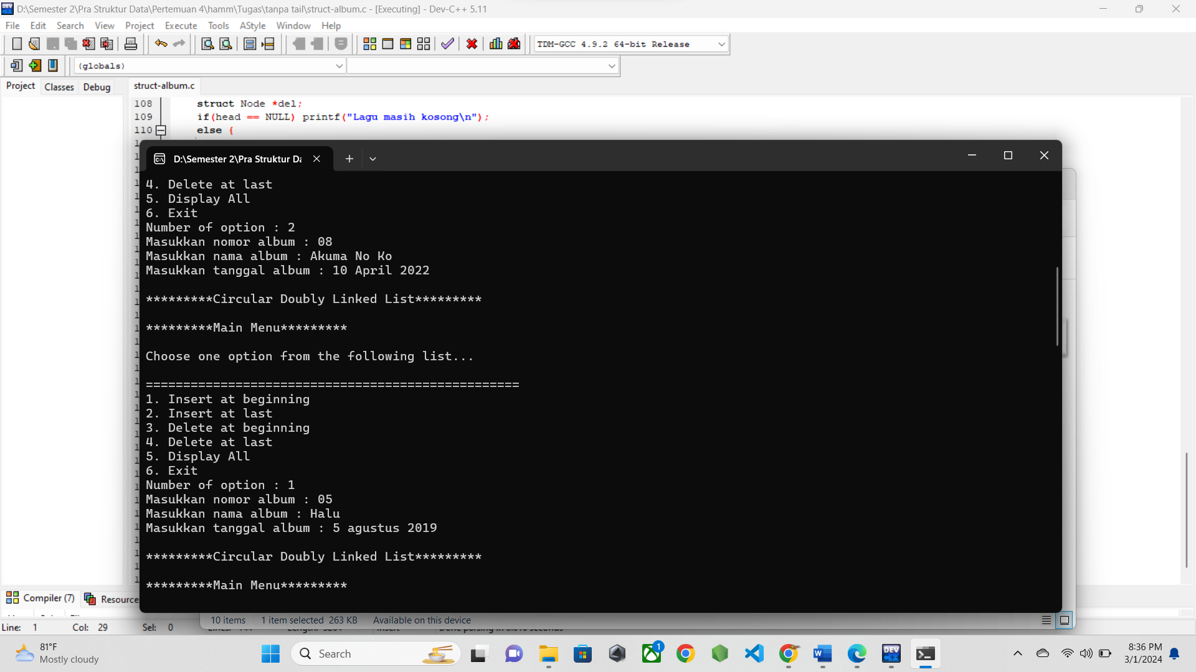

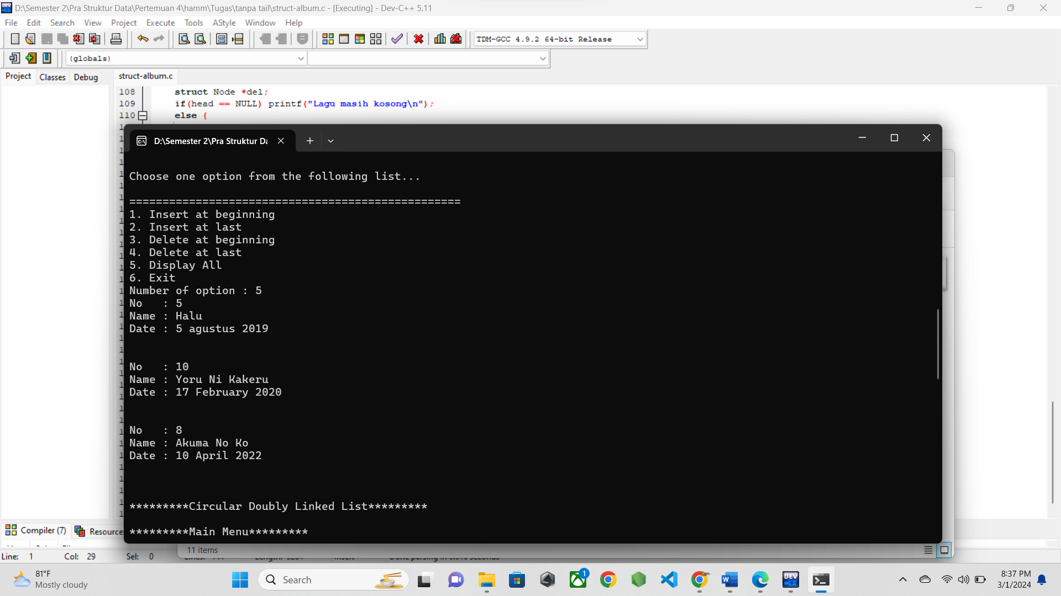

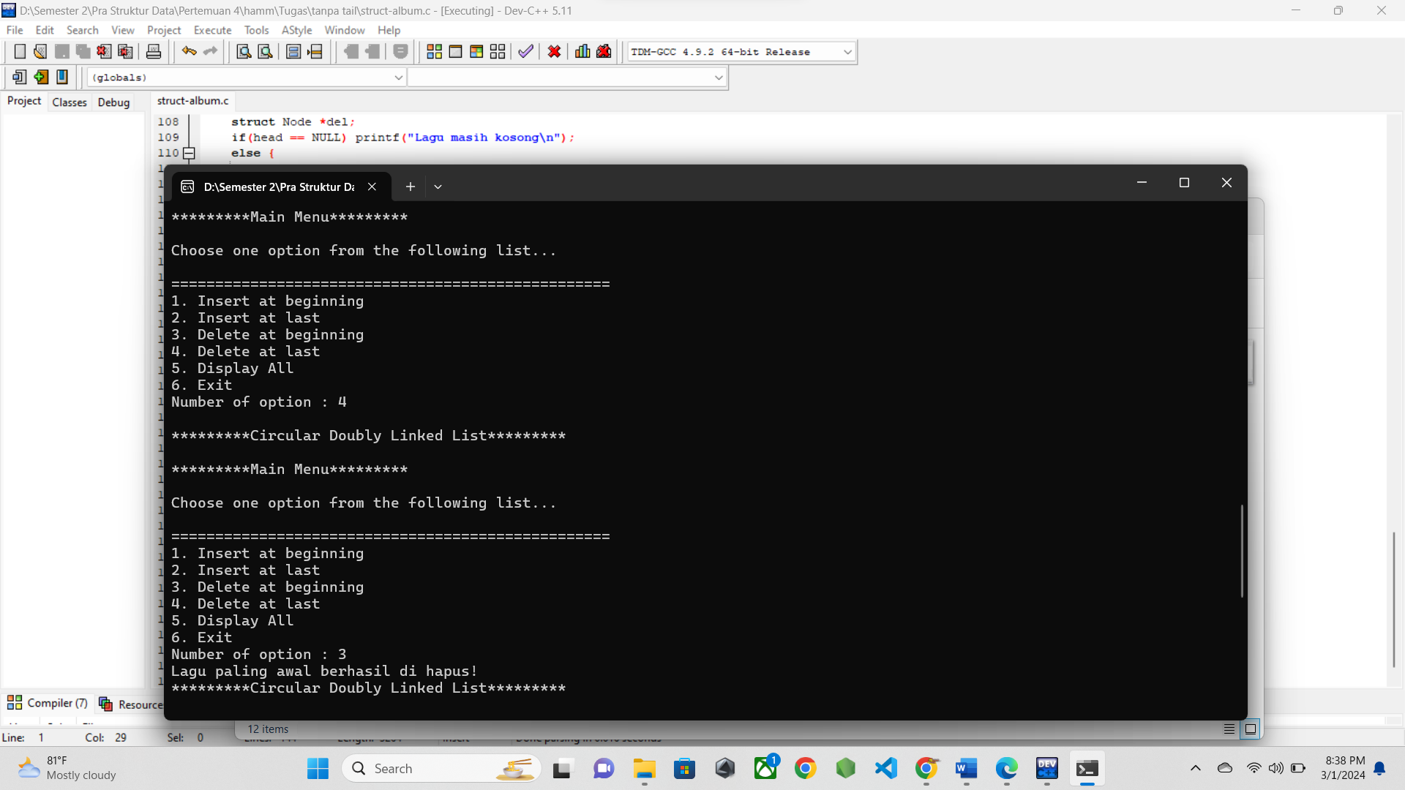

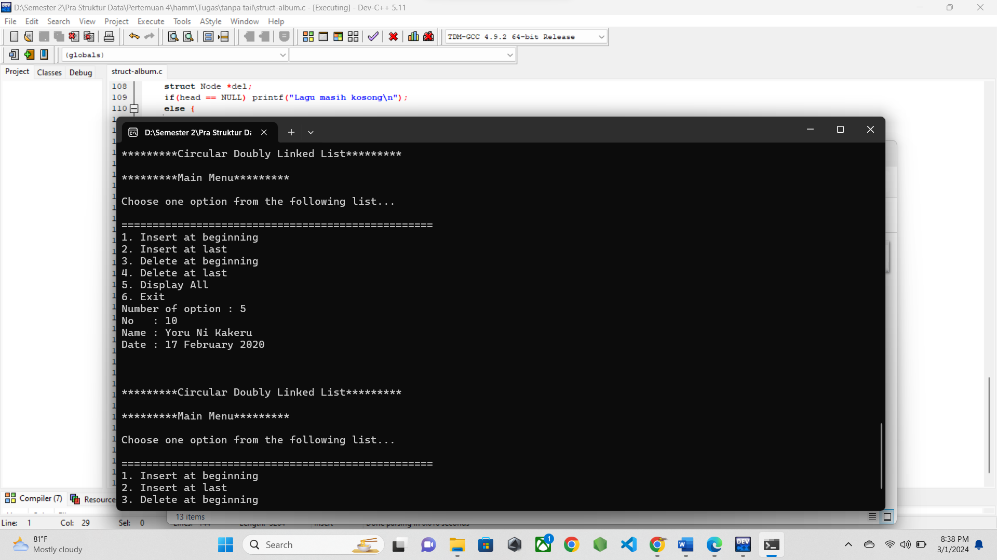

* 1. **PENJELASAN PROGRAM**

Program ini adalah tugas untuk implementasi linke list pada struct lagu. Saya memilih menggunakan single linked list karena struct lagu ini tidak memburuhkan hal yang terlalu kompleks. Jadi di sini awalnya saya menginputkan data node di akhir linkedlist, lalu di awal. Lalu di ikuti dengan menampilkan data apa saja yang ada pada program. Lalu diikuti dengan menghapus data pada node di akhir dan awal linked list dan menampilkan data yang tersisa.

Perbedaan program saya disbanding latihan adala, intuk input pada awal maupun akhir node, saya menggunakan function yang mereturn struct sehingga pengulangan kode yang sama bisa di minimalisir.